**National Institute Of Technology, Tiruchirappalli – 620 015**

**Summer Internship Program 2025**

**Design and Analysis of Digital VLSI Circuits and**

**AES Cryptographic Implementation**

**HARISH S**

**(22EC1234)**

**

**St. Joseph’s Institute of Technology**

**Chennai**

**BONAFIDE CERTIFICATE**

This is to certify that **Harish S** (Register No. **22EC1234**), a student of **Bachelor of Engineering** at St. Joseph’s Institute of Technology, has undergone a **Summer Internship** at the **Department of Electronics and Communication Engineering**, **National Institute of Technology, Tiruchirappalli**, from **27.05.2025 to 20.06.2025**.

During this period, he was actively involved in the Internship Program on **“Digital VLSI Design”** and has contributed significantly under the guidance of the faculty and research staff. He has demonstrated keen interest, commitment, and eagerness to learn, while also submitting a detailed report of the internship activities undertaken.

This certificate is issued as a **bona fide record** of the work carried out and the report submitted by the individual during the specified internship period.

## Dr. M. BHASKAR

### Professor

**ABSTRACT**

This project focuses on the design and development of fundamental digital systems using Verilog HDL, implemented and simulated through the Vivado design environment. The learning journey began with an orientation and a detailed introduction to Verilog and simulation techniques, followed by the hands-on implementation of essential digital modules such as half adders, full adders, ripple carry adders, and both combinational and sequential multipliers. Building on this foundation, an 8-bit Arithmetic Logic Unit (ALU) was designed, along with a custom 8-bit CPU capable of executing 8 basic instructions.

As a culmination of the project, a mini project was undertaken to implement the AES (Advanced Encryption Standard) algorithm, supporting both encryption and decryption functionalities. The AES module was coded in Verilog, simulated for correctness, and verified through testbenches. The entire design flow—from problem definition to simulation and result analysis—was carried out to demonstrate the practical application of digital design principles in cryptographic systems.

**ACKNOWLEDGEMENTS**

I want to express my sincere gratitude to my mentor, **Prof. M. Bhaskar**, Professor and Head, Department of Electronics and Communication Engineering, National Institute of Technology, Tiruchirappalli. His constant guidance, steadfast support, and encouragement were crucial throughout this internship. His insightful feedback, patience, and exceptional mentorship were truly instrumental in the successful completion of this project.

My heartfelt thanks also go to **Mr. Thivagar T**, Research Scholar, Department of Electronics and Communication Engineering, NIT Tiruchirappalli, for his technical support, motivation, and invaluable assistance during the project's implementation phase.

I want to thank my friends and family for their unwavering support, continuous motivation, and belief in me throughout the entire course of this internship.

**TABLE OF CONTENTS**

|  |  |
| --- | --- |
|  | **Activity Undertaken** |
| Week 1  27.05.2025 | Orientation and Project Overview |
| 28.05.2025 - 1.06.2025 | Introduction to Verilog and Simulation in Vivado |
| Week 2  02.06.2025 - 08.06.2025 | Implementation of Basic Digital Modules |
| Week 3  09.06.2025 - 15.06.2025 | Design of an 8-bit Arithmetic Logic Unit (ALU)  Development of an 8-bit, 8-Instruction CPU in Verilog |
| Week 4  16.06.2025 - 20.06.2025 | Mini Project Implementation |

### ii

## Decoder

**Introduction:**

The Verilog code provided is a simple implementation of a 2-to-4 line decoder using basic logic gates like NOT and AND. In the decod1 module, there are two input selection lines (s0 and s1) and four output lines (i0 to i3). For each possible combination of the inputs, only one output line is set high, which means it produces a "one-hot" output.

To achieve this, the inputs are first inverted as needed, and then specific combinations are passed through AND gates to activate the correct output. This way, the decoder translates the 2-bit binary input into one of four distinct outputs.

The decod1tb testbench is used to simulate this decoder. It goes through all the possible input combinations from 00 to 11, applying them with short time delays. This helps verify that the decoder is working as expected in all cases.

Output waveform:

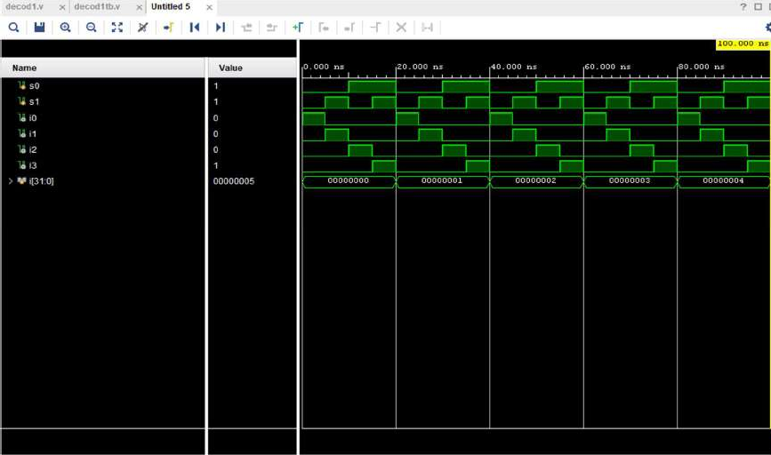

**Design Code:**

module decod1( input s0,s1, output i0,i1,i2,i3

);

not(s00,s0);

not(s11,s1) ;

and(i0,s00,s11);

and(i1,s00,s1);

and(i2,s0,s11);

and(i3,s0,s1); endmodule

**Test bench code:**

module decod1tb(); reg s0, s1;

wire i0, i1, i2, i3; integer i;

decod1 a(s0, s1, i0, i1, i2, i3); initial begin

for (i = 0; i < 5; i = i + 1) begin s0 = 0;

s1 = 0;

#5

s0 = 0;

s1 = 1;

#5

s0 = 1;

s1 = 0;

#5

s0 = 1;

s1 = 1;

#5;

end

$finish; end

endmodule

**Analysis:**

**Power Consumption:**

The image shows the power analysis of an FPGA design. The total on-chip power is **1.164 W**, with **39%** (**0.456 W**) being static power and **61%** (**0.709 W**) being dynamic power. The junction temperature is a safe **27.0°C**, with a thermal margin of **73.0°C**. No off-chip power is used, and the analysis confidence level is marked as **LOW**.

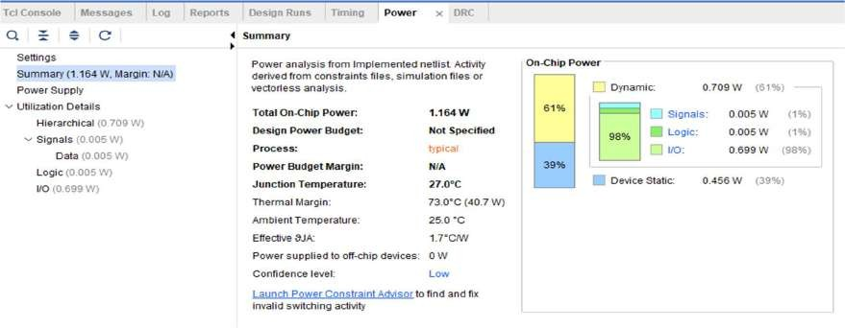

**Delay:**

The **minimum total setup delay** is **4.460 ns**. The **maximum total setup delay** is **4.637 ns**.

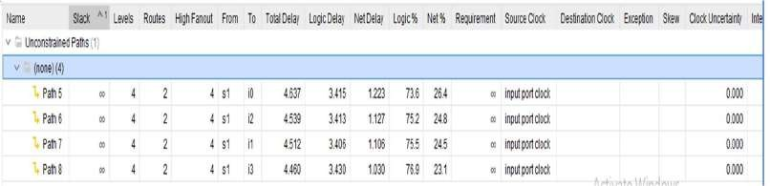

The **minimum total hold delay** is **0.459 ns**. The **maximum total hold delay** is **0.599 ns**.

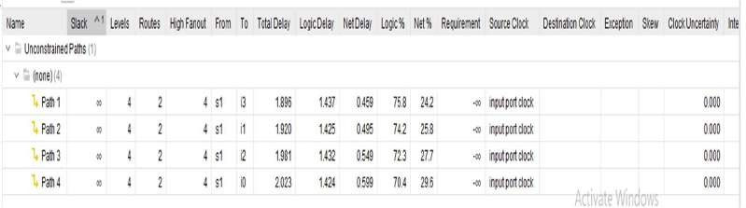

**Area:**

The image shows the **Post-Implementation Utilization Report** of an FPGA design. It indicates resource usage:

* **LUT** wasutilized only **1%**.
* 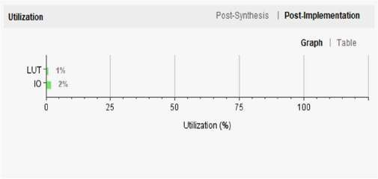**IO** has the highest usage at **2%**.

**RTL Schematic:**

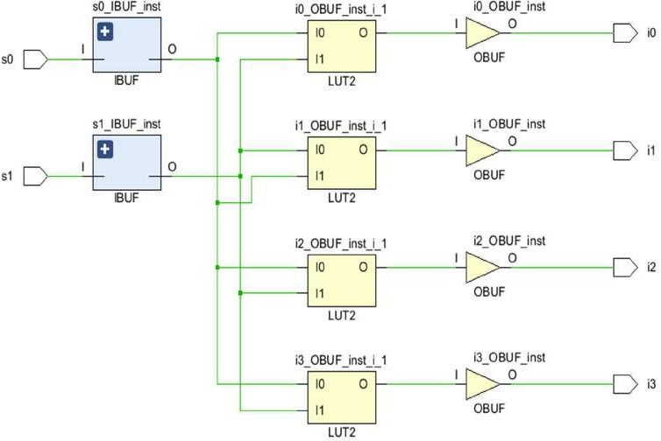

# Decoder using NAND gates

## Introduction:

The provided Verilog code implements a 2-to-4 line decoder entirely using NAND gates, showcasing a universal gate-based design. In the decod2 module, two input selection signals (s0 and s1) control four output lines (i0 to i3), ensuring that only one output is high for each unique input combination.

Instead of using traditional NOT or AND gates, the design cleverly uses NAND gates to generate inverted signals—for example, s00 is created by NANDing s0 with itself. These inverted and original signals are then combined using further NAND gates to produce the correct one-hot output pattern.

To confirm that the decoder works correctly, the decod2tb testbench runs through all possible input combinations (from 00 to 11) with time delays, checking that the output matches the expected behavior in each case during simulation.

**Output waveform:**

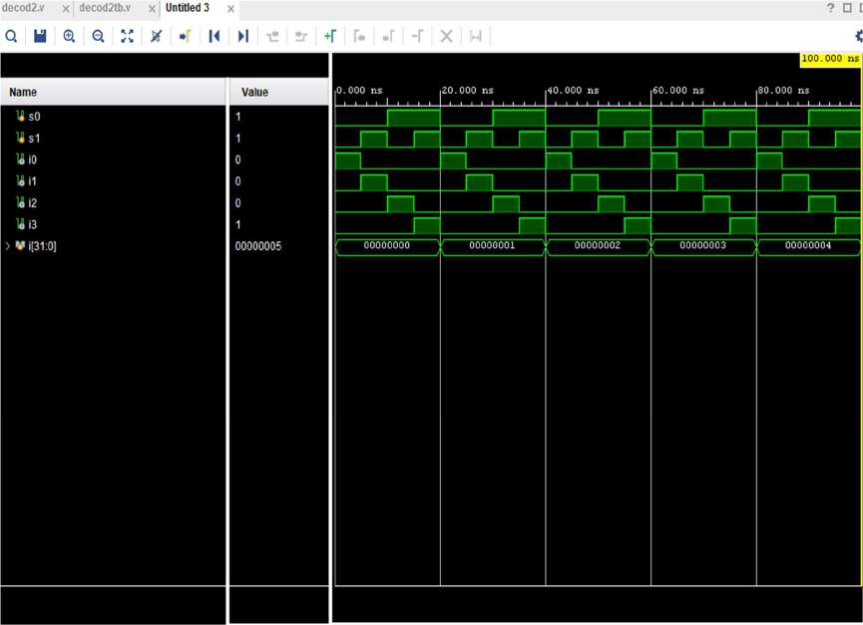

**Design Code:**

module decod2( input s0,s1, output i0,i1,i2,i3

);

wire w0,w1,w2,w3; nand(s00,s0,s0);

nand(s11,s1,s1) ; nand(w0,s00,s11); nand(w1,s00,s1);

nand(w2,s0,s11);

nand(w3,s0,s1);

nand(i0,w0,w0);

nand(i1,w1,w1);

nand(i2,w2,w2);

nand(i3,w3,w3); endmodule

**Test bench code :**

module decod2tb(); reg s0, s1;

wire i0, i1, i2, i3; integer i;

decod2 a(s0, s1, i0, i1, i2, i3); initial begin

for (i = 0; i < 5; i = i + 1) begin s0 = 0;

s1 = 0;

#5

s0 = 0;

s1 = 1;

#5

s0 = 1;

s1 = 0;

#5

s0 = 1;

s1 = 1;

#5;

end

$finish; end

endmodule

**Analysis:**

**Power Consumption:**

The image shows the power analysis of an FPGA design. The total on-chip power is **2.036 W**, with **23% (0.463 W)** being static power and **77% (1.573 W)** being dynamic power. The junction temperature is a safe **28.50°C**, with a thermal margin of **71.5°C**. No off-chip power is used, and the analysis confidence level is marked as **LOW**.

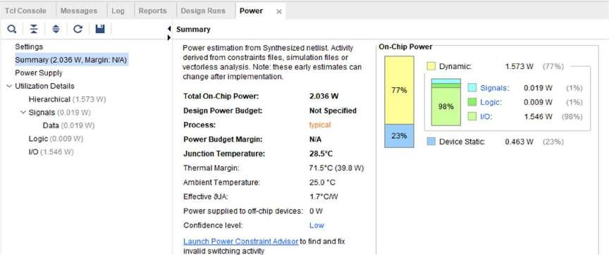

**Delay:**

The **minimum total setup delay** is **2.758 ns**. The **maximum total setup delay** is **2.790 ns**.

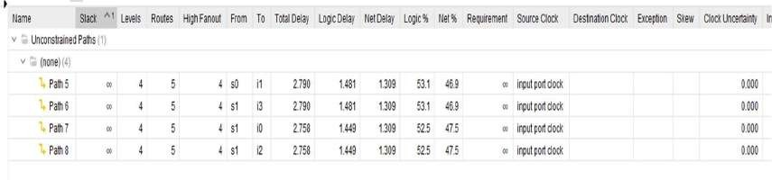

The **minimum total hold delay** is **1.211 ns**. The **maximum total hold delay** is **1.222 ns**

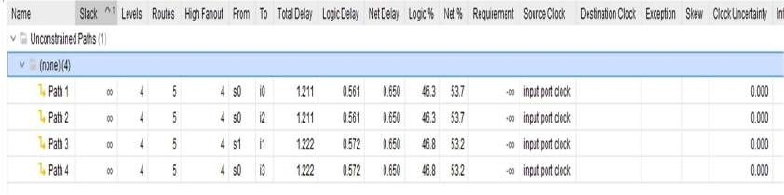

**Area:**

The image shows the **Post-Implementation Utilization Report** of an FPGA design. It indicates resource usage:

* **LUT** utilized only **1%**.
* 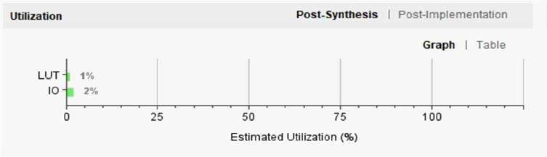**IO** has the highest usage at **2%**.

**RTL Schematic:**

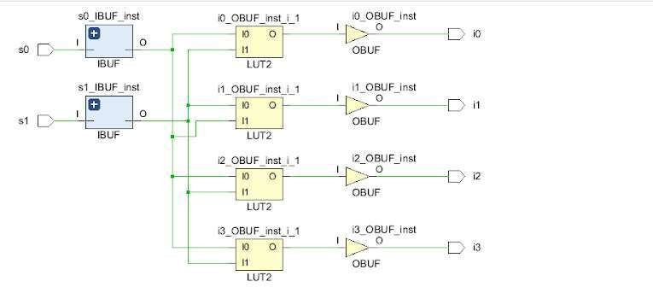

# Decoder 3 to 8

**Introduction:**

This Verilog code demonstrates how a 3-to-8 line decoder can be built using only NAND gates, which are universal gates capable of forming any digital logic. The decod3 module takes three input selection lines (s0, s1, and s2) and generates eight output lines (i[0] to i[7]), ensuring that only one output is high for each unique input combination.

To mimic the behavior of NOT and AND gates, the design first inverts the input signals using NAND gates applied to the same input (e.g., s00 = NAND(s0, s0)). These inverted signals, along with the original ones, are then combined through additional NAND operations to generate the correct output for each input pattern.

Each output is carefully designed to respond to a specific combination of inputs, so the decoder activates only one output at a time—just like a standard 3-to-8 decoder. This implementation highlights how even complex digital logic can be created entirely using universal gates like NAND, without needing other basic gates.

**Output waveform:**

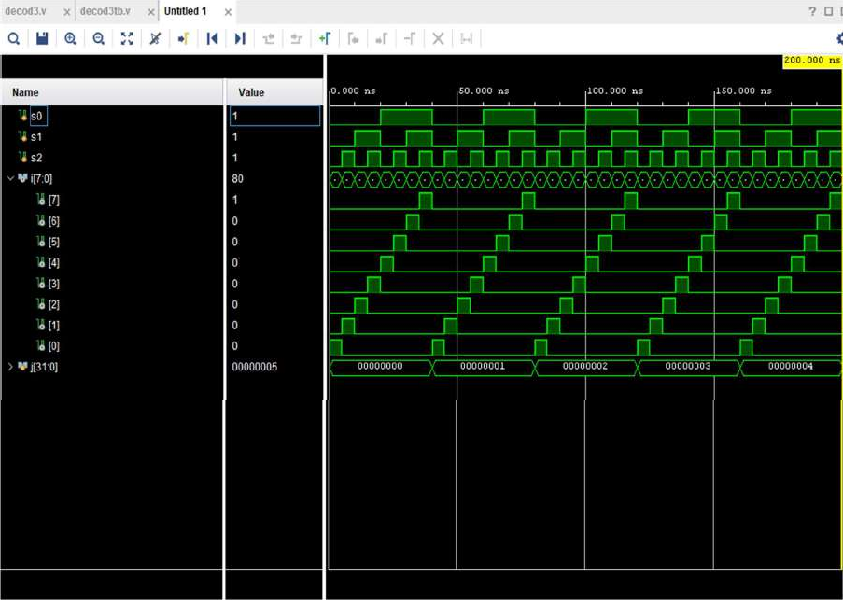

**Design Code:**

module decod3( input s0,s1,s2, output [7:0]i

);

wire [7:0]w1;

wire [7:0]w2;

wire [7:0]w3;

nand(s00,s0,s0);

nand(s11,s1,s1);

nand(s22,s2,s2);

nand(w1[0],s22,s11); nand(w2[0],w1[0],w1[0]);

nand(w3[0],s00,w2[0]);

nand(i[0],w3[0],w3[0]);

nand(w1[1],s2,s11); nand(w2[1],w1[1],w1[1]);

nand(w3[1],s00,w2[1]);

nand(i[1],w3[1],w3[1]);

nand(w1[2],s22,s1); nand(w2[2],w1[2],w1[2]);

nand(w3[2],s00,w2[2]);

nand(i[2],w3[2],w3[2]);

nand(w1[3],s2,s1); nand(w2[3],w1[3],w1[3]);

nand(w3[3],s00,w2[3]);

nand(i[3],w3[3],w3[3]);

nand(w1[4],s22,s11); nand(w2[4],w1[4],w1[4]);

nand(w3[4],s0,w2[4]);

nand(i[4],w3[4],w3[4]);

nand(w1[5],s2,s11); nand(w2[5],w1[5],w1[5]);

nand(w3[5],s0,w2[5]);

nand(i[5],w3[5],w3[5]);

nand(w1[6],s22,s1); nand(w2[6],w1[6],w1[6]);

nand(w3[6],s0,w2[6]);

nand(i[6],w3[6],w3[6]);

nand(w1[7],s2,s1); nand(w2[7],w1[7],w1[7]);

nand(w3[7],s0,w2[7]);

nand(i[7],w3[7],w3[7]); endmodule

**Test bench code:**

module decod3tb();

reg s0, s1, s2; wire [7:0]i; integer j;

decod3 a(s0, s1, s2, i[7:0]); initial begin

for (j = 0; j < 5; j = j + 1) begin s0 = 0;s1 = 0;s2 = 0;

#5

s0 = 0;s1 = 0;s2 = 1; #5

s0 = 0;s1 = 1;s2 = 0; #5

s0 = 0;s1 = 1;s2 = 1; #5

s0 = 1;s1 = 0;s2 = 0; #5

s0 = 1;s1 = 0;s2 = 1; #5

s0 = 1;s1 = 1;s2 = 0; #5

s0 = 1;s1 = 1;s2 = 1; #5;

end

$finish; end

endmodule

**Analysis:**

**Power Consumption:**

The image shows the power analysis of an FPGA design. The total on-chip power is **2.69 W**, with **17% (0.468 W)** being static power and **83% (2.222 W)** being dynamic power. The junction temperature is a safe **29.7°C**, with a thermal margin of **70.3°C**. No off-chip power is used, and the analysis confidence level is marked as **LOW**.

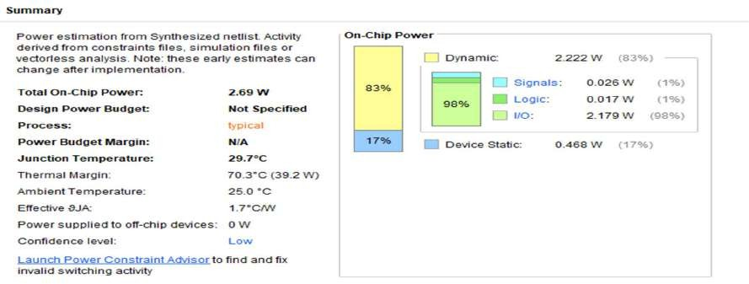

**Delay:**

The **minimum total setup delay** is **2.789 ns**. The **maximum total setup delay** is **2.811 ns**.

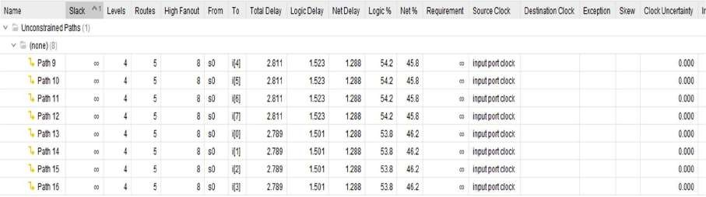

The **minimum total hold delay** is **1.218 ns**. The **maximum total hold delay** is **1.229 ns**.

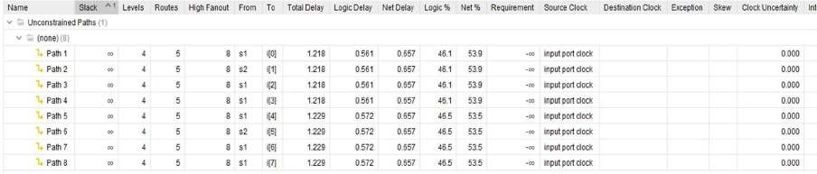

**Area:**

The image shows the **Post-Implementation Utilization Report** of an FPGA design. It indicates resource usage:

* **LUT** utilized only **1%**.
* 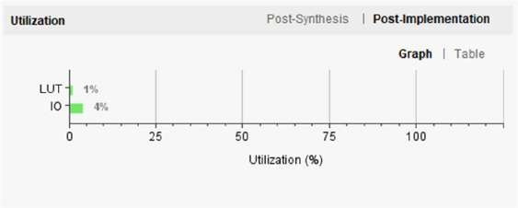**IO** has the highest usage at **4%**

**RTL Schematic:**

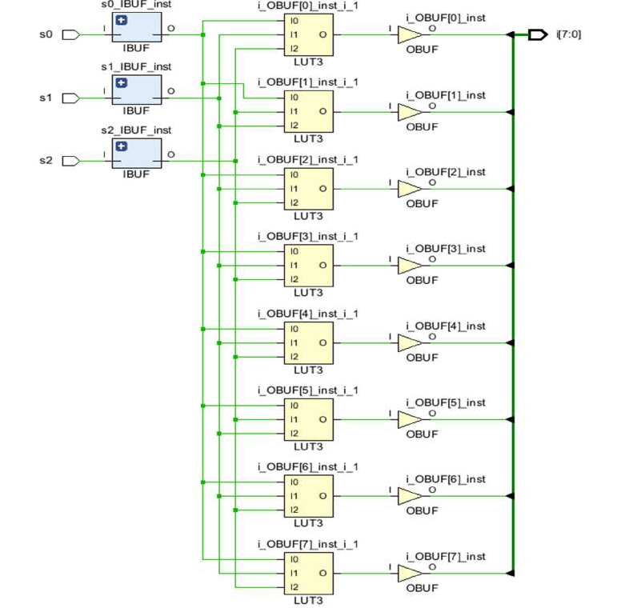

# 3 to 8 Decoder using 2 to 4 Decoder

**Introduction:**

This Verilog design implements a 3-to-8 line decoder using two smaller 2-to-4 decoders, all built entirely from NAND gates. The first module, decod41, functions as a 2-to-4 decoder with an additional enable input e. It takes two selection lines (s0 and s1) and generates four outputs (i0 to i3), but only when the enable signal is active. The outputs are created using NAND-based logic to mimic inversion and AND-like behavior.

The second module, decod4, combines two instances of decod41 to form a complete 3-to-8 decoder. It uses the third input bit (another s0, representing the MSB in this case) to selectively enable one of the two 2-to-4 decoders. This splits the eight output lines between them—when one is active, the other is disabled—ensuring that only one output is high at any given time.

This approach not only demonstrates how larger decoders can be built from smaller ones, but also highlights the use of modular, gate-level design for building scalable and efficient digital systems using just NAND gates.

**Output waveform:**

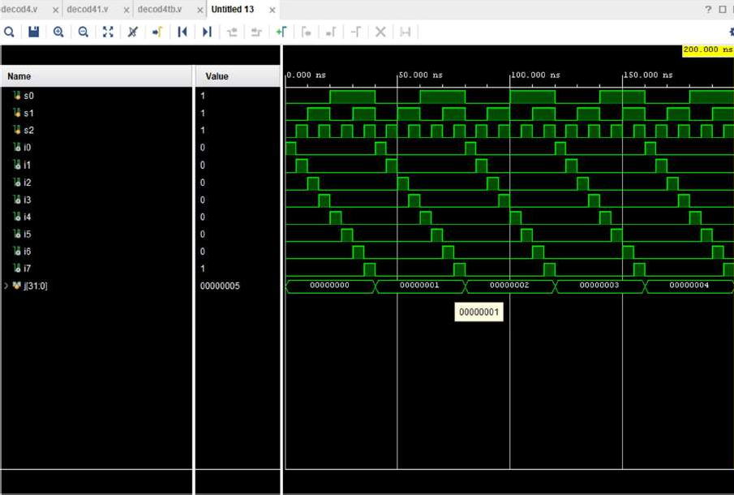

**Design Code**:

module decod41( input s0,s1,e, output i0,i1,i2,i3

);

wire w1[0:3];

wire w2[0:3];

wire w3[0:3];

nand(s00,s0,s0);

nand(s11,s1,s1) ;

nand(w1[0],s00,s11); nand(w2[0],w1[0],w1[0]);

nand(w3[0],w2[0],e);

nand(i0,w3[0],w3[0]);

nand(w1[1],s0,s11); nand(w2[1],w1[1],w1[1]);

nand(w3[1],w2[1],e);

nand(i1,w3[1],w3[1]);

nand(w1[2],s00,s1); nand(w2[2],w1[2],w1[2]);

nand(w3[2],w2[2],e);

nand(i2,w3[2],w3[2]);

nand(w1[3],s0,s1); nand(w2[3],w1[3],w1[3]);

nand(w3[3],w2[3],e);

nand(i3,w3[3],w3[3]); endmodule

module decod4( input s0,s1,s2,

output i0,i1,i2,i3,i4,i5,i6,i7

);

wire w; nand(w,s0,s0);

decod41 b(s2,s1,w,i0,i1,i2,i3); decod41 a(s2,s1,s0,i4,i5,i6,i7);

endmodule

**Test bench:**

module decod4tb(); reg s0, s1, s2;

wire i0,i1,i2,i3,i4,i5,i6,i7; integer j;

decod4 a(s0, s1, s2, i0,i1,i2,i3,i4,i5,i6,i7); initial begin

for (j = 0; j < 5; j = j + 1) begin s0 = 0;s1 = 0;s2 = 0;

#5

s0 = 0;s1 = 0;s2 = 1; #5

s0 = 0;s1 = 1;s2 = 0; #5

s0 = 0;s1 = 1;s2 = 1; #5

s0 = 1;s1 = 0;s2 = 0; #5

s0 = 1;s1 = 0;s2 = 1; #5

s0 = 1;s1 = 1;s2 = 0; #5

s0 = 1;s1 = 1;s2 = 1; #5;

end

$finish; end

endmodule

**Analysis:**

**Power Consumption:**

The image shows the power analysis of an FPGA design. The total on-chip power is **2.69W**, with **17% (0.486 W)** being static power and **83% (2.222 W)** being dynamic power. The junction temperature is a safe **29.7°C**, with a thermal margin of **70.3°C**. No off-chip power is used, and the analysis confidence level is marked as **LOW**.

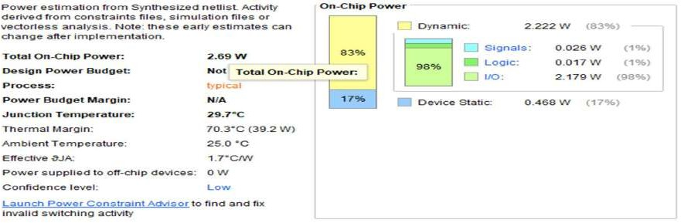

**Delay:**

The **minimum total setup delay** is **2.789 ns**. The **maximum total setup delay** is **2.811 ns**.

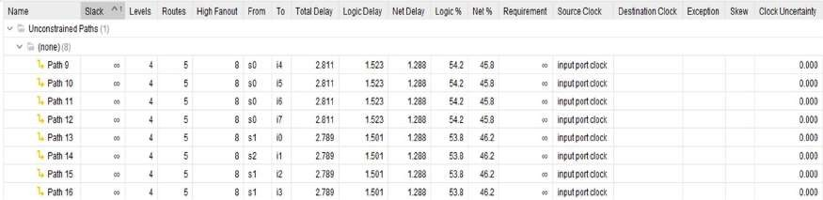

The **minimum total hold delay** is **1.218 ns**

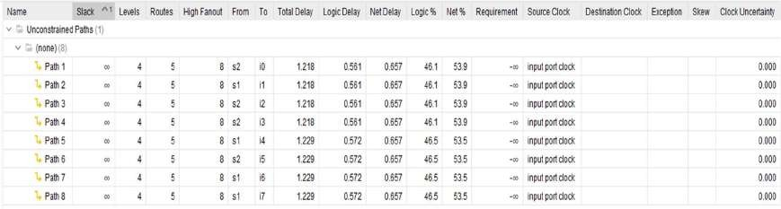The **maximum total hold delay** is **1.229 ns**.

**Area:**

The image shows the **Post-Implementation Utilization Report** of an FPGA design. It indicates resource usage:

* **LUT** utilized only **1%**.
* 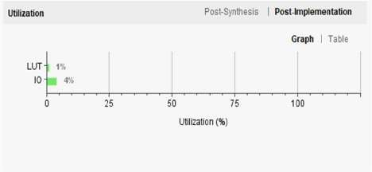**IO** has the highest usage at **4%**.

**RTL Schematic:**

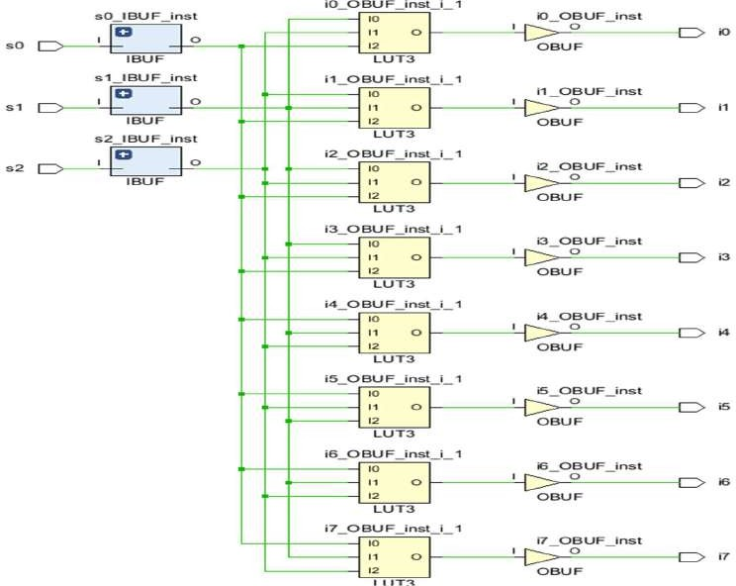

# 1 to 4 Demux

**Introduction:**

This Verilog code creates a 1-to-4 demultiplexer (demux) using basic logic gates like NOT and AND. The demux1 module has one data input (d) and two selection inputs (s0 and s1). Based on the values of the select lines, the data input is routed to one of four outputs (y0 to y3).

The design works by first generating the inverted forms of the select signals, allowing all four possible combinations of s0 and s1 to be formed. These combinations are then ANDed with the data input to ensure that only one output line is active (logic high) at a time—specifically the one corresponding to the selected path. When d is 1, one output goes high based on the select lines; otherwise, all outputs stay low.

The demux1tb testbench is used to simulate the design. It systematically tests different combinations of the select lines and data input, making sure the demux behaves as expected under all conditions.

.

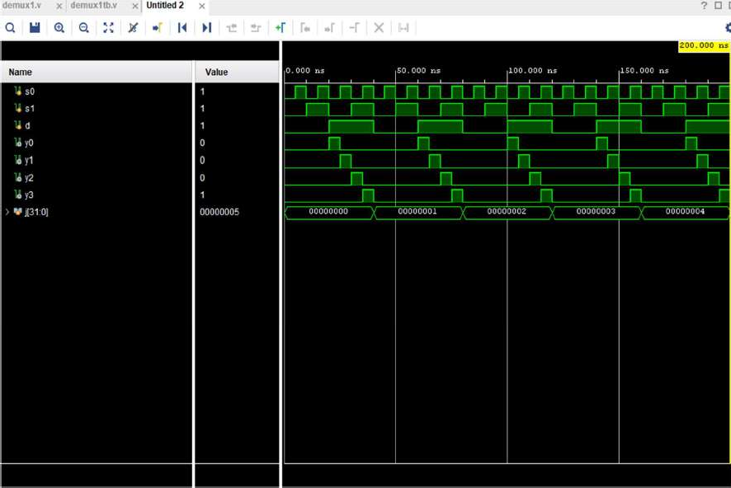**Output waveform**

**Design Code:**

module demux1( input d, s0, s1,

output y0, y1, y2, y3); wire w0, w1;

wire [3:0] a;

not(w0, s0);

not(w1, s1); and(a[0], w1, w0);

and(y0, d, a[0]);

and(a[1], s0, w1);

and(y1, d, a[1]);

and(a[2], w0, s1);

and(y2, d, a[2]);

and(a[3], s1, s0);

and(y3, d, a[3]); endmodule

**Testbench code:**

module demux1tb(); reg s0, s1, d; wire y0,y1,y2,y3; integer j;

demux1 a(d, s0, s1, y0,y1,y2,y3); initial begin

for (j = 0; j < 5; j = j + 1) begin d = 0;s1 = 0;s0 = 0;

#5

d = 0;s1 = 0;s0 = 1; #5

d = 0;s1 = 1;s0 = 0; #5

d = 0;s1 = 1;s0 = 1; #5

d = 1;s1 = 0;s0 = 0; #5

d = 1;s1 = 0;s0 = 1; #5

d = 1;s1 = 1;s0 = 0; #5

d = 1;s1 = 1;s0 = 1; #5;

end

$finish; end

endmodule

**Analysis:**

**Power Consumption:**

The image shows the power analysis of an FPGA design. The total on-chip power is **1.579 W**, with **29% (0.459 W)** being static power and **71% (1.120 W)** being dynamic power. The junction temperature is a safe **27.7°C**, with a thermal margin of **72.3°C**. No off-chip power is used, and the analysis confidence level is marked as **LOW**.

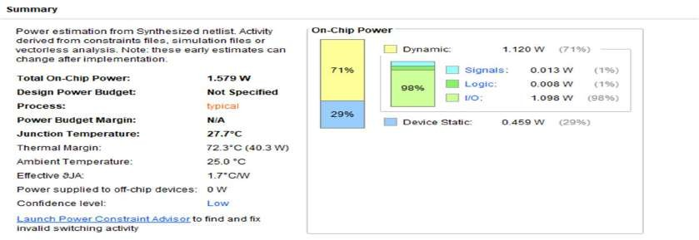

**Delay:**

The **minimum total setup delay** is **2.774 ns**. The **maximum total setup delay** is **2.796 ns**.

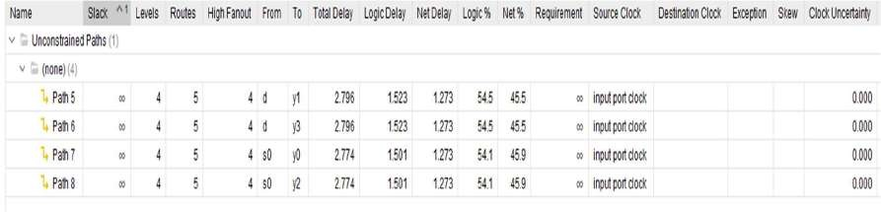

The **minimum total hold delay** is **1.211 ns**. The **maximum total hold delay** is **1.222 ns**.

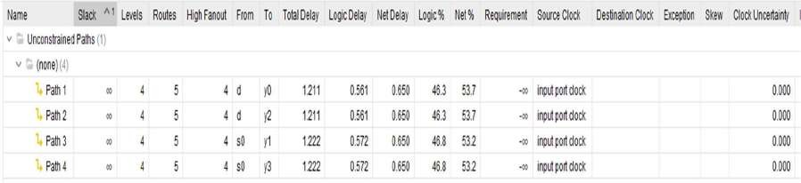

**Area:**

The image shows the **Post-Implementation Utilization Report** of an FPGA design. It indicates resource usage:

* **LUT** each utilized only **1%**.
* **IO** has the highest usage at **3%**.

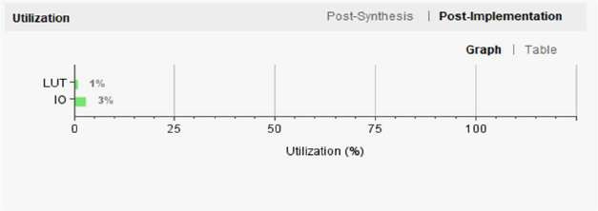

**RTL Schematic:**

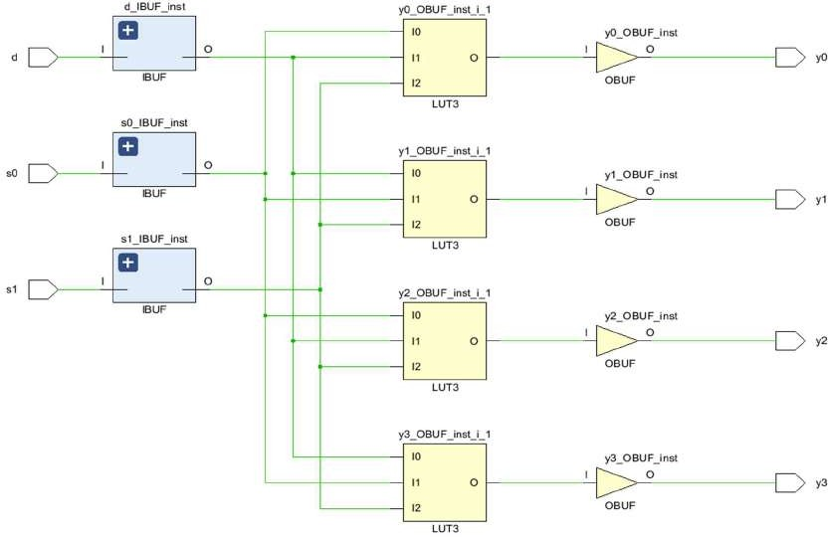

# 1 to 4 Demux using Nand

**Introduction:**

This Verilog code creates a 1-to-4 demultiplexer (demux) using basic logic gates like NOT and AND. The demux1 module has one data input (d) and two selection inputs (s0 and s1). Based on the values of the select lines, the data input is routed to one of four outputs (y0 to y3).

The design works by first generating the inverted forms of the select signals, allowing all four possible combinations of s0 and s1 to be formed. These combinations are then ANDed with the data input to ensure that only one output line is active (logic high) at a time—specifically the one corresponding to the selected path. When d is 1, one output goes high based on the select lines; otherwise, all outputs stay low.

The demux1tb testbench is used to simulate the design. It systematically tests different combinations of the select lines and data input, making sure the demux behaves as expected under all conditions.

**Output waveform**

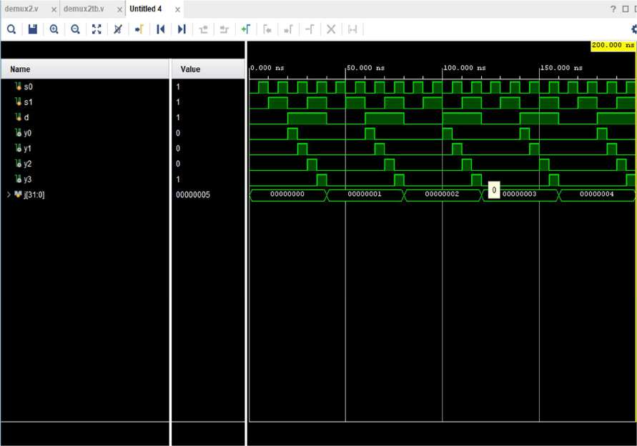

**Design Code :**

module demux2( input d, s0, s1,

output y0, y1, y2, y3); wire w1[0:3];

wire w2[0:3];

wire w3[0:3];

nand(s00,s0,s0);

nand(s11,s1,s1) ;

nand(w1[0],s00,s11); nand(w2[0],w1[0],w1[0]);

nand(w3[0],w2[0],d);

nand(y0,w3[0],w3[0]);

nand(w1[1],s0,s11); nand(w2[1],w1[1],w1[1]);

nand(w3[1],w2[1],d);

nand(y1,w3[1],w3[1]);

nand(w1[2],s00,s1); nand(w2[2],w1[2],w1[2]);

nand(w3[2],w2[2],d);

nand(y2,w3[2],w3[2]);

nand(w1[3],s0,s1); nand(w2[3],w1[3],w1[3]);

nand(w3[3],w2[3],d);

nand(y3,w3[3],w3[3]); endmodule

**Test bench:**

module demux2tb(); reg s0, s1, d; wire y0,y1,y2,y3; integer j;

demux2 a(d, s0, s1, y0,y1,y2,y3); initial begin

for (j = 0; j < 5; j = j + 1) begin d = 0;s1 = 0;s0 = 0;

#5 d = 0;s1 = 0;s0 = 1; #5 d = 0;s1 = 1;s0 = 0; #5 d = 0;s1 = 1;s0 = 1; #5 d = 1;s1 = 0;s0 = 0; #5 d = 1;s1 = 0;s0 = 1; #5 d = 1;s1 = 1;s0 = 0; #5 d = 1;s1 = 1;s0 = 1; #5;

end

$finish; end

endmodule

**Analysis:**

**Power Consumption:**

The image shows the power analysis of an FPGA design. The total on-chip power is **1.579 W**, with **29% (0.459 W)** being static power and **71% (1.120 W)** being dynamic power. The junction temperature is a safe **27.7.0°C**, with a thermal margin of **72.3°C**. No off-chip power is used, and the analysis confidence level is marked as **LOW**.

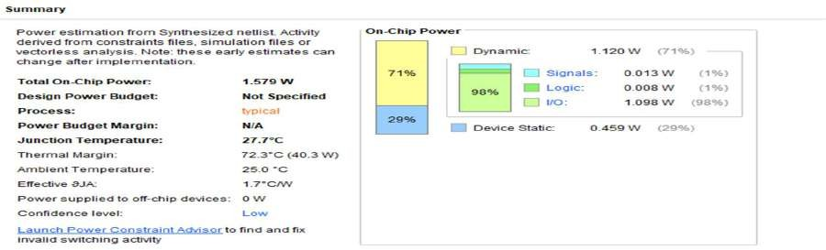

**Delay:**

The **minimum total setup delay** is **2.774 ns**. The **maximum total setup delay** is **2.796 ns**.

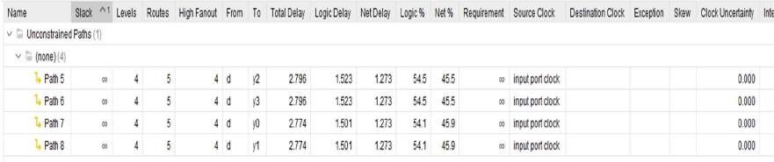

The **minimum total hold delay** is **1.211 ns**. The **maximum total hold delay** is **1.222 ns**.

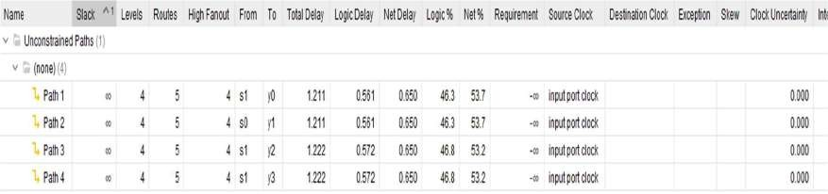

**Area:**

The image shows the **Post-Implementation Utilization Report** of an FPGA design. It indicates resource usage:

* **LUT** and **FF** are each utilized only **1%**.
* **IO** has the highest usage at **3%**.

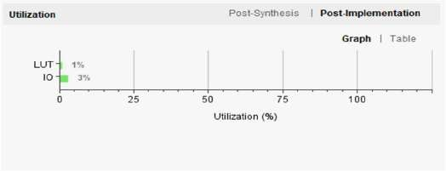

**RTL Schematic:**

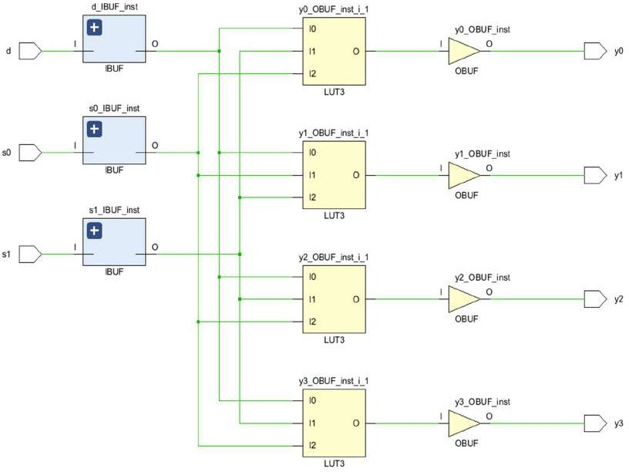

# 4:1 Multiplexer

## Introduction:

The Verilog code implements a 4-to-1 multiplexer (mux) using fundamental logic gates—NOT, AND, and OR. The mux_1 module takes four data inputs (i0 to i3) and two select lines (s0 and s1). Based on the values of these select lines, it routes one of the four inputs to the output y.

To do this, the circuit first generates inverted versions of the select lines to cover all possible combinations. Using these, it creates four enable signals (t0 to t3) that each correspond to a specific selection case. These are then ANDed with their respective inputs, producing intermediate outputs (w0 to w3). Finally, all the intermediate values are combined using an OR gate to generate the final output.

This design neatly shows how a multiplexer can be built step by step using only basic logic operations, making it easy to understand and modular for further extension.

**Output waveform:**

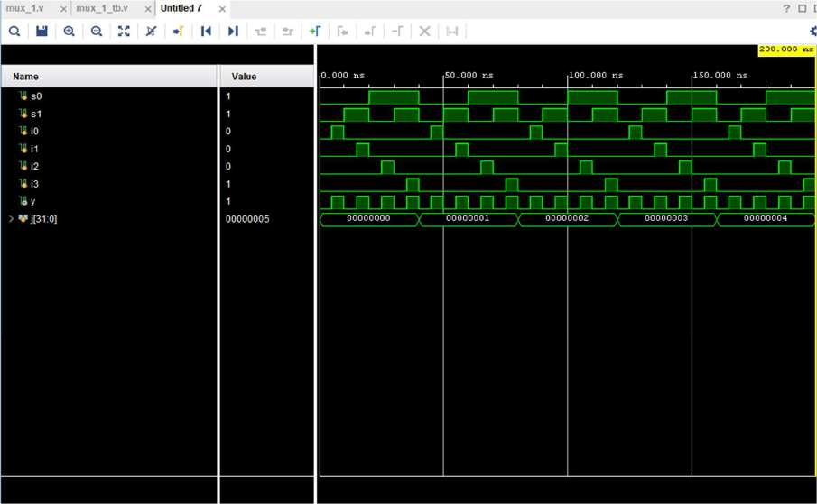

**Design Code:**

module mux_1(

input s0, s1, i0, i1, i2, i3, output y);

wire s0n, s1n;

wire w0, w1, w2, w3; wire w4, w5;

not (s0n, s0);

not (s1n, s1); wire t0;

and (t0, s0n, s1n);

and (w0, i0, t0); wire t1;

and (t1, s0n, s1);

and (w1, i1, t1); wire t2;

and (t2, s0, s1n);

and (w2, i2, t2); wire t3;

and (t3, s0, s1);

and (w3, i3, t3);

or (w4, w0, w1);

or (w5, w2, w3);

or (y, w4, w5); endmodule

Test Bench code:

module mux_1_tb(); reg s0,s1,i0,i1,i2,i3; wire y;

integer j;

mux_1 a(s0,s1,i0,i1,i2,i3,y); initial begin

for (j = 0; j < 5; j = j + 1) begin

s1 = 0 ;s0 = 0 ;i0=0 ;i1=0 ;i2=0 ;i3=0; #5 s1 = 0 ;s0 = 0 ;i0=1 ;i1=0 ;i2=0 ;i3=0; #5 s1 = 1 ;s0 = 0 ;i0=0 ;i1=0 ;i2=0 ;i3=0; #5 s1 = 1 ;s0 = 0 ;i0=0 ;i1=1 ;i2=0 ;i3=0; #5 s1 = 0 ;s0 = 1 ;i0=0 ;i1=0 ;i2=0 ;i3=0; #5 s1 = 0 ;s0 = 1 ;i0=0 ;i1=0 ;i2=1 ;i3=0; #5 s1 = 1 ;s0 = 1 ;i0=0 ;i1=0 ;i2=0 ;i3=0; #5 s1 = 1 ;s0 = 1 ;i0=0 ;i1=0 ;i2=0 ;i3=1; #5;

end

$finish; end

endmodule

**Analysis:**

**Power Consumption:**

The image shows the power analysis of an FPGA design. The total on-chip power is **1.199 W**, with **38% (0.456 W)** being static power and **62% (0.743 W)** being dynamic power. The junction temperature is a safe **27.1°C**, with a thermal margin of **72.9°C**. No off-chip power is used, and the analysis confidence level is marked as **LOW**.

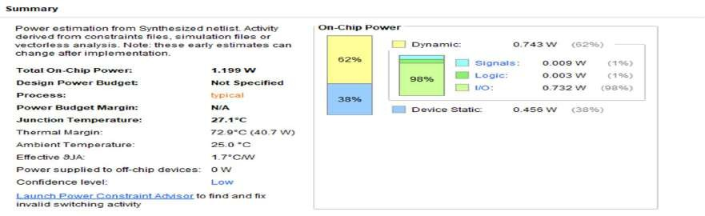

**Delay:**

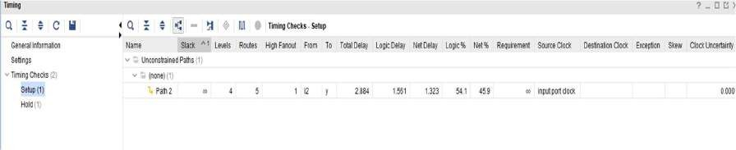The **total setup delay** is 2.884 ns.

The **total hold delay** is **1.205 ns**.

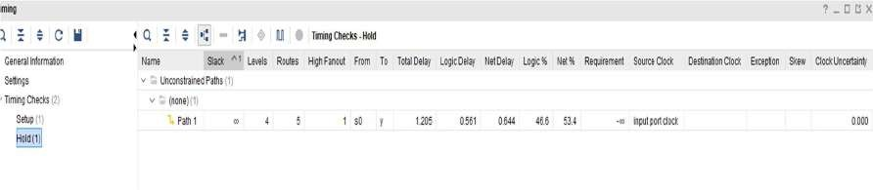

**Area:**

The image shows the **Post-Implementation Utilization Report** of an FPGA design. It indicates resource usage:

* **LUT** utilized only **1%**.
* 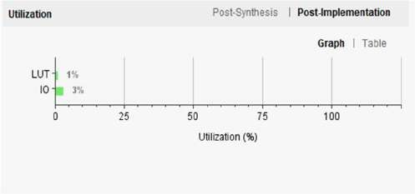**IO** has the highest usage at **3%**.

**RTL Schematic:**

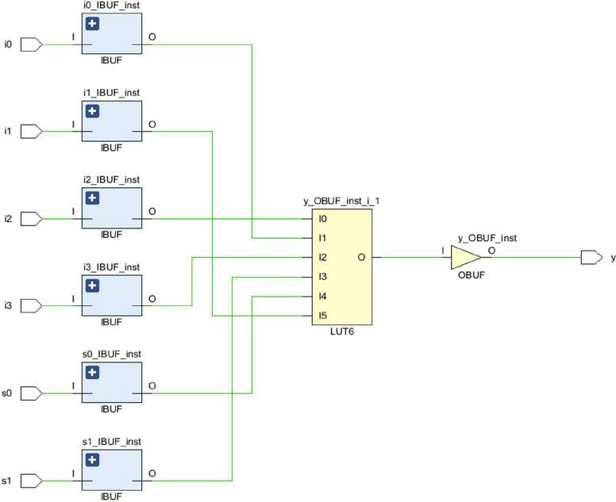

# Mux using NAND only gates

## Introduction:

The given Verilog code implements a 4-to-1 multiplexer using only NAND gates, demonstrating how universal gates can construct complex logic. The mux_2 module selects one of the four input lines (i0 to i3) based on two selection inputs (s0, s1) and routes the selected input to the output y. The design starts by generating inverted forms of s0 and s1 using NAND gates (s00, s11), then builds four control terms that simulate AND conditions for each input using multiple NAND layers. The selected input is isolated by ANDing the respective input with its selector term, again implemented via NANDs (w2[0] to w2[3]). Finally, these are combined in pairs and then merged using more NANDs to simulate OR functionality and produce the final output. This design showcases how multiplexers can be built without any other logic gates, relying entirely on the versatility of NAND.

**Output waveform:**

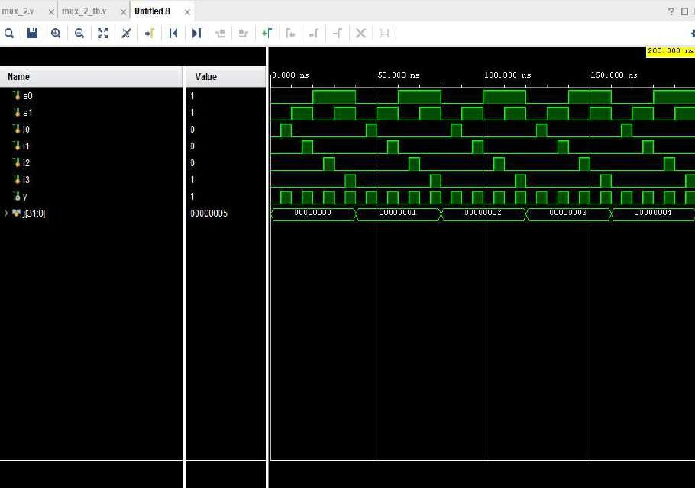

**Design Code:**

module mux_2(input s0,s1,i0,i1,i2,i3, output y

);

wire s00,s11; wire [3:0]w0;

wire [3:0]w1;

wire [3:0]w2;

wire [1:0] w3;

wire [1:0] w4;

nand(s00,s0,s0);

nand(s11,s1,s1);

nand(w0[0],s00,s11); nand(w1[0],w0[0],w0[0]);

nand(w2[0],w1[0],i0);

nand(w0[1],s00,s1); nand(w1[1],w0[1],w0[1]);

nand(w2[1],w1[1],i1);

nand(w0[2],s0,s11); nand(w1[2],w0[2],w0[2]);

nand(w2[2],w1[2],i2);

nand(w0[3],s0,s1); nand(w1[3],w0[3],w0[3]);

nand(w2[3],w1[3],i3);

nand(w3[0],w2[0],w2[1]);

nand(w4[0],w3[0],w3[0]);

nand(w3[1],w2[2],w2[3]);

nand(w4[1],w3[1],w3[1]);

nand(y,w4[0],w4[1]); endmodule

**Test bench code:**

module mux_2_tb();

reg s0,s1,i0,i1,i2,i3; wire y;

integer j;

mux_2 a(s0,s1,i0,i1,i2,i3,y); initial begin

for (j = 0; j < 5; j = j + 1) begin

s1 = 0 ;s0 = 0 ;i0=0 ;i1=0 ;i2=0 ;i3=0; #5

s1 = 0 ;s0 = 0 ;i0=1 ;i1=0 ;i2=0 ;i3=0; #5

s1 = 1 ;s0 = 0 ;i0=0 ;i1=0 ;i2=0 ;i3=0; #5

s1 = 1 ;s0 = 0 ;i0=0 ;i1=1 ;i2=0 ;i3=0; #5

s1 = 0 ;s0 = 1 ;i0=0 ;i1=0 ;i2=0 ;i3=0; #5

s1 = 0 ;s0 = 1 ;i0=0 ;i1=0 ;i2=1 ;i3=0; #5

s1 = 1 ;s0 = 1 ;i0=0 ;i1=0 ;i2=0 ;i3=0; #5

s1 = 1 ;s0 = 1 ;i0=0 ;i1=0 ;i2=0 ;i3=1; #5;

end

$finish; end

endmodule

**Analysis:**

**Power Consumption:**

The image shows the power analysis of an FPGA design. The total on-chip power is **1.199 W**, with **38% (0.456 W)** being static power and **62% (0.743 W)** being dynamic power. The junction temperature is a safe **27.1°C**, with a thermal margin of **72.9°C**. No off-chip power is used, and the analysis confidence level is marked as **LOW**.

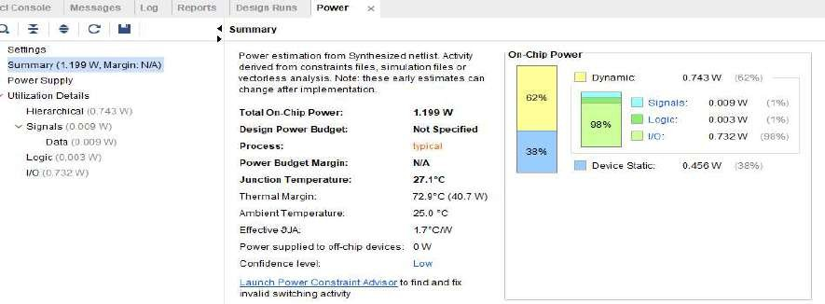

## Delay:

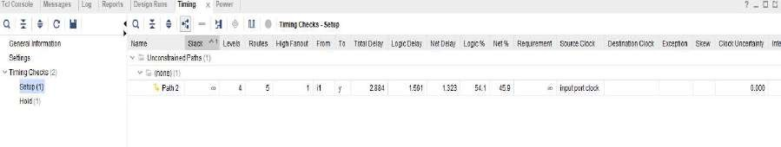The **total setup delay** is **2.884 ns**.

The **total hold delay** is **1.205 ns**.

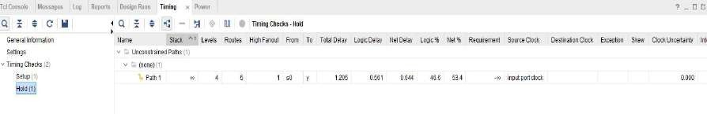

**Area:**

The image shows the **Post-Implementation Utilization Report** of an FPGA design. It indicates resource usage:

* **LUT** utilized only **1%**.
* 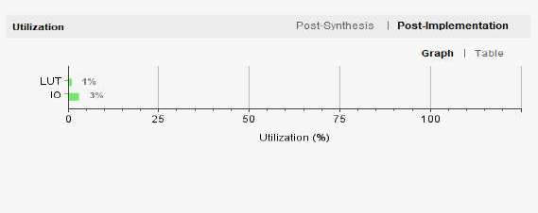**IO** has the highest usage at **3%**.

**RTL Schematic:**

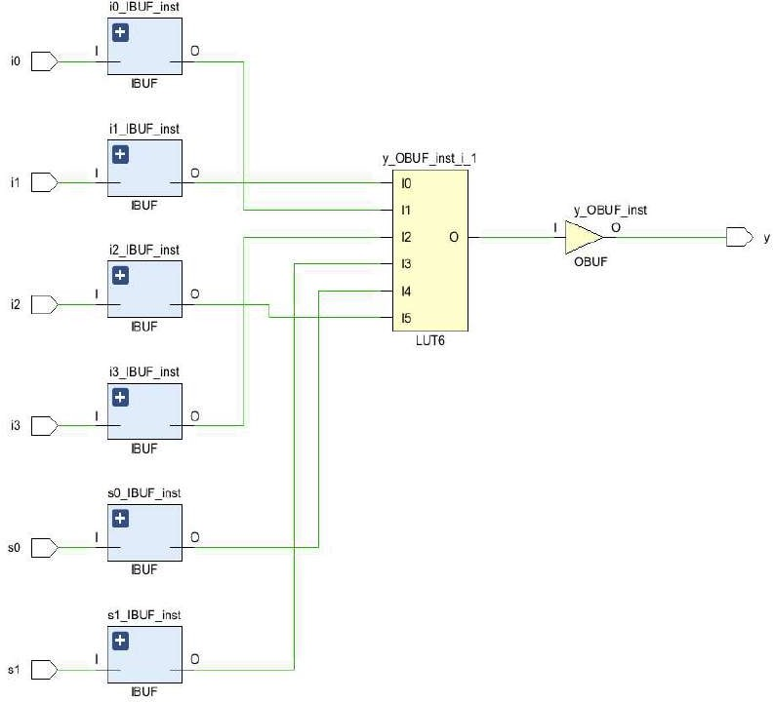

# Serial-In Serial-Out

**Introduction:**

This Verilog code implements a 4-stage Serial-In Serial-Out (SISO) shift register, named siso_sr. It takes in a serial data input (si) and shifts the data through four flip-flops (with internal signals like qa, qb, and qc) on each rising edge of the clock, but only when the shift enable signal (sr) is active. If the reset signal (rst) is high, all outputs are cleared immediately.

The final output (so) represents the value stored in the last flip-flop, showing the result of the shifting operation after four clock cycles.

To test this design, the testbench siso_srtb generates a clock and controls the inputs (si, sr, and rst) to simulate realistic behavior. It checks the shifting mechanism by first sending a 1 followed by a sequence of 0s, allowing us to track the bit as it moves through each stage of the shift register over time.

**Output waveform:**

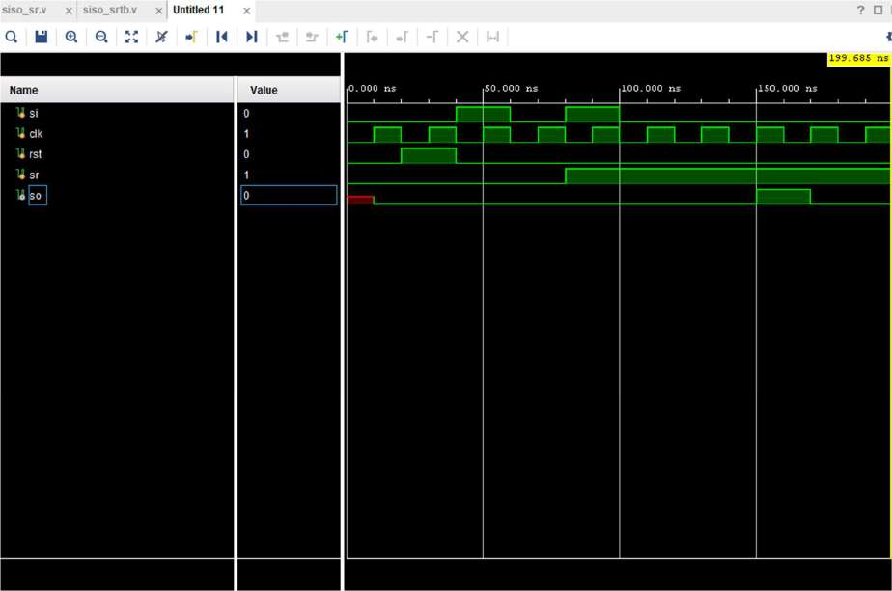

**Design Code:**

module siso_sr( input clk,rst,si,sr, output so);

reg qa,qb,qc,so;

always @(posedge clk or posedge rst) if(sr) begin

if(rst) begin

qa <= 1'b0; qb <= 1'b0; qc <=1'b0; so <= 1'b0; end

else begin

qa <= si; qb <= qa; qc <= qb; so <= qc; end

end

else begin

qa <= 1'b0; qb <= 1'b0; qc <=1'b0; so <= 1'b0; end

endmodule **Testbench Code:** module siso_srtb();

reg si,clk,rst,sr; wire so;

siso_sr uut(clk, rst, si, sr, so); always

begin

#10 clk=~clk; end

initial

begin

rst=0; clk=0; si=0; sr=0; #20 rst=1;

#20 rst=0; si=1;

#20 si=0;sr=0;

#20 sr=1;si=1;

#20 si=0;

#20 si=0;

#20 si=0;

#20 si=0;

#20 si=0;

#20;

$finish; end

endmodule

**Analysis:**

**Power Consumption:**

The image shows the power analysis of an FPGA design. The total on-chip power is **0.583 W**, with **77% (0.451 W)** being static power and **23% (0.132 W)** being dynamic power. The junction temperature is a safe **26.0°C**, with a thermal margin of **74.0°C**. No off-chip power is used, and the analysis confidence level is marked as **LOW**.

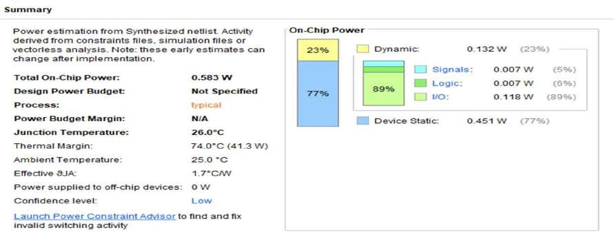

**Delay:**

The **minimum total setup delay** is **1.186 ns**. The **maximum total setup delay** is **1.638 ns**.

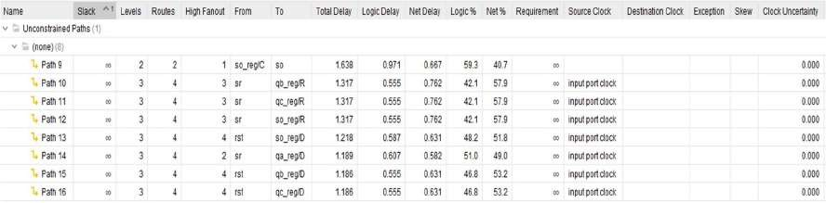

The **minimum total hold delay** is **0.123 ns**. The **maximum total hold delay** is **0.775 ns**.

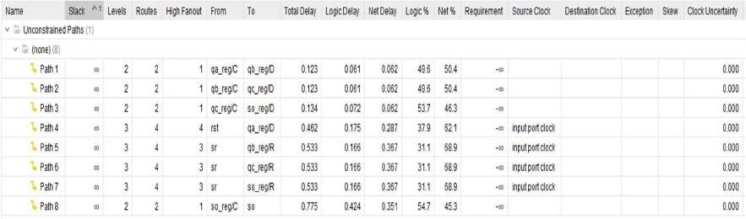

**Area:**

The image shows the **Post-Implementation Utilization Report** of an FPGA design. It indicates resource usage:

* **LUT** and **FF** are each utilized only **1%**.
* 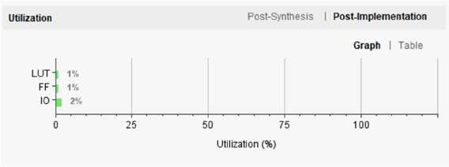**IO** has the highest usage at **2%**.

**RTL Schematic:**

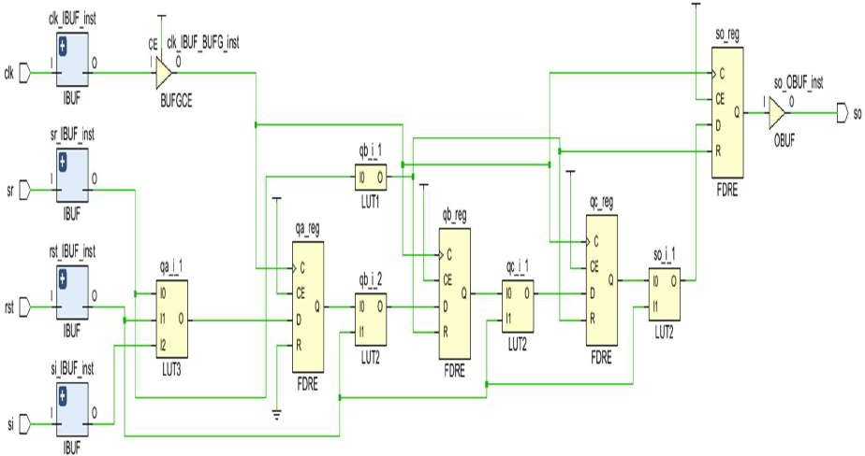

**Serial-In Serial-Out (Left Shift)**

**Introduction:**

This Verilog code defines a 4-stage Serial-In Serial-Out (SISO) shift register with **left shifting**, named siso_sl. When the shift enable signal (sr) is active, and on every rising edge of the clock, the input bit (si) is loaded into the last stage (qc). From there, it shifts left through the other flip-flops—moving to qb, then qa, and finally to the output so.

If the reset signal (rst) is high, all internal flip-flops and the output are cleared to 0, ensuring a clean start.

The accompanying testbench, siso_srtb, simulates the design by toggling inputs and generating a clock signal.

It checks the left-shift behavior by inputting a 1 followed by 0s while the shift is enabled, observing how the 1 propagates left through the stages across clock cycles. It also verifies that the reset correctly clears all stages.

**Output waveform:**

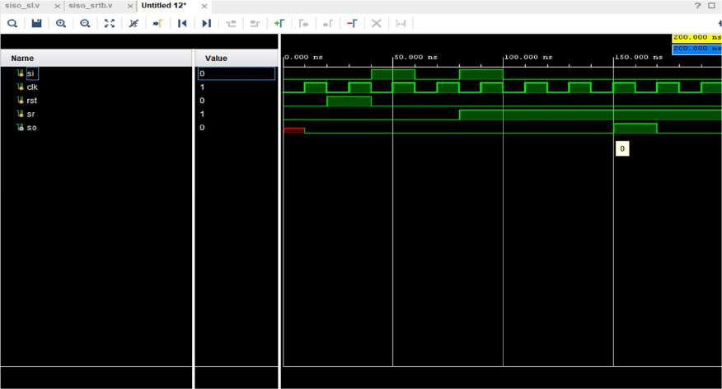

**Design Code:**

module siso_sl( input clk,rst,si,sr, output reg so); reg qa,qb,qc;

always @(posedge clk or posedge rst) if(sr) begin

if(rst) begin

qa <= 1'b0; qb <= 1'b0; qc <=1'b0; so <= 1'b0; end

else begin

qc <= si;qb <= qc; qa <= qb;so<=qa; end

end

else begin

qa <= 1'b0; qb <= 1'b0; qc <=1'b0; so <= 1'b0; end

endmodule

**Testbench Code:**

module siso_srtb(); reg si,clk,rst,sr; wire so;

siso_sl uut(clk, rst, si, sr, so); always

begin

#10 clk=~clk; end

initial

begin

rst=0; clk=0; si=0; sr=0; #20 rst=1;

#20 rst=0; si=1;

#20 si=0;sr=0;

#20 sr=1;si=1;

#20 si=0;

#20 si=0;

#20 si=0;

#20 si=0;

#20 si=0;

#20;

$finish; end

endmodule

**Analysis:**

**Power Consumption:**

The image shows the power analysis of an FPGA design. The total on-chip power is **0.583 W**, with **77% (0.451 W)** being static power and **23% (0.132 W)** being dynamic power. The junction temperature is a safe **26.0°C**, with a thermal margin of **74.0°C**. No off-chip power is used, and the analysis confidence level is marked as **LOW**.

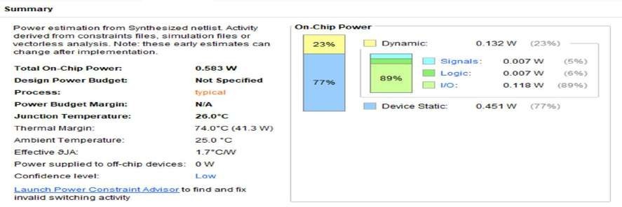

**Delay:**

The **minimum total setup delay** is **1.638 ns**. The **maximum total setup delay** is **1.186 ns**.

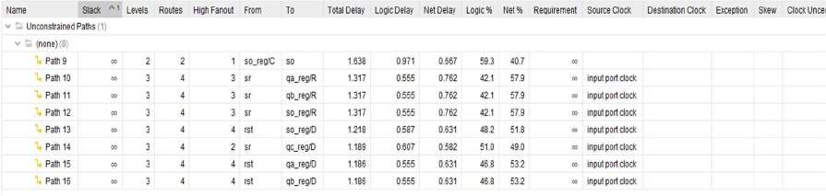

The **minimum total hold delay** is **0.123 ns**. The **maximum total hold delay** is **0.775 ns**.

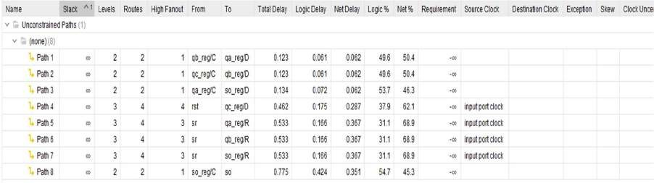

**Area:**

The image shows the **Post-Implementation Utilization Report** of an FPGA design. It indicates resource usage:

* **LUT** and **FF** are each utilized only **1%**.
* 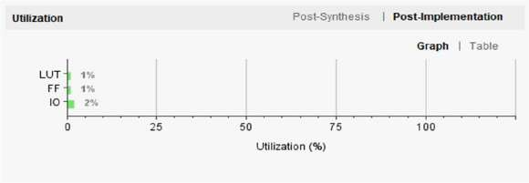**IO** has the highest usage at **2%**.

**RTL Schematic:**

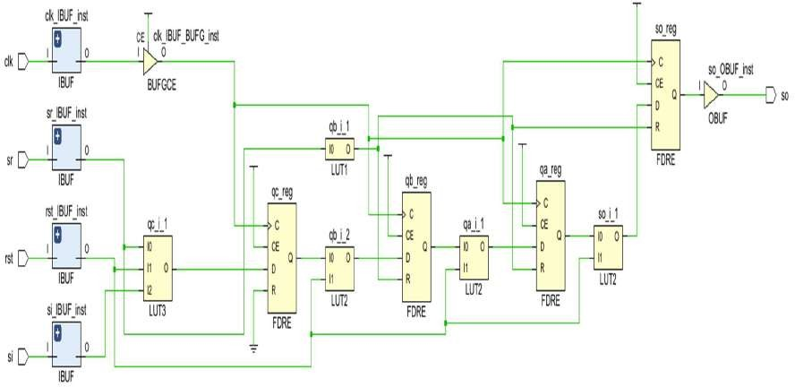

# Serial-In Serial-Out (SISO) shift register

**Introduction:**

The Verilog module siso_srsl implements a 4-stage Serial-In Serial-Out (SISO) shift register with **bidirectional shifting** capability. It allows data to shift either **left or right**, based on the control signal ctrl. When the shift enable signal s is high and the reset rst is low, the shift operation takes place:

* If ctrl = 1, the register performs a **right shift**
* If ctrl = 0, it performs a **left shift**

If rst is activated, all internal registers and the output are cleared, resetting the shift register to zero.

The corresponding testbench, siso_srsltb, tests this functionality by feeding a sequence of input bits and switching the ctrl signal to alternate between left and right shifts. This helps verify the correctness of both shift directions and ensures the reset works as expected.

Overall, this design effectively demonstrates a flexible, bidirectional SISO shift register using simple control logic.

**Output waveform:**

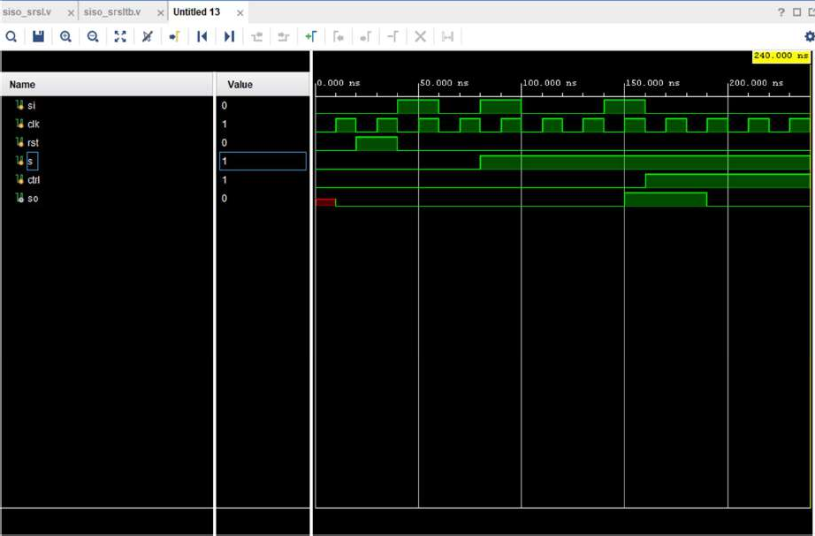

**Design Code:**

module siso_srsl( input clk,rst,si,s,ctrl, output reg so);

reg qa,qb,qc;

always @(posedge clk or posedge rst) if(s) begin

if(rst) begin

qa <= 1'b0; qb <= 1'b0; qc <=1'b0; so <= 1'b0; end

else if(ctrl) begin

qa <= si; qb <= qa; qc <= qb; so <= qc; end

else begin

qc <= si;qb <= qc; qa <= qb;so<=qa; end

end

else begin

qa <= 1'b0; qb <= 1'b0; qc <=1'b0; so <= 1'b0; end

endmodule

**Testbench Code:**

module siso_srsltb(); reg si,clk,rst,s,ctrl; wire so;

siso_srsl uut(clk, rst, si, s, ctrl, so); always

begin #10 clk=~clk; end initial begin

rst=0; clk=0; si=0; s=0;ctrl=0; #20 rst=1;

#20 rst=0; si=1;

#20 si=0;s=0;

#20 s=1;si=1;ctrl=0;

#20 si=0;

#20 si=0;

#20 si=1;

#20 si=0;ctrl=1;

#20 si=0;

#20 si=0;

#20 si=0;

#20; $finish; end

endmodule

**Analysis:**

**Power Consumption:**

The image shows the power analysis of an FPGA design. The total on-chip power is **0.725 W**, with **62% (0.452 W)** being static power and **38% (0.272 W)** being dynamic power. The junction temperature is a safe **26.3°C**, with a thermal margin of **73.7°C**. No off-chip power is used, and the analysis confidence level is marked as **LOW**.

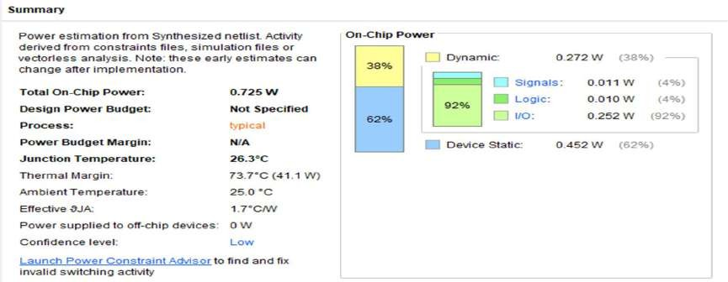

**Delay:**

The **minimum total setup delay** is **1.213 ns**. The **maximum total setup delay** is **1.638 ns**.

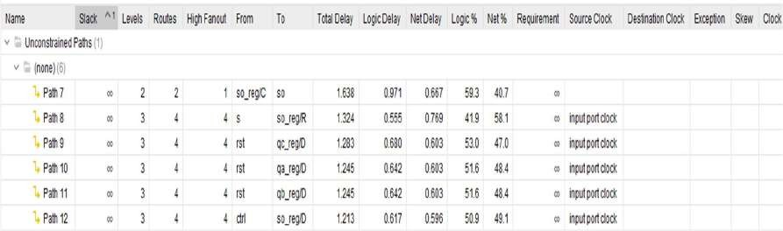

The **minimum total hold delay** is **0.123 ns**. The **maximum total hold delay** is **0.775 ns**.

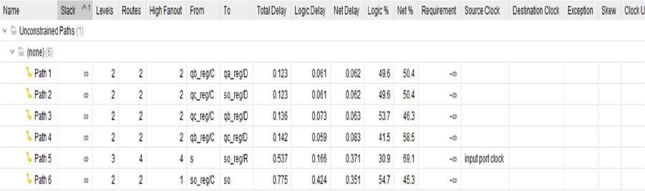

**Area:**

The image shows the **Post-Implementation Utilization Report** of an FPGA design. It indicates resource usage:

* **LUT** and **FF** are each utilized only **1%**.
* 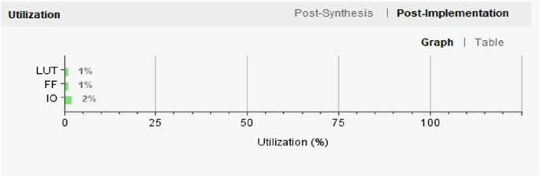**IO** has the highest usage at **2%**.

**RTL Schematic:**

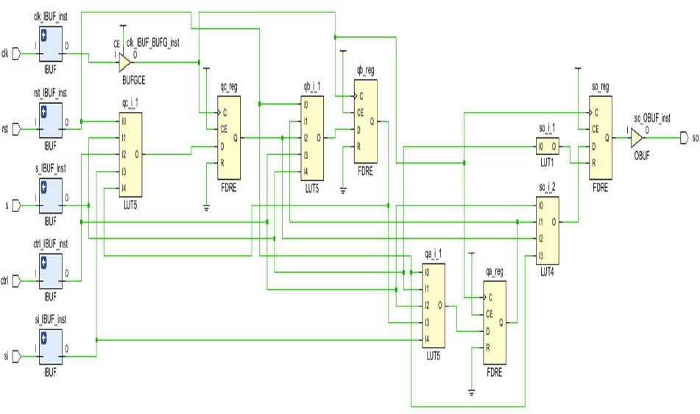

# Parallel-In Parallel-Out (PIPO)

**Introduction:**

The pipo module is a 4-bit **parallel-in parallel-out (PIPO) register** that captures data on the **rising edge of the clock (clk)**, but only when the **enable signal (e) is high**. If the **reset (rst)** is active, the output (q) is cleared to zero. Additionally, if the enable is low, the register doesn't store new data and instead clears the output, effectively acting like a gated data latch with reset.

The testbench, pipotb, simulates this behavior by applying various 4-bit inputs and toggling the enable and reset signals. This helps verify that the register correctly loads data when enabled and clears the output when either reset is active or enable is low.

Such a module is useful in digital systems for **temporary data storage or buffering**, especially when data needs to be held or moved in a synchronized and controlled manner.

**Output waveform:**

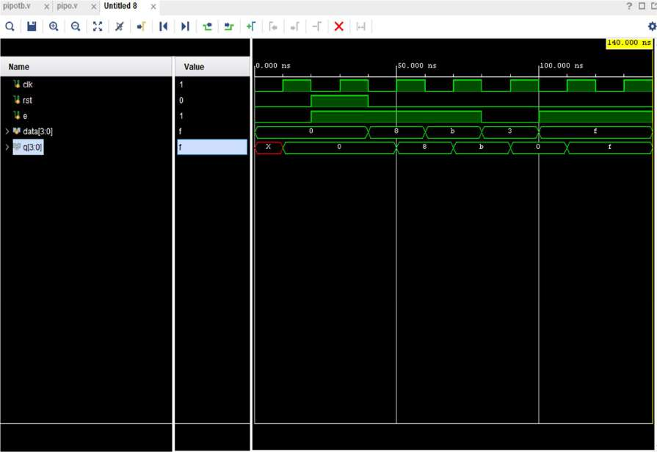

**Design Code:**

module pipo( input clk,rst,e, input [3:0]data, output reg [3:0]q);

always @(posedge clk or posedge rst) begin if(e) begin

if (rst) begin

q<= 4'b0000; end else begin

q <= data; end end

else begin

q<= 4'b0000;

end end

endmodule

**Testbench Code:**

module pipotb(); reg clk,rst,e; reg [3:0]data;

wire [3:0]q;

pipo uut(clk, rst,e,data,q); always begin

#10 clk=~clk; end

initial begin rst=0;clk=0;data=4'b0000;e=0; #20 rst=1; e=1;

#20 rst=0; data=4'b1000;

#20 rst=0; data=4'b1011;

#20 rst=0;e=0; data=4'b0011;

#20 rst=0;e=1; data=4'b1111;

#40;

$finish; end

endmodule

**Analysis:**

**Power Consumption:**

The image shows the power analysis of an FPGA design. The total on-chip power is **2.067 W**, with **22% (0.463 W)** being static power and 7**8% (1.604 W)** being dynamic power. The junction temperature is a safe **28.6°C**, with a thermal margin of **71.4°C**. No off-chip power is used, and the analysis confidence level is marked as **LOW**.

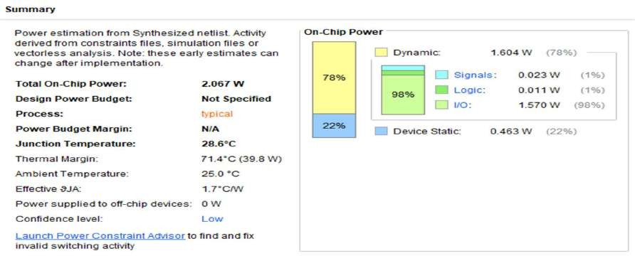

**Delay:**

The **minimum total setup delay** is **1.218 ns**. The **maximum total setup delay** is **1.638 ns**.

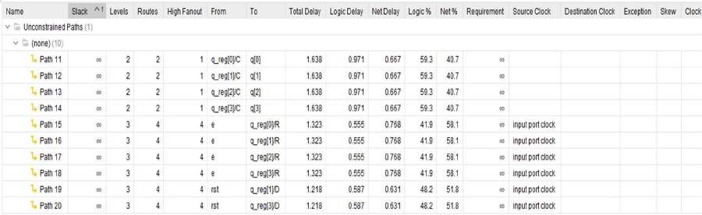

The **minimum total hold delay** is **0.456 ns**. The **maximum total hold delay** is **0.775 ns**.

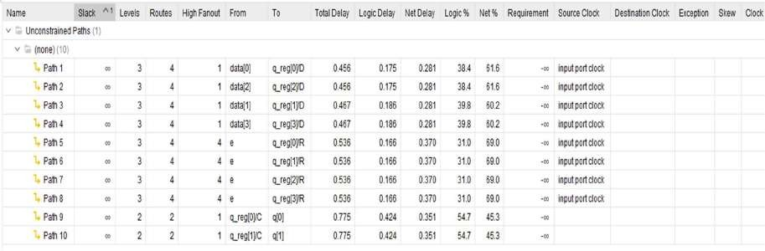

**Area:**

The image shows the **Post-Implementation Utilization Report** of an FPGA design. It indicates resource usage:

* **LUT** and **FF** are each utilized only **1%**.
* 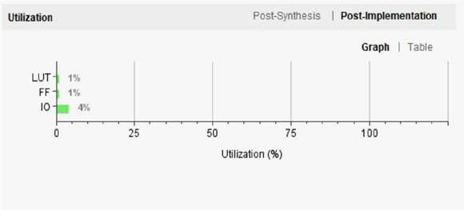**IO** has the highest usage at **4%**.

**RTL Schematic:**

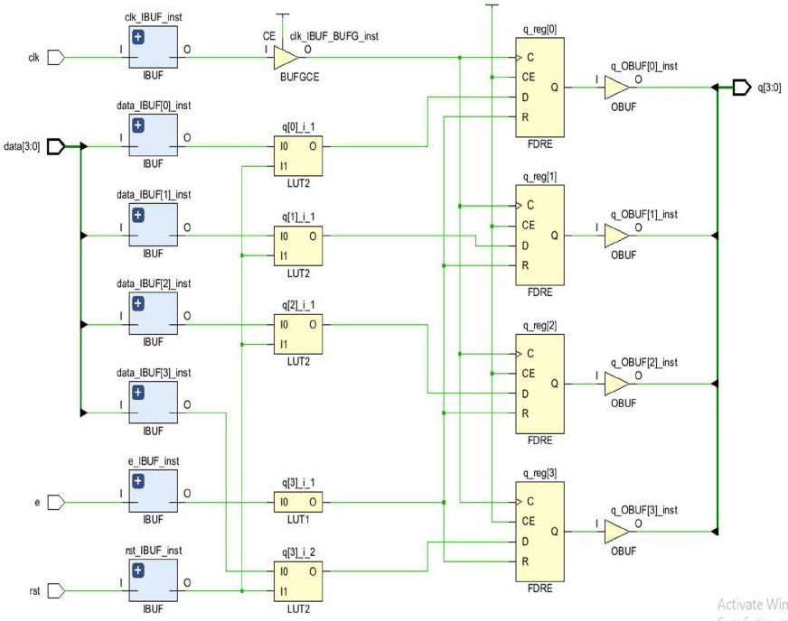

# Universal Shift Register

**Introduction:**

The usr module is a **Universal Shift Register** that supports multiple operations: **shift right**, **shift left**, and **parallel load**. It uses control signals sr (shift right) and sl (shift left) to determine the direction of serial data movement through its internal flip-flops using the serial input (si). Alternatively, it can perform a **parallel load** from a 4-bit input (pin) when the plin signal is active, storing that data into the output register (pout).

The plo signal acts as an **output enable** for parallel operations, allowing control over when the data appears on the output. A reset signal (rst) clears all outputs, ensuring the register starts from a known state.

The testbench usrtb thoroughly tests the module by simulating different scenarios—serial shifting in both directions, parallel loading, and reset conditions. This ensures the design works correctly across all supported modes.

Thanks to its flexible functionality, this universal shift register is well-suited for use in **data buffering, communication protocols, and general data manipulation** tasks in digital systems

**Output waveform:**

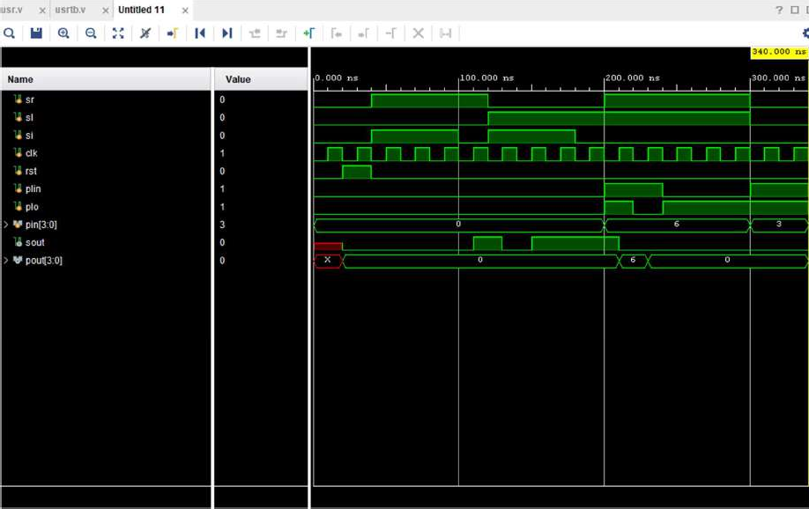

**Design Code:**

module usr(

input sr,sl,si,clk,rst,plin,plo, output reg sout,

input [3:0]pin,

output reg [3:0]pout); reg qa,qb,qc;

always @(posedge clk or posedge rst) begin if(rst)begin

pout<=4'b0000; sout<=0; qc=0;qa=0;qb=0;

end

else begin case({sr,sl})

2'b00: begin /* No operation */ end 2'b11 : begin

if(plin) begin

if (plo) begin pout<=pin ;sout<=0;

end

else begin pout<=0;sout<=0;

end end

else begin

if (plo) begin

pout<=pout ;sout<=0; end

else begin pout<=0;sout<=0;

end end end

2'b10 : begin qa <= si; qb <= qa; qc <= qb; sout <= qc; pout<=0; end 2'b01 : begin qc <= si; qb <= qc; qa <= qb; sout <= qa; pout<=0; end default: begin /* no operation */ end

endcase end

end endmodule

**Testbench Code:**

module usrtb();

reg sr,sl,si,clk,rst,plin,plo; reg [3:0]pin;

wire sout; wire [3:0]pout;

usr a (sr,sl,si,clk,rst,plin,plo, sout,pin[3:0],pout[3:0]); always

begin

#10 clk=~clk; end

initial

begin

rst=0; clk=0; si=0; sr=0;sl=0;plin=0;plo=0;pin=4'b0000; #20 rst=1;

#20 rst=0; si=1;sr=1;sl=0;plin=0;plo=0;pin=4'b0000;

#60 rst=0; si=0;sr=1;sl=0;plin=0;plo=0;pin=4'b0000;

#20 rst=0; si=1;sr=0;sl=1;plin=0;plo=0;pin=4'b0000;

#60 rst=0; si=0;sr=0;sl=1;plin=0;plo=0;pin=4'b0000;

#20 rst=0; si=0;sr=1;sl=1;plin=1;plo=1;pin=4'b0110;

#20 rst=0; si=0;sr=1;sl=1;plin=1;plo=0;pin=4'b0110;

#20 rst=0; si=0;sr=1;sl=1;plin=0;plo=1;pin=4'b0110;

#40;

#20 rst=0; si=0;sr=0;sl=0;plin=1;plo=1;pin=4'b0011;

#40;

$finish; end

endmodule

**Analysis:**

**Power Consumption:**

The image shows the power analysis of an FPGA design. The total on-chip power is **1.127 W**, with **40% (0.455 W)** being static power and **60% (0.671 W)** being dynamic power. The junction temperature is a safe **26.9°C**, with a thermal margin of **73.1°C**. No off-chip power is used, and the analysis confidence level is marked as **LOW**.

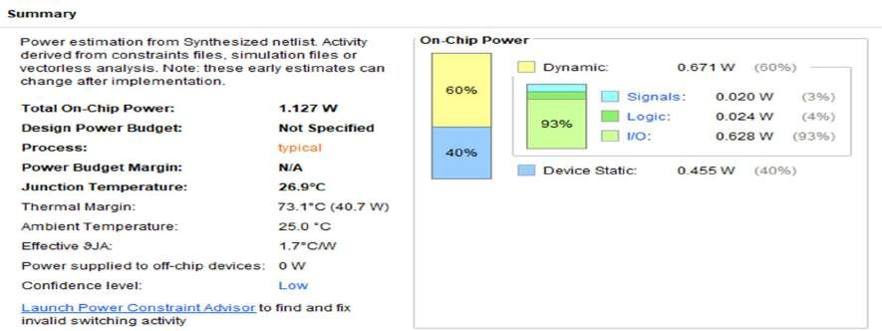

**Delay:**

The **minimum total setup delay** is **1.307 ns**. The **maximum total setup delay** is **1.638 ns**.

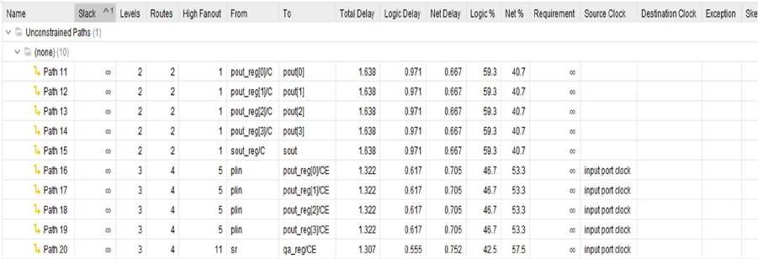

The **minimum total hold delay** is **0.123 ns**. The **maximum total hold delay** is **0.464 ns**.

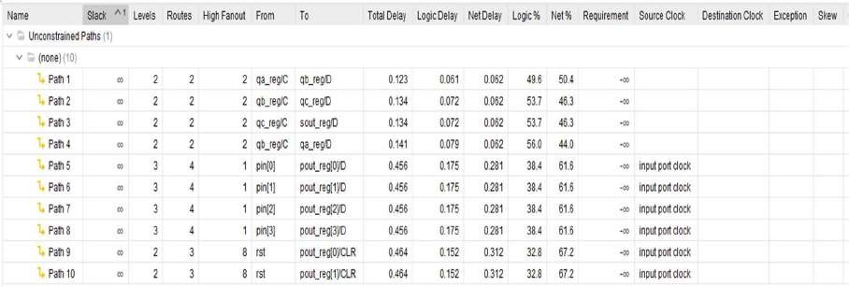

**Area:**

The image shows the **Post-Implementation Utilization Report** of an FPGA design. It indicates resource usage:

* **LUT** and **FF** are each utilized only **1%**.
* 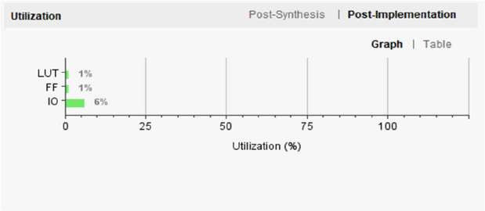**IO** has the highest usage at **6%**.

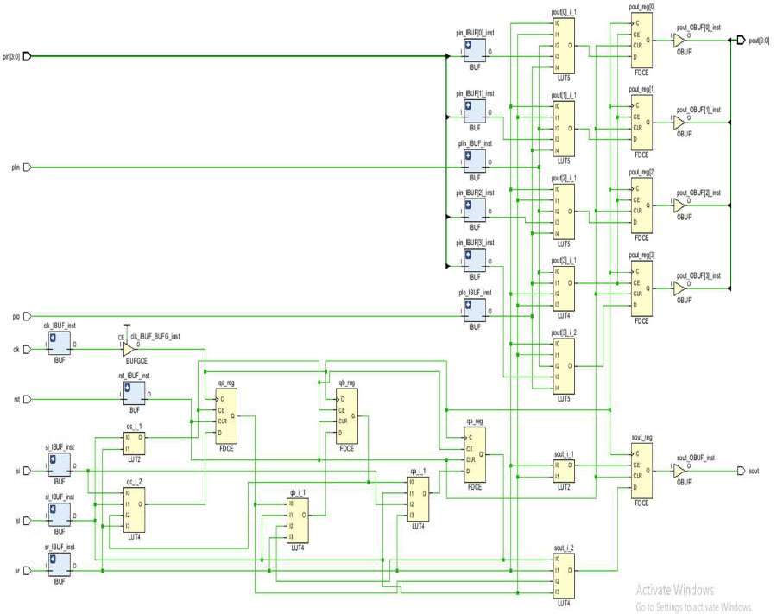**RTL Schematic:**

# Programmable Up counter

#### Introduction:

The given Verilog code defines a 4-bit **up-counter** with a **synchronous load** and an **asynchronous reset**, implemented in the upcount module. The counter increments on every **rising edge of the clock (clk)** and stores the result in a 4-bit output register out.

If the **reset signal (rst) is high**, the counter is **immediately cleared to zero**, regardless of the clock — this makes it an **asynchronous reset**. If reset is not active, the counter checks two conditions **synchronously** with the clock:

* If the **load signal (ld) is active**, or
* If the counter has reached its maximum value of **15 (1111 in binary)**

In either case, it **loads a new value from the input** instead of continuing to count. If none of these conditions are true, the counter simply **increments by one** on each clock cycle.

This design is particularly useful in digital systems where you need a counter that can **wrap around**, **reload from a specific value**, or respond quickly to resets—making it suitable for timers, event counters, and control sequencing logic.

**Output waveform:**

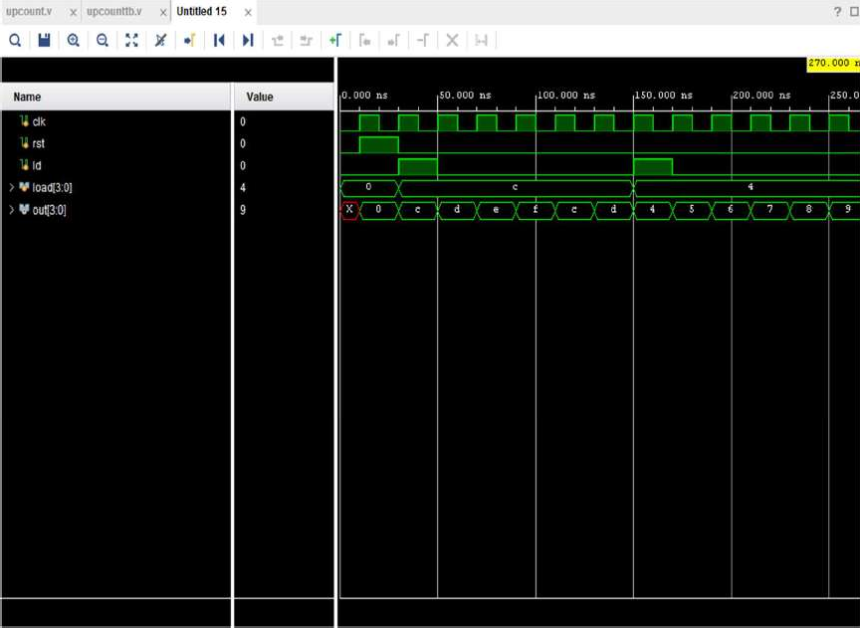

**Design Code:**

module upcount( input clk,rst,ld, input [3:0]load, output reg [3:0]out);

always @(posedge clk or posedge rst) begin if(rst)

out<=0; else begin

if(ld || out==4'b1111) out<=load;

else

out<=out+1;

end end

endmodule

**Test bench code:**

module upcounttb(); reg clk,rst,ld;

reg [3:0]load;

wire [3:0]out;

upcount uut(clk, rst,ld,load,out); always begin

#10 clk=~clk; end

initial begin rst=0;clk=0;load=4'b0000;ld=0; #10 rst=1;

#20 rst=0;ld=1;load=4'b1100;

#20 ld=0;

#80;

#20 ld=1;load=4'b0100;

#20 ld=0;

#100;

$finish; end

endmodule

**Analysis:**

**Power Consumption:**

The image shows the power analysis of an FPGA design. The total on-chip power is **2.298 W**, with **20% (0.465 W)** being static power and **80% (1.834 W)** being dynamic power. The junction temperature is a safe **29.0°C**, with a thermal margin of **71.0°C**. No off-chip power is used, and the analysis confidence level is marked as **LOW**.

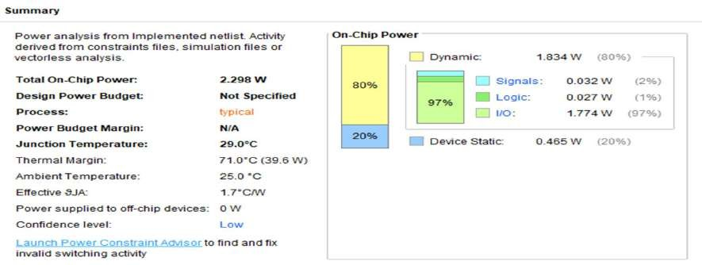

**Delay:**

The **minimum total setup delay** is **1.806 ns**. The **maximum total setup delay** is **3.230 ns**.

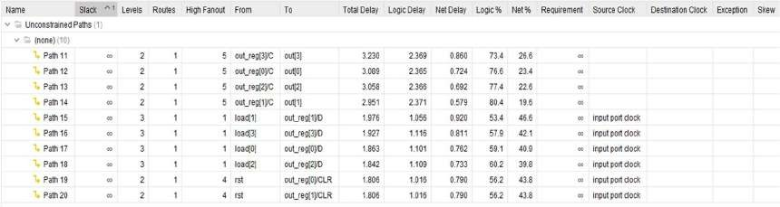

The **minimum total hold delay** is **0.098 ns**. The **maximum total hold delay** is **1.392 ns**.

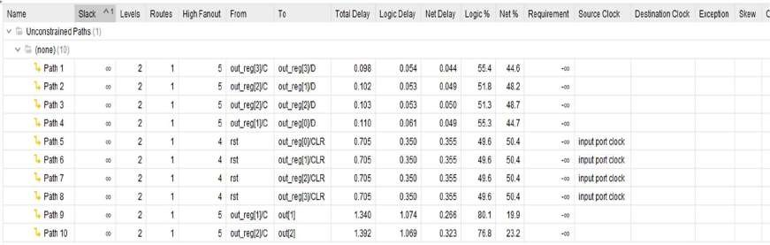

**Area:**

The image shows the **Post-Implementation Utilization Report** of an FPGA design. It indicates resource usage:

* **LUT** and **FF** are each utilized only **1%**.
* 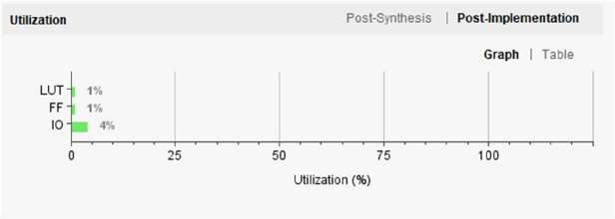**IO** has the highest usage at **4%**.

**RTL Schematic:**

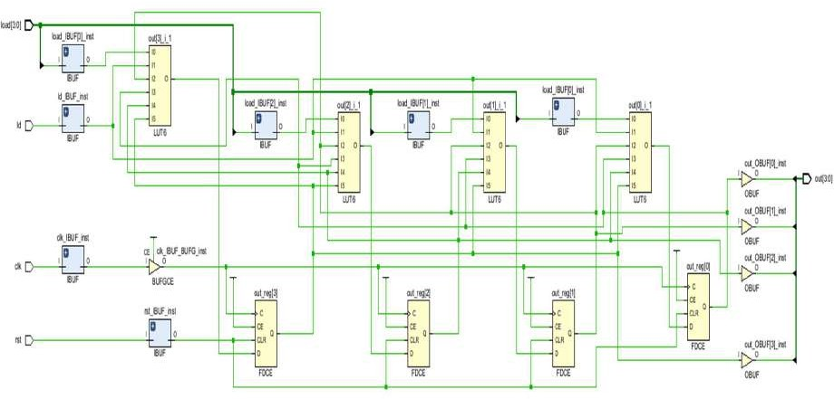

# Down counter

#### Introduction:

The given Verilog code defines a 4-bit **down-counter** with a **synchronous load** and an **asynchronous reset**, implemented in the docount module. The counter **counts down** on every **rising edge of the clock (clk)**, and its current value is held in the 4-bit output register out.

If the **reset signal (rst) is high**, the counter is **immediately cleared to zero**, regardless of the clock—this is what makes the reset **asynchronous**. Otherwise, on each clock cycle, the counter checks two conditions:

* If the **load signal (ld) is active**, or
* If the counter value has reached **zero (0000)**

If either of these is true, the counter **reloads a new value** from the input load. If not, it simply **decrements** the count by one on each clock cycle.

This kind of down-counter is especially useful in applications like **timers, countdown systems, or event schedulers**, where you need the ability to **reset**, **reload a start value**, and **count down to zero**.

**Output waveform:**

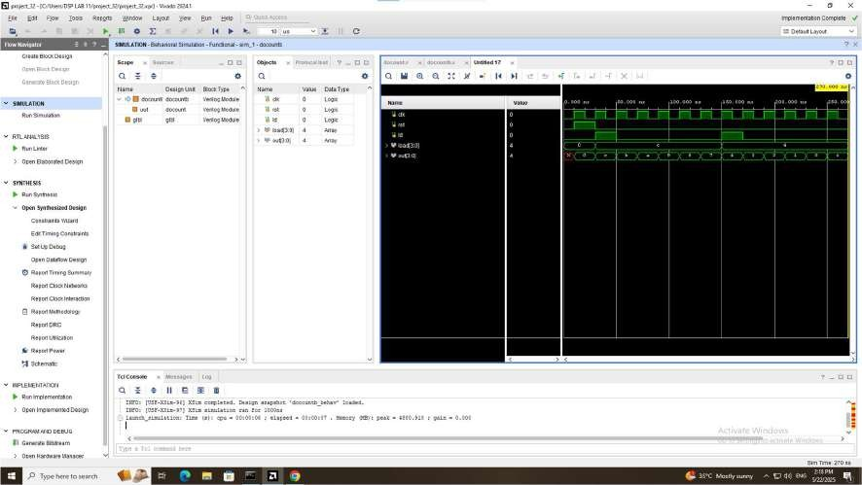

**Design Code:**

module docount( input clk,rst,ld, input [3:0]load, output reg [3:0]out);

always @(posedge clk or posedge rst) begin if(rst)

out<=0; else begin

if(ld || out==4'b0000) out<=load;

else

out<=out-1;

end end

endmodule

**Testbench code:**

module docountb(); reg clk,rst,ld;

reg [3:0]load;

wire [3:0]out;

docount uut(clk, rst,ld,load,out); always begin

#10 clk=~clk; end

initial begin rst=0;clk=0;load=4'b0000;ld=0; #10 rst=1;

#20 rst=0;ld=1;load=4'b1100;

#20 ld=0;

#80;

#20 ld=1;load=4'b0100;

#20 ld=0;

#100;

$finish; end

endmodule

**Analysis:**

**Power Consumption:**

The image shows the power analysis of an FPGA design. The total on-chip power is **4.546 W**, with **11% (0.486 W)** being static power and **89% (4.060 W)** being dynamic power. The junction temperature is a safe **32.9°C**, with a thermal margin of **67.1°C**. No off-chip power is used, and the analysis confidence level is marked as **LOW**.

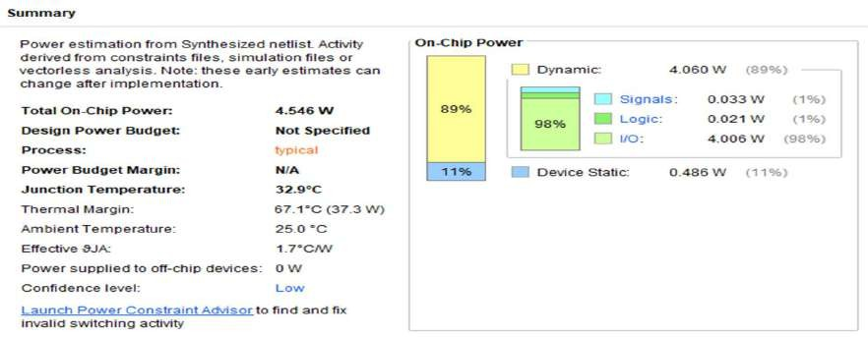

**Delay:**

The **minimum total setup delay** is **1.154 ns**. The **maximum total setup delay** is **1.656 ns**.

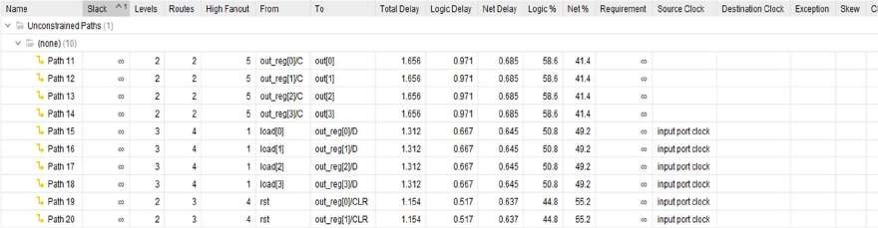

The **minimum total hold delay** is **0.131ns**. The **maximum total hold delay** is **0.783 ns**.

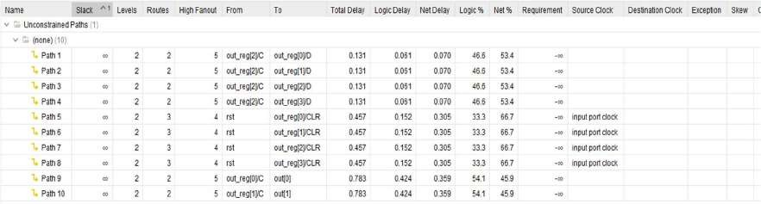

**Area:**

The image shows the **Post-Implementation Utilization Report** of an FPGA design. It indicates resource usage:

* **LUT** and **FF** are each utilized only **1%**.
* 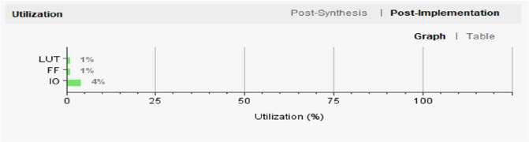**IO** has the highest usage at **4%**.

**RTL Schematic:**

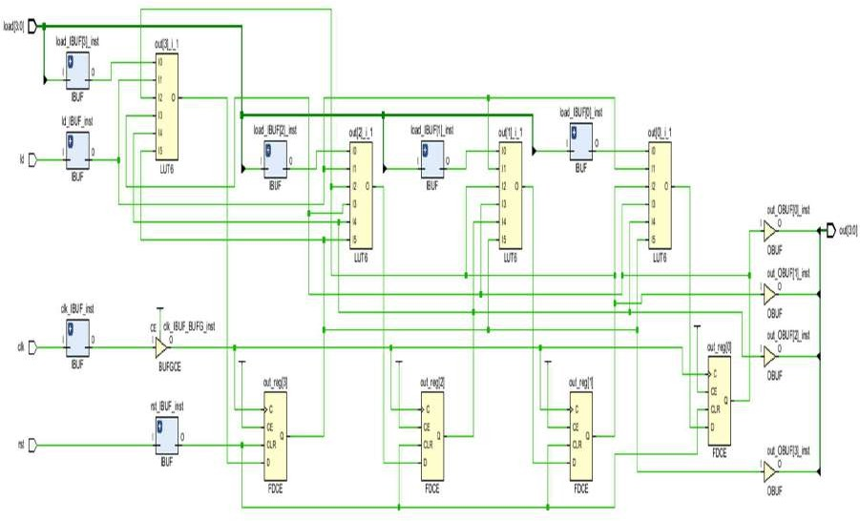

# Up-Down counter

#### Introduction:

The given Verilog code implements a 4-bit up/down counter (updncount) with **synchronous load**, **asynchronous reset**, and a **direction control input** (ctr) that determines whether the counter counts up or down. On every **rising edge of the clock (clk)**, the counter first evaluates the **asynchronous reset (rst)**, and if asserted, it **immediately resets the output to zero**, independent of the clock. If reset is not active, the counter's behavior is directed by the ctr signal: when ctr = 1, the counter operates in **up-counting mode**, incrementing the current value unless the **load signal (ld) is high** or the counter has reached its **maximum value (1111 or 15)**. In either case, it synchronously loads a new value from the load input. Conversely, when ctr = 0, the counter functions in **down-counting mode**, decrementing the value unless ld is high or the counter reaches **zero (0000)**, at which point it also loads the new value. This flexible design supports both upward and downward counting, along with runtime reloading of custom start values, making it highly suitable for **bidirectional timers**, **event-driven counters**, and **state-controlled digital systems** where dynamic control over counting direction and initialization is essential.

**Output waveform:**

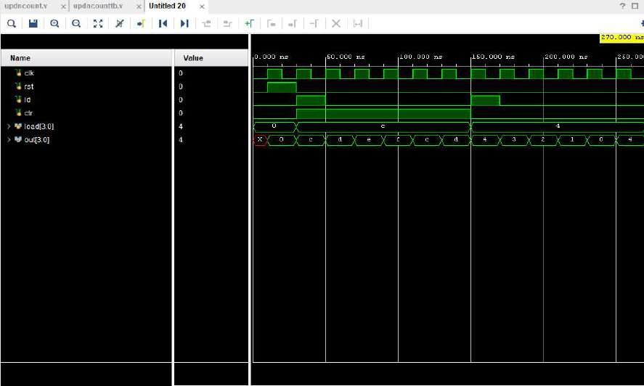

**Design Code**:

module updncount( input clk,rst,ld,ctr,

input [3:0]load, output reg [3:0]out);

always @(posedge clk or posedge rst) begin if(rst)

out<=0;

else begin if(ctr)begin

if(ld || out==4'b1111) out<=load;

else

out<=out+1;

end

else begin

if(ld || out==4'b0000) out<=load;

else

out<=out-1;

end end

end endmodule

**Test bench code**:

module updncounttb(); reg clk,rst,ld,ctr;

reg [3:0]load;

wire [3:0]out;

updncount uut(clk, rst,ld,ctr,load,out); always begin

#10 clk=~clk; end

initial begin rst=0;clk=0;load=4'b0000;ld=0;ctr=0; #10 rst=1;

#20 rst=0;ctr=1;ld=1;load=4'b1100;

#20 ld=0;

#80;

#20 ld=1;ctr=0;load=4'b0100;

#20 ld=0;

#100;

$finish; end

endmodule

**Analysis**:

**Power Consumption:**

The image shows the power analysis of an FPGA design. The total on-chip power is **4.481 W**, with **11% (0.485 W)** being static power and **89% (3.996 W)** being dynamic power. The junction temperature is a safe **32.7°C**, with a thermal margin of **67.3°C**. No off-chip power is used, and the analysis confidence level is marked as **LOW**.

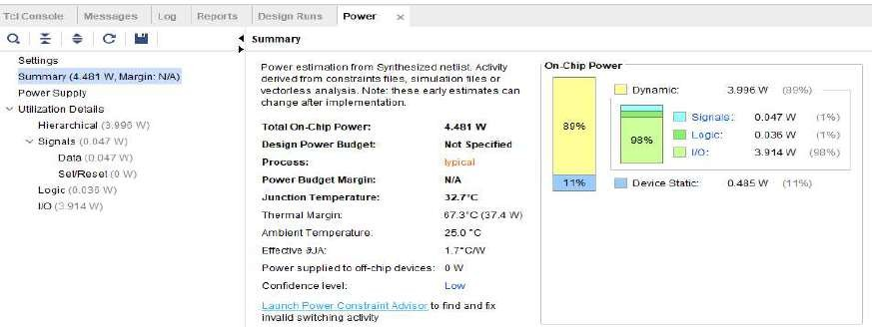

**Delay:**

The **minimum total setup delay** is **1.154 ns**. The **maximum total setup delay** is **1.670 ns**.

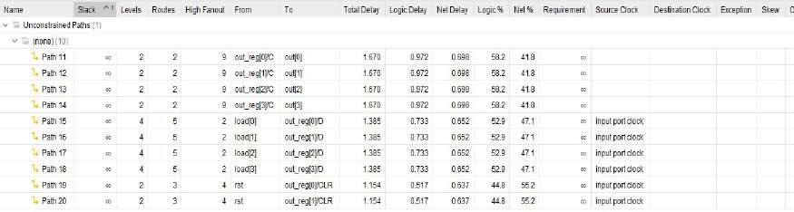

The **minimum total hold delay** is **0.148 ns**. The **maximum total hold delay** is **0.790 ns**

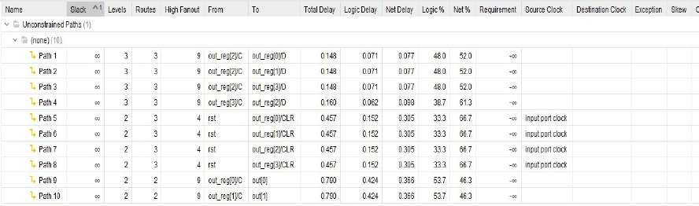

**Area:**

The image shows the **Post-Implementation Utilization Report** of an FPGA design. It indicates resource usage:

* **LUT** and **FF** are each utilized only **1%**.
* 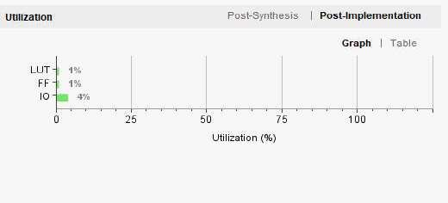**IO** has the highest usage at **4%**.

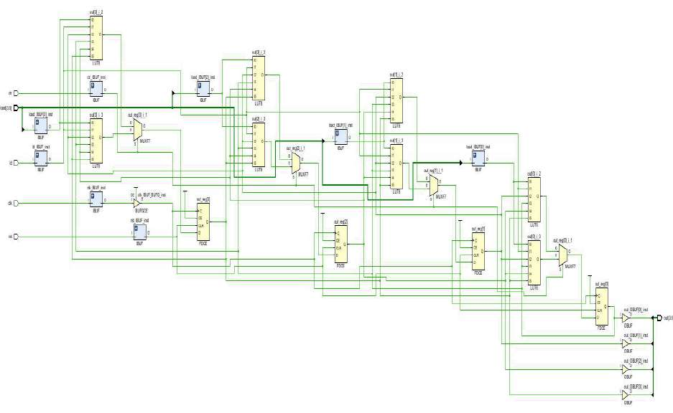**RTL Schematic:**

# Programmable mod n up-counter

#### Introduction:

The given Verilog code defines a **modulo-N up-counter**, specifically a **mod-7 up-counter**, with both **synchronous load** and **asynchronous reset** features. The module modnup uses two 4-bit registers:

* out holds the current counter value (visible as output),
* a is an internal counter that keeps track of clock cycles.

On every **rising edge of the clock** or when the **reset (rst)** signal is active, the counter performs the following:

* If reset is asserted, out is cleared to 0000 and a is initialized to 0001.
* If the **load signal (ld)** is high, the input load value is stored in out, and a is reset to 0000.

During regular operation, a increments with each clock pulse. Once a reaches **6** (meaning 7 total cycles, including when a = 0), the counter **wraps around**:

* It reloads the load value into out,
* Resets a to 0001,
* And begins the cycle again.

This implementation effectively creates a **mod-7 behavior**, making it ideal for systems that require periodic actions, such as **timing intervals**, **rotating schedules**, or **repeating control sequences**.

**Output waveform:**

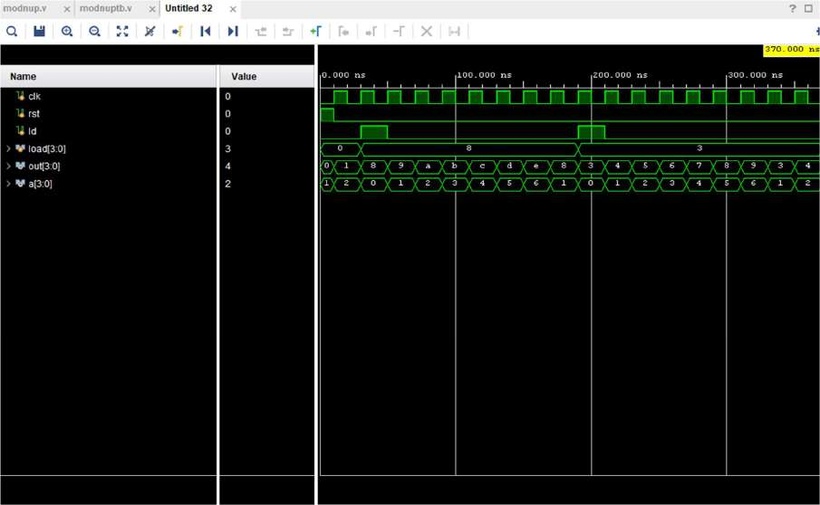

**Design Code:**

module modnup ( input clk, rst, ld, input [3:0] load, output reg [3:0] out, output reg [3:0] a);

always @(posedge clk or posedge rst) begin if (rst) begin

out <= 4'b0000; a <= 4'b0001;

end

else if (ld) begin out <= load; a <= 4'b0000;

end

else begin

if (a == 4'd6) begin

out <= load; a <= 4'b0001; end

else begin

a <= a + 1; out <= out + 1; end

end end

endmodule

**Testbench code:**

module modnuptb(); reg clk, rst, ld; reg [3:0] load;

wire [3:0] out;

wire [3:0] a;

modnup uut (.clk(clk),.rst(rst),.ld(ld),.load(load),.out(out),.a(a)); always begin

#10 clk = ~clk; end

initial begin

clk = 0;rst = 1;ld = 0;load = 4'b0000; #10 rst = 0;

#20 ld = 1;load = 4'b1000; #20 ld = 0;

#120;

#20 ld = 1;load = 4'b0011; #20 ld = 0;

#160;

$finish; end

endmodule

**Analysis:**

**Power Consumption:**

The image shows the power analysis of an FPGA design. The total on-chip power is **7.265 W**, with **7% (0.516 W)** being static power and **93% (6.749 W)** being dynamic power. The junction temperature is a safe **37.6°C**, with a thermal margin of **62.4°C**. No off-chip power is used, and the analysis confidence level is marked as **LOW**.

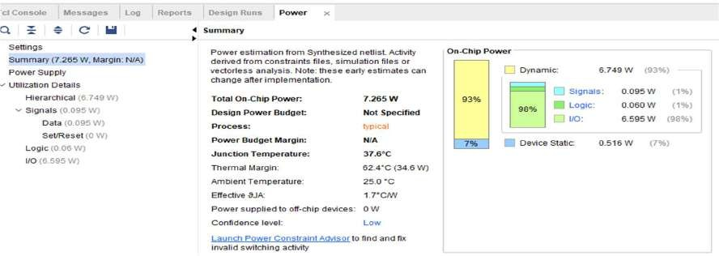

**Delay:**

The **minimum total setup delay** is **1.524 ns**. The **maximum total setup delay** is **1.660 ns**

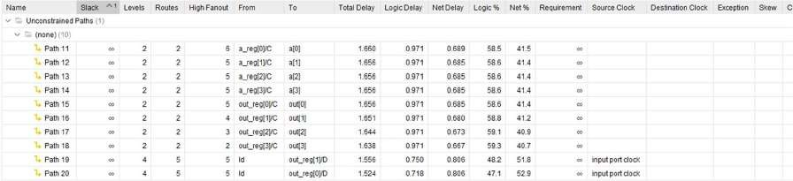

The **minimum total hold delay** is **0.131 ns**. The **maximum total hold delay** is **0.464 ns**.

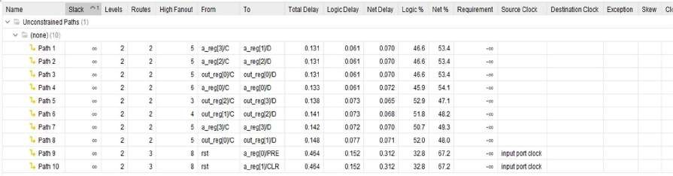

**Area:**

The image shows the **Post-Implementation Utilization Report** of an FPGA design. It indicates resource usage:

* **LUT** and **FF** are each utilized only **1%**. **IO** has the highest usage at **5%**.

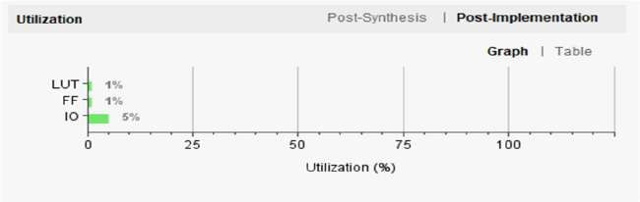

**RTL Schematic:**

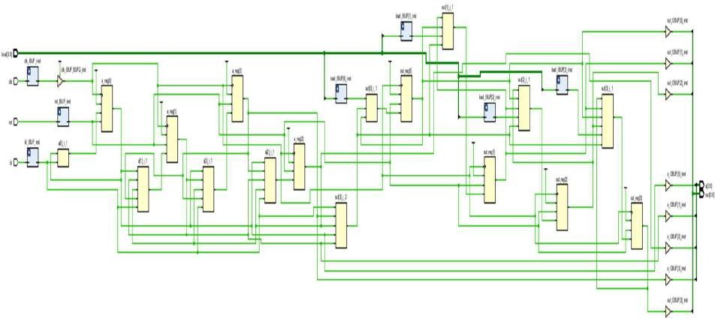

# Programmable Mod-N Down-Counter

#### Introduction:

The given Verilog code implements a **modulo-N down-counter**, specifically a **mod-7 down-counter**, with both **synchronous load** and **asynchronous reset**. The module modndown uses two 4-bit registers:

* out holds the current count value (and is the main output),
* a is an internal counter that tracks the number of clock cycles.

On each **rising edge of the clock** or when the **asynchronous reset (rst)** is triggered:

* If reset is active, the counter clears out to 0000 and initializes a to 0001.
* If the **load signal (ld)** is high, the load value is loaded into out, and a is reset to 0000.

During normal operation, on each clock cycle:

* The counter **decrements** out by 1,
* And increments the internal tracker a.

When a reaches **6**, meaning **7 clock cycles** have passed (counting from a = 0), the counter **reloads the value from load into out**, and resets a to 0001. This wraps the behavior in a repeating **mod-7 cycle**.

This kind of down-counter is especially useful in scenarios where operations must repeat after fixed intervals—such as **timing windows**, **task scheduling**, or **clock division** in digital systems.

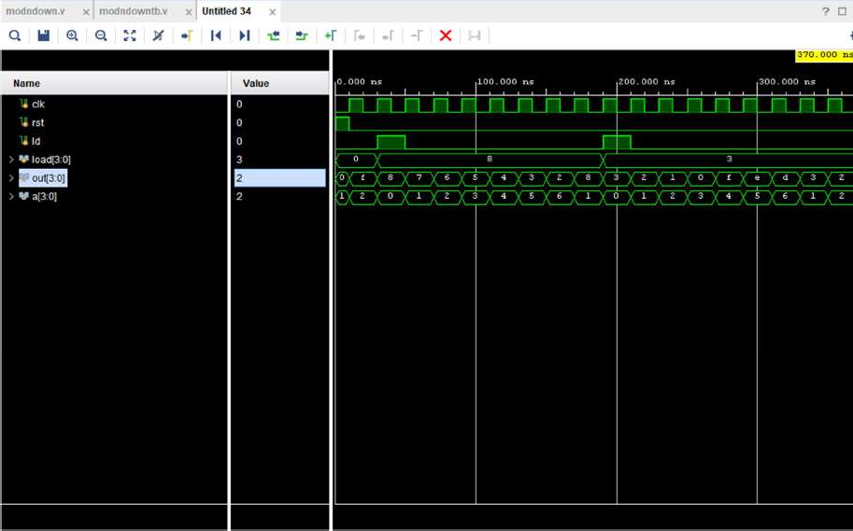**Output waveform:**

**Design Code**: module modndown (

input clk, rst, ld, input [3:0] load, output reg [3:0] out, output reg [3:0] a

);

always @(posedge clk or posedge rst) begin if (rst) begin

out <= 4'b0000; a <= 4'b0001;

end

else if (ld) begin

out <= load; a <= 4'b0000; end

else begin

if (a == 4'd6) begin

out <= load; a <= 4'b0001; end

else begin

a <= a + 1; out <= out - 1; end

end end

endmodule

**Test bench code**:

module modndowntb(); reg clk, rst, ld;

reg [3:0] load;

wire [3:0] out;

wire [3:0] a;

modndown uut (.clk(clk),.rst(rst),.ld(ld),.load(load),.out(out),.a(a)); always begin

#10 clk = ~clk; end

initial begin

clk = 0;rst = 1;ld = 0;load = 4'b0000; #10 rst = 0;

#20 ld = 1;load = 4'b1000; #20 ld = 0;

#120;

#20 ld = 1;load = 4'b0011; #20 ld = 0;

#160;

$finish; end

endmodule

**Analysis:**

**Power Consumption:**

The image shows the power analysis of an FPGA design. The total on-chip power is **3.561 W**, with **13% (0.476 W)** being static power and **87% (3.084 W)** being dynamic power. The junction temperature is a safe **31.2°C**, with a thermal margin of **68.8°C**. No off-chip power is used, and the analysis confidence level is marked as **LOW**.

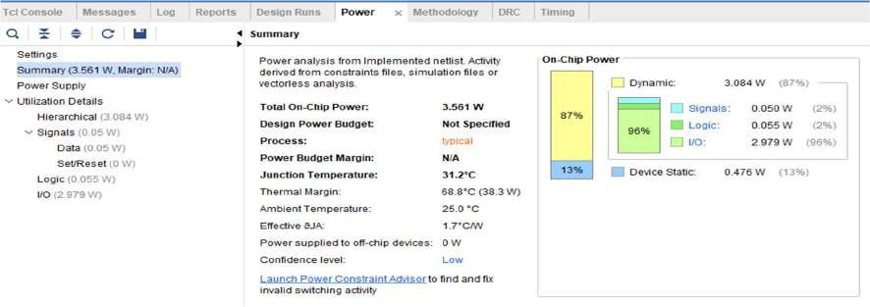

**Delay:**

The **minimum total setup delay** is **2.303 ns**. The **maximum total setup delay** is **3.135 ns**

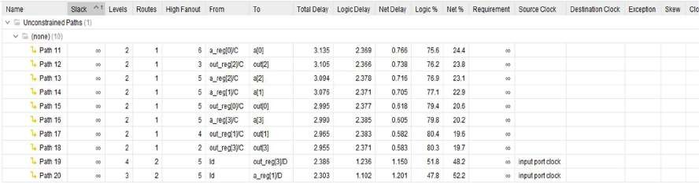

The **minimum total hold delay** is **0.096 ns**. The **maximum total hold delay** is **0.817 ns**.

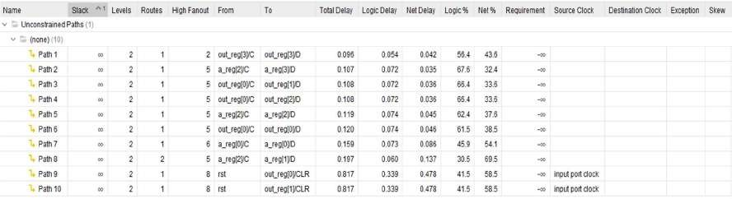

**Area:**

The image shows the **Post-Implementation Utilization Report** of an FPGA design. It indicates resource usage:

* **LUT** and **FF** are each utilized only **1%**.
* 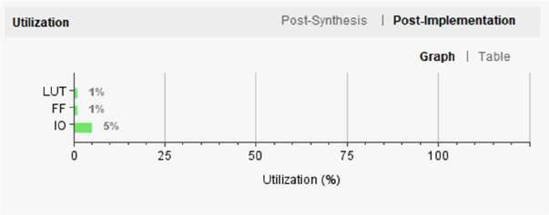**IO** has the highest usage at **5%**.

**RTL Schematic:**

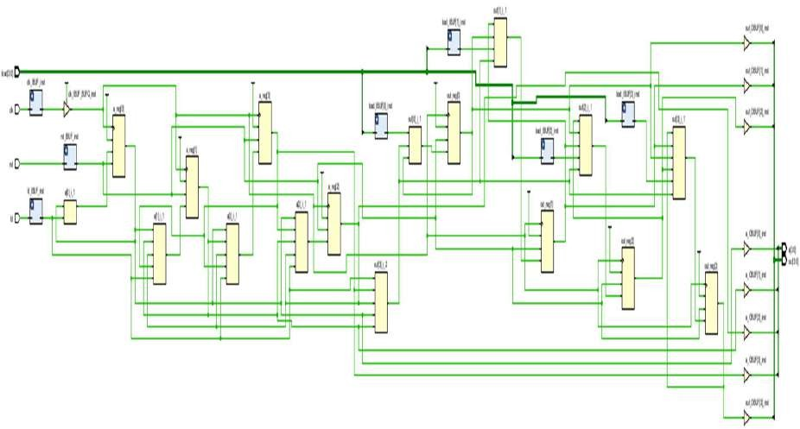

# PRBS 4 bit

#### Introduction:

The given Verilog code implements a **4-bit Pseudo-Random Binary Sequence (PRBS) generator** using a **Linear Feedback Shift Register (LFSR)** approach. The prbs4 module maintains a 4-bit shift register q, which updates on every **rising edge of the clock (clk)**.

When the **clear (clr)** signal is asserted, the register is **reset to zero**. If the **load signal (load)** is high, the register is **initialized with a fixed non-zero seed** (in this case, 4'd8). This ensures that the sequence doesn't get stuck in the all-zero state, which is invalid for LFSRs.

If neither reset nor load is active, the register performs a **right shift**, and the **new most significant bit** is calculated as the **XOR of the two least significant bits** (q[0] ^ q[1]). This XOR-based feedback mechanism generates a sequence of bits that **appears random**, but is actually **deterministic** and **repeats** after a fixed number of cycles, known as the **maximum length sequence** (for a 4-bit LFSR, this can be up to 15 unique states).

**Output waveform:**

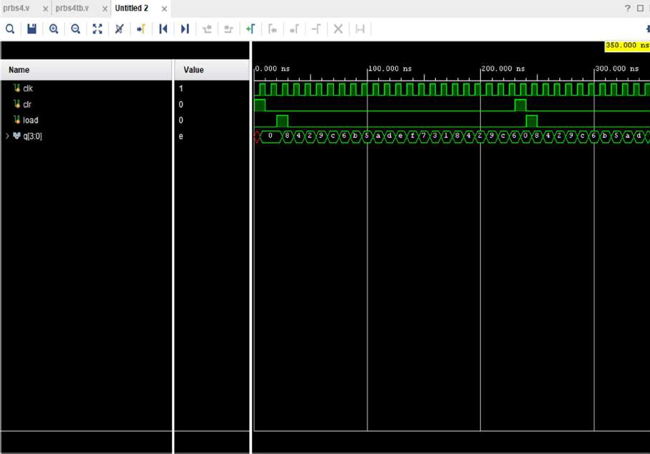

**Design Code:**

module prbs4(clk,clr,load,q); input clk,clr,load; output[3:0]q;

reg[3:0]q;

always@(posedge clk) begin

if(clr)

q<=4'd0;

else begin if(load) q<=4'd8;

else

q<={(q[0]^q[1]),q[3:1]};

end end

endmodule

**Test bench code**:

module prbs4tb(); reg clk,clr,load; wire [3:0] q;

prbs4 uut (.clk(clk), .clr(clr), .load(load), .q(q)); initial begin

clk = 0;

forever #5 clk = ~clk; end

initial begin clr = 1;

load = 0;

#10 clr = 0;

#10 load = 1;

#10 load = 0;

#200;clr = 1;

#10 clr = 0;load = 1;

#10 load = 0;

#100;

$finish; end

endmodule

**Analysis:**

**Power Consumption:**

The image shows the power analysis of an FPGA design. The total on-chip power is **1.082 W**, with **42% (0.455 W)** being static power and **58% (0.627 W)** being dynamic power. The junction temperature is a safe **26.9°C**, with a thermal margin of **73.1°C**. No off-chip power is used, and the analysis confidence level is marked as **LOW**.

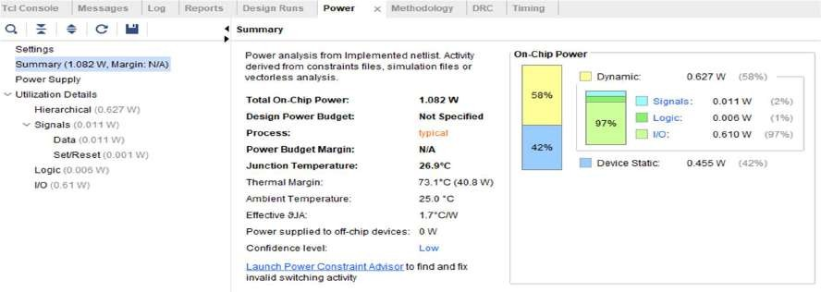

**Delay:**

The **minimum total setup delay** is **0.616 ns**. The **maximum total setup delay** is **3.181 ns**

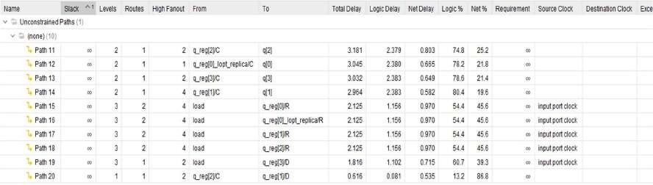

The **minimum total hold delay** is **0.080 ns**. The **maximum total hold delay** is **1.353 ns**.

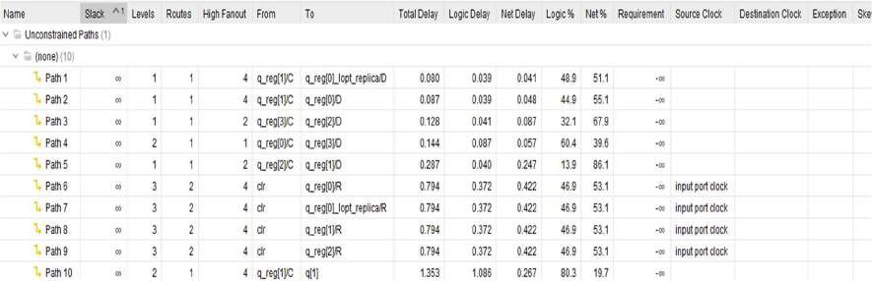

**Area:**

The image shows the **Post-Implementation Utilization Report** of an FPGA design. It indicates resource usage:

* **LUT** and **FF** are each utilized only **1%**.
* 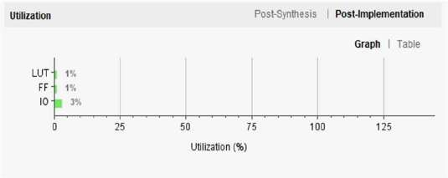**IO** has the highest usage at **3%**.

**RTL Schematic**

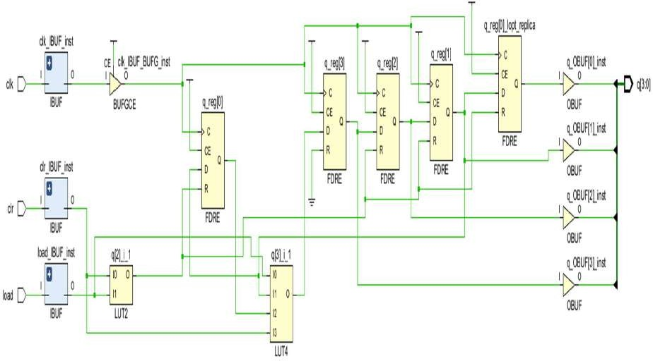

# PRBS 8 bit

#### Introduction:

The given Verilog code implements an **8-bit Pseudo-Random Binary Sequence (PRBS) generator** using a Linear Feedback Shift Register (LFSR) with a configurable seed input. The internal 8-bit register lfsr updates on every positive clock edge based on a feedback bit calculated using an XOR of selected taps (lfsr[7], lfsr[5], lfsr[4], and lfsr[3]), ensuring a maximal-length pseudo-random sequence.

When the reset (rst) is high, the register initializes to a non-zero value (8'h1). If the seed valid (sv) signal is high, the generator loads a user-provided seed es (unless it is zero, in which case it loads 8'h1). Otherwise, the register shifts left, inserting the feedback bit into the least significant bit.

The output out continuously reflects the LFSR state, making this module useful for applications like data scrambling, self-testing, and random pattern generation in digital systems.

**Output waveform:**

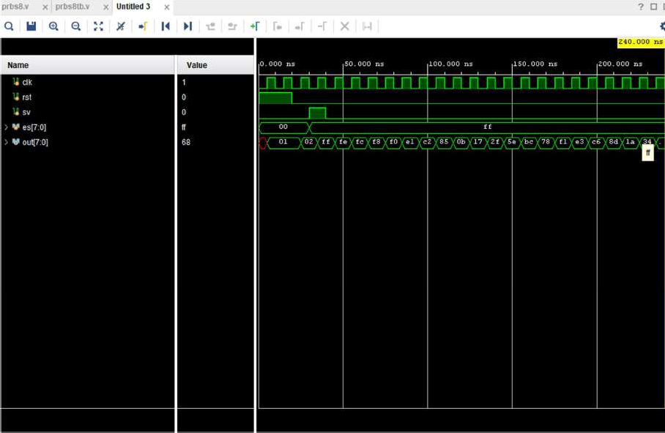

**Design Code:**

module prbs8 ( input wire clk, input wire rst, input wire [7:0] es, input wire sv,

output wire [7:0] out

);

reg [7:0] lfsr;

wire fb = lfsr[7] ^ lfsr[5] ^ lfsr[4] ^ lfsr[3]; always @(posedge clk) begin

if (rst) begin

lfsr <= 8'h1;

end else if (sv) begin if (es != 8'h00) begin lfsr <= es;

end else begin lfsr <= 8'h1; end

end else begin

lfsr <= {lfsr[6:0], fb}; end

end

assign out = lfsr; endmodule

**Test bench code**:

module prbs8tb(); reg clk,rst,sv; reg [7:0] es;

wire [7:0] out;

prbs8 uut (.clk(clk),.rst(rst),.es(es),.sv(sv),.out(out)); always #5 clk = ~clk;

initial begin

clk = 0;rst = 1;es = 0;sv = 0; #20;rst = 0;

#10;es = 8'hFF;sv = 1; #10;sv = 0;

#200;

$finish; end

endmodule

**Analysis:**

**Power Consumption:**

The image shows the power analysis of an FPGA design. The total on-chip power is **6.814 W**, with **7% (0.510 W)** being static power and **93% (6.304 W)** being dynamic power. The junction temperature is a safe **36.8°C**, with a thermal margin of **63.2°C**. No off-chip power is used, and the analysis confidence level is marked as **LOW.**

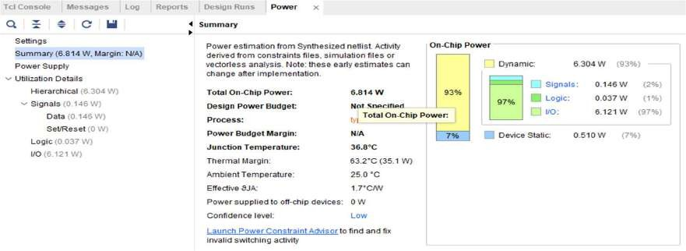

**Delay:**

The **minimum total setup delay** is **1.644 ns**. The **maximum total setup delay** is **1.222 ns**.

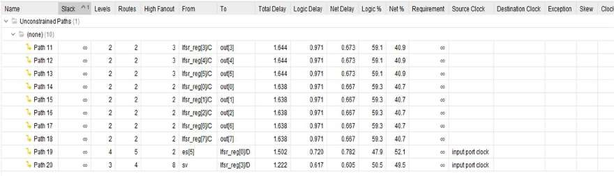

The **minimum total hold delay** is **0.135 ns**. The **maximum total hold delay** is **0.464 ns**.

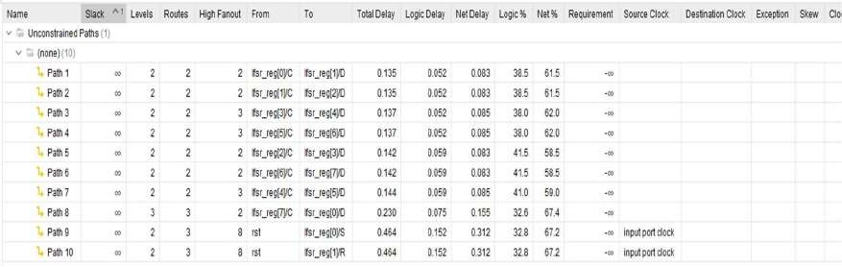

**Area:**

The image shows the **Post-Implementation Utilization Report** of an FPGA design. It indicates resource usage:

* **LUT** and **FF** are each utilized only **1%**.
* 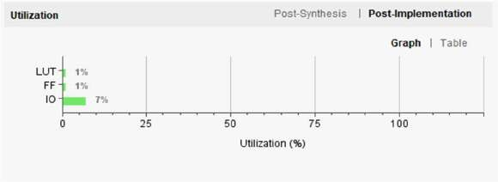**IO** has the highest usage at **7%**.

**RTL Schematic:**

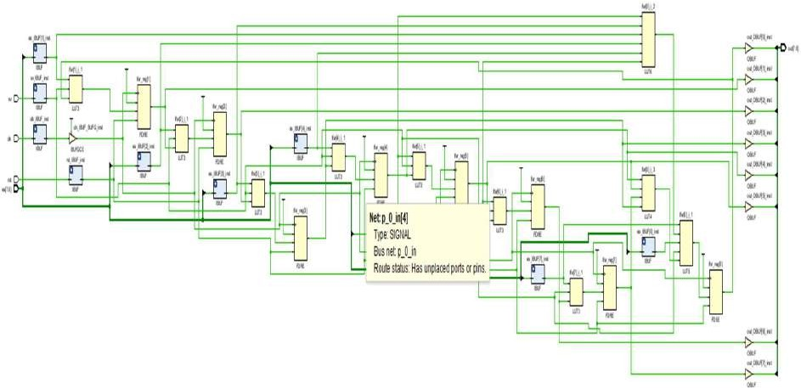

# Ripple Carry Adder

**Introduction:**

### This Verilog code implements an 8-bit Ripple Carry Adder using NAND gate-based full adders. The fulladd module generates sum and carry using logic built solely from NAND gates, demonstrating basic gate-level arithmetic design. The rca module chains eight fulladd blocks to handle 8-bit addition, passing carry between stages. The rcatb testbench verifies functionality through several test cases, including operations with and without carry-in, and edge cases like overflow. This design emphasizes fundamental digital logic implementation and verification through structured modular design and waveform simulation.

**Output waveform:**

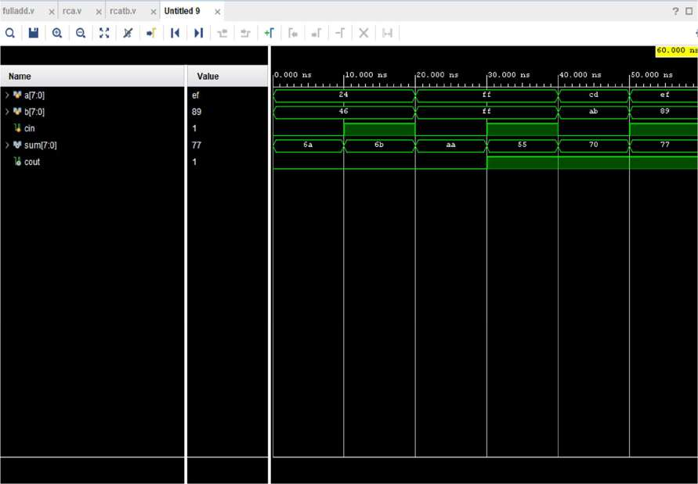

**Design Code:**

module fulladd( input a, b, cin, output sum, cout

);

wire n1a, n2a, n3a, n4, n5, n6; wire ab_xor;

wire ab, bc, ac; wire na, nb, nc; wire or1, or2;

nand(n1a, a, b);

nand(n2a, a, n1a);

nand(n3a, b, n1a); nand(ab_xor, n2a, n3a);

nand(n4, ab_xor, cin); nand(n5, ab_xor, n4); nand(n6, cin, n4);

nand(sum, n5, n6);

wire n1b, n2b, n3b; nand(n1b, a, b); nand(ab, n1b, n1b);

nand(n2b, b, cin); nand(bc, n2b, n2b);

nand(n3b, a, cin); nand(ac, n3b, n3b);

nand(na, ab, ab);

nand(nb, bc, bc);

nand(nc, ac, ac);

nand(or1, na, nb); nand(or2, or1, nc); nand(cout, or2, or2);

endmodule

module rca( input [7:0]a,

input [7:0]b, input cin,

output [7:0]sum,cout

);

wire [6:0]c;

fulladd a1(a[0],b[0],cin,sum[0],c[0]);

fulladd a2(a[1],b[1],c[0],sum[1],c[1]);

fulladd a3(a[2],b[2],c[1],sum[2],c[2]);

fulladd a4(a[3],b[3],c[2],sum[3],c[3]);

fulladd a5(a[4],b[4],c[3],sum[4],c[4]);

fulladd a6(a[5],b[5],c[4],sum[5],c[5]);

fulladd a7(a[6],b[6],c[5],sum[6],c[6]);

fulladd a8(a[7],b[7],c[6],sum[7],cout); endmodule

**Testbench Code:**

module rcatb(); reg [7:0]a;

reg [7:0]b; reg cin;

wire [7:0]sum; wire cout;

rca a1 (.a(a),.b(b),.cin(cin),.sum(sum),.cout(cout)); initial begin

a = 8'h24; b = 8'h46; cin = 0; #10;

a = 8'h24; b = 8'h46; cin = 1; #10;

a = 8'hFF; b = 8'hFF; cin = 0; #10;

a = 8'hFF; b = 8'hFF; cin = 1; #10;

a = 8'hCD; b = 8'hAB; cin = 0; #10;

a = 8'hEF; b = 8'h89; cin = 1; #10;

$finish; end

endmodule

**Analysis:**

**Power Consumption:**

The image shows the power analysis of an FPGA design. The total on-chip power is **9.55 W**, with **6% (0.546 W)** being static power and **94% (9.005 W)** being dynamic power. The junction temperature is a safe **41.5°C**, with a thermal margin of **58.5°C**. No off-chip power is used, and the analysis confidence level is marked as **LOW**.

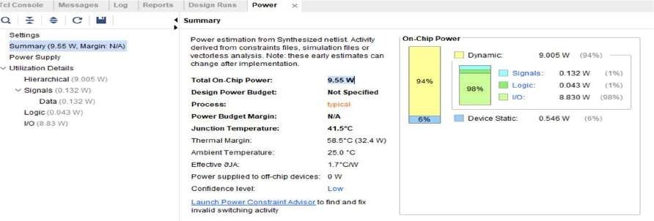

**Delay:**

The **minimum total setup delay** is **2.767 ns**. The **maximum total setup delay** is **3.634 ns**.

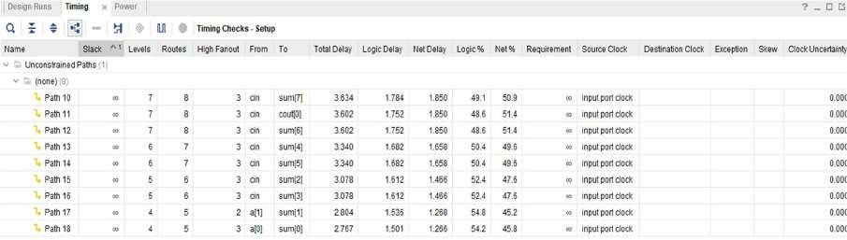

The **minimum total hold delay** is **1.218 ns**. The **maximum total hold delay** is **1.205 ns**.

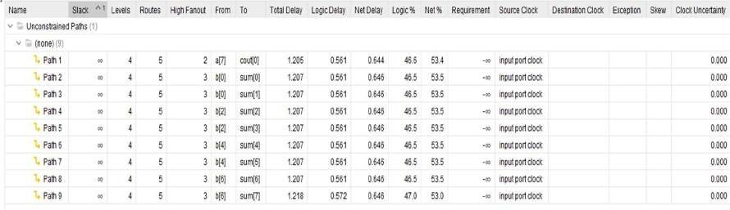

**Area:**

The image shows the **Post-Implementation Utilization Report** of an FPGA design. It indicates resource usage:

* **LUT** utilized only **1%**.
* 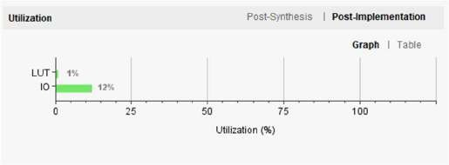**IO** has the highest usage at **12%**.

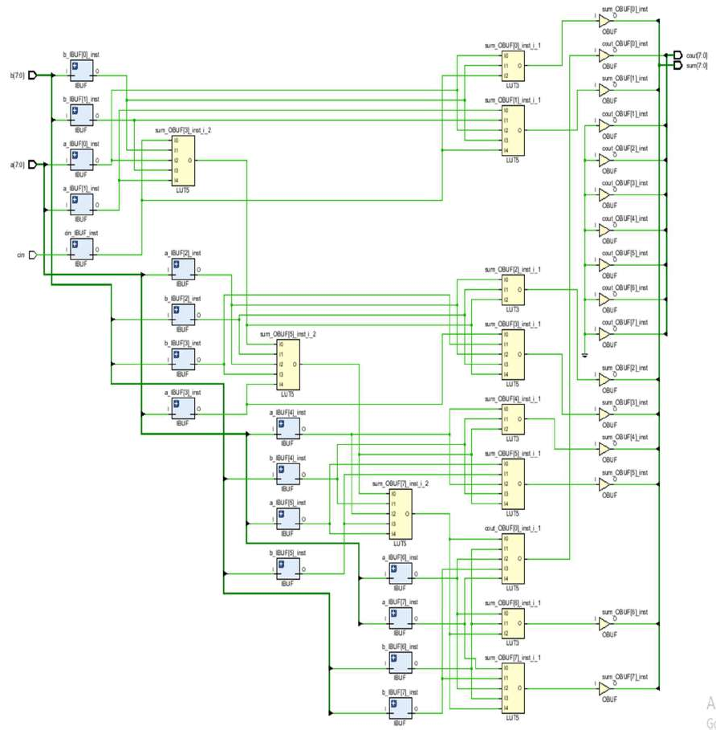**RTL Schematic:**

# Carry Lookahead Adder

**Introduction:**

### This Verilog design implements an 8-bit **Carry Lookahead Adder (CLA)** using generate and propagate logic to compute carries in parallel, significantly improving speed over traditional ripple carry adders. The crylook module calculates sum and carry-out efficiently by precomputing carry signals for all bit positions. The accompanying crylooktb testbench verifies the adder’s performance through several test cases, including typical additions, overflow scenarios, and random inputs. The design demonstrates optimized digital arithmetic using structural Verilog and is ideal for high-speed arithmetic units in ALUs and processors.

**Output waveform:**

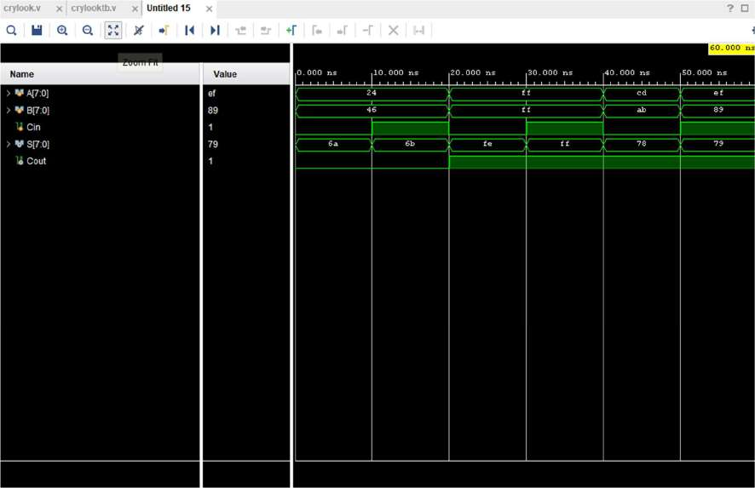

**Design Code:**

module crylook( input [7:0] A, B, input Cin, output [7:0] S, output Cout

);

wire [7:0] G, P;

wire [7:0] C;

assign G = A & B; assign P = A ^ B;

assign C[0] = Cin;

assign C[1] = G[0] | (P[0] & C[0]);

assign C[2] = G[1] | (P[1] & C[1]);

assign C[3] = G[2] | (P[2] & C[2]);

assign C[4] = G[3] | (P[3] & C[3]);

assign C[5] = G[4] | (P[4] & C[4]);

assign C[6] = G[5] | (P[5] & C[5]);

assign C[7] = G[6] | (P[6] & C[6]);

assign Cout = G[7] | (P[7] & C[7]); assign S = P ^ C;

endmodule

**Testbench Code:**

module crylooktb(); reg [7:0] A, B;

reg Cin; wire [7:0] S; wire Cout;

crylook cla(.A(A), .B(B), .Cin(Cin), .S(S), .Cout(Cout));

initial begin

A = 8'h24; B = 8'h46; Cin = 0; #10; A = 8'h24; B = 8'h46; Cin = 1; #10; A = 8'hFF; B = 8'hFF; Cin = 0; #10; A = 8'hFF; B = 8'hFF; Cin = 1; #10; A = 8'hCD; B = 8'hAB; Cin = 0; #10; A = 8'hEF; B = 8'h89; Cin = 1; #10;

$finish; end

endmodule

**Analysis:**

**Power Consumption:**

The image shows the power analysis of an FPGA design. The total on-chip power is **4.781 W**, with **10% (0.488 W)** being static power and **90% (4.293 W)** being dynamic power. The junction temperature is a safe **33.3°C**, with a thermal margin of **66.7°C**. No off-chip power is used, and the analysis confidence level is marked as **LOW**.

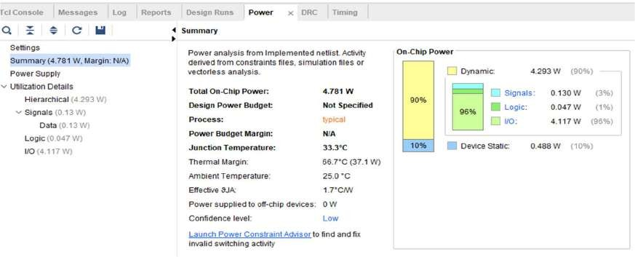

**Delay:**

The **minimum total setup delay** is **5.089 ns**. The **maximum total setup delay** is **6.383 ns**.

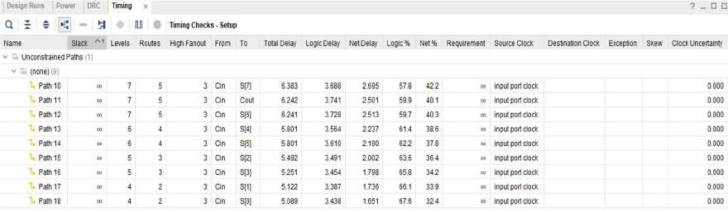

The **minimum total hold delay** is **1.919 ns**. The **maximum total hold delay** is **2.209 ns**.

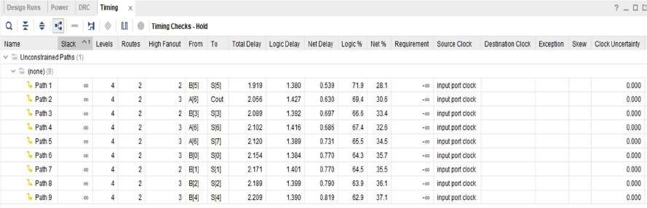

**Area:**

The image shows the **Post-Implementation Utilization Report** of an FPGA design. It indicates resource usage:

* **LUT** utilized only **1%**.
* 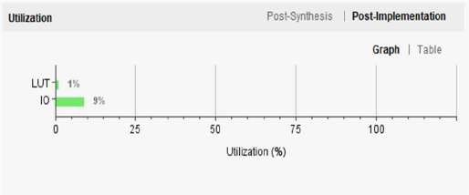**IO** has the highest usage at **9%**.

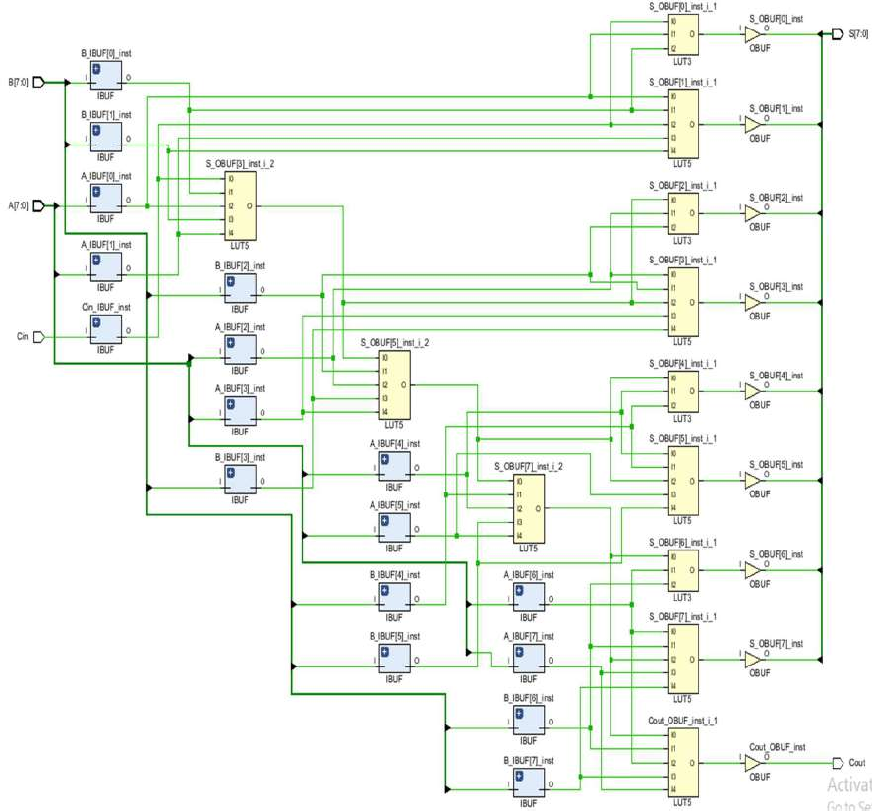**RTL Schematic:**

# Carry Select Adder

**Introduction:**

### This Verilog design implements an 8-bit **Carry Select Adder (CSLA)**, which speeds up addition by precomputing sum and carry for both possible carry-in values (0 and 1) in parallel. Two sets of full adders generate intermediate results, and 2-to-1 multiplexers select the correct sum and carry based on the actual carry-in (cin). The csadder module outputs the 8-bit sum (s) and final carry-out (cout). The testbench csaddertb validates the design using various test cases, including overflow and random inputs. CSLA improves addition speed by reducing carry propagation delay, making it ideal for high-speed arithmetic units.

**Output waveform:**

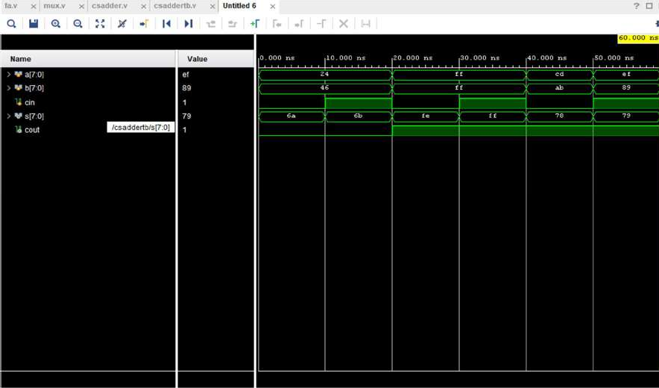

**Design Code:**

module fa(

input a, b, cin, output sum, cout

);

assign sum = a^b^cin;

assign cout= (a&b)|(b&cin)|(cin&a);

endmodule

module mux(input s0,i0,i1, output y); wire s00;

wire w0,w1; nand(s00,s0,s0);

nand(w0,s00,i0);

nand(w1,i1,s0);

nand(y,w1,w0);

endmodule module csadder(

input [7:0]a,

input [7:0]b, input cin, output [7:0]s, output cout); wire [7:0]c1;

wire [7:0]s1;

wire [7:0]c2;

wire [7:0]s2;

fa a0(a[0],b[0],1'b0,s1[0],c1[0]);

fa a1(a[1],b[1],c1[0],s1[1],c1[1]);

fa a2(a[2],b[2],c1[1],s1[2],c1[2]);

fa a3(a[3],b[3],c1[2],s1[3],c1[3]);

fa a4(a[4],b[4],c1[3],s1[4],c1[4]);

fa a5(a[5],b[5],c1[4],s1[5],c1[5]);

fa a6(a[6],b[6],c1[5],s1[6],c1[6]);

fa a7(a[7],b[7],c1[6],s1[7],c1[7]);

fa b0(a[0],b[0],1'b1,s2[0],c2[0]);

fa b1(a[1],b[1],c2[0],s2[1],c2[1]);

fa b2(a[2],b[2],c2[1],s2[2],c2[2]);

fa b3(a[3],b[3],c2[2],s2[3],c2[3]);

fa b4(a[4],b[4],c2[3],s2[4],c2[4]);

fa b5(a[5],b[5],c2[4],s2[5],c2[5]);

fa b6(a[6],b[6],c2[5],s2[6],c2[6]);

fa b7(a[7],b[7],c2[6],s2[7],c2[7]);

mux z1(cin,s1[0],s2[0],s[0]);

mux z2(cin,s1[1],s2[1],s[1]);

mux z3(cin,s1[2],s2[2],s[2]);

mux z4(cin,s1[3],s2[3],s[3]);

mux z5(cin,s1[4],s2[4],s[4]);

mux z6(cin,s1[5],s2[5],s[5]);

mux z7(cin,s1[6],s2[6],s[6]);

mux z8(cin,s1[7],s2[7],s[7]);

mux f(cin,c1[7],c2[7],cout); endmodule

**Testbench Code:**

module csaddertb(); reg [7:0]a;

reg [7:0]b; reg cin; wire [7:0]s; wire cout;

csadder a1 (.a(a),.b(b),.cin(cin),.s(s),.cout(cout)); initial begin

a = 8'h24; b = 8'h46; cin = 0; #10;

a = 8'h24; b = 8'h46; cin = 1; #10;

a = 8'hFF; b = 8'hFF; cin = 0; #10;

a = 8'hFF; b = 8'hFF; cin = 1; #10;

a = 8'hCD; b = 8'hAB; cin = 0; #10;

a = 8'hEF; b = 8'h89; cin = 1; #10;

$finish; end

endmodule

**Analysis:**

**Power Consumption:**

The image shows the power analysis of an FPGA design. The total on-chip power is **4.98 W**, with **10% (0.490 W)** being static power and **90% (4.490 W)** being dynamic power. The junction temperature is a safe **33.6°C**, with a thermal margin of **66.4°C**. No off-chip power is used, and the analysis confidence level is marked as **LOW**.

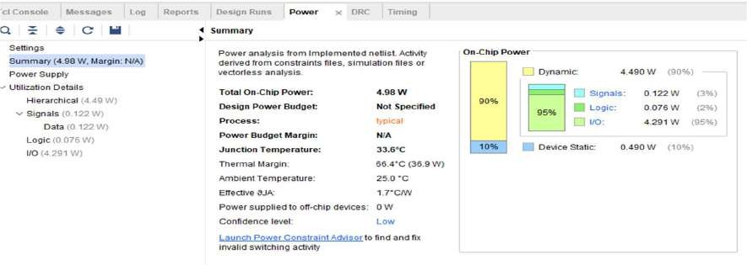

**Delay:**

The **minimum total setup delay** is **4.880 ns**. The **maximum total setup delay** is **6.029 ns**.

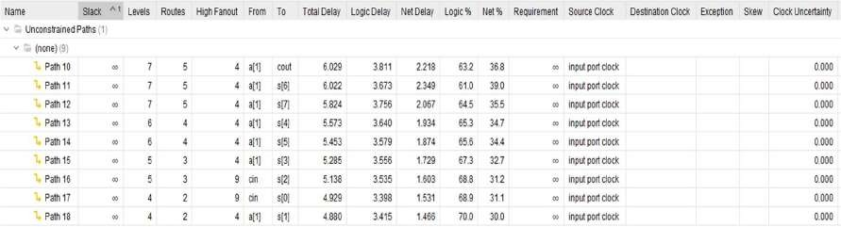

The **minimum total hold delay** is **1.400 ns**. The **maximum total hold delay** is **1.421 ns**.

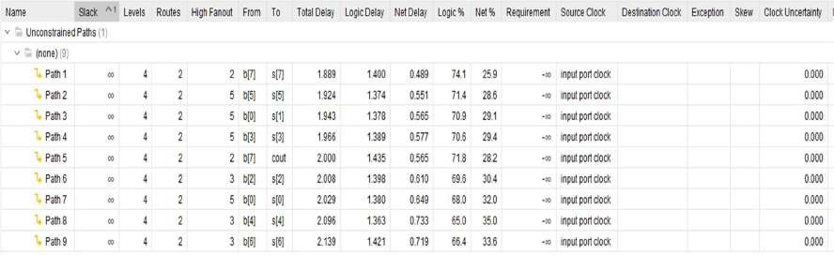

**Area:**

The image shows the **Post-Implementation Utilization Report** of an FPGA design. It indicates resource usage:

* **LUT** utilized only **1%**.
* 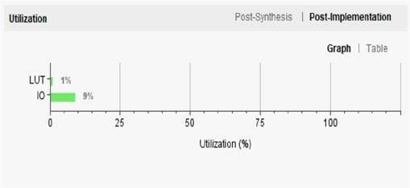**IO** has the highest usage at **9%**.

**RTL Schematic:**

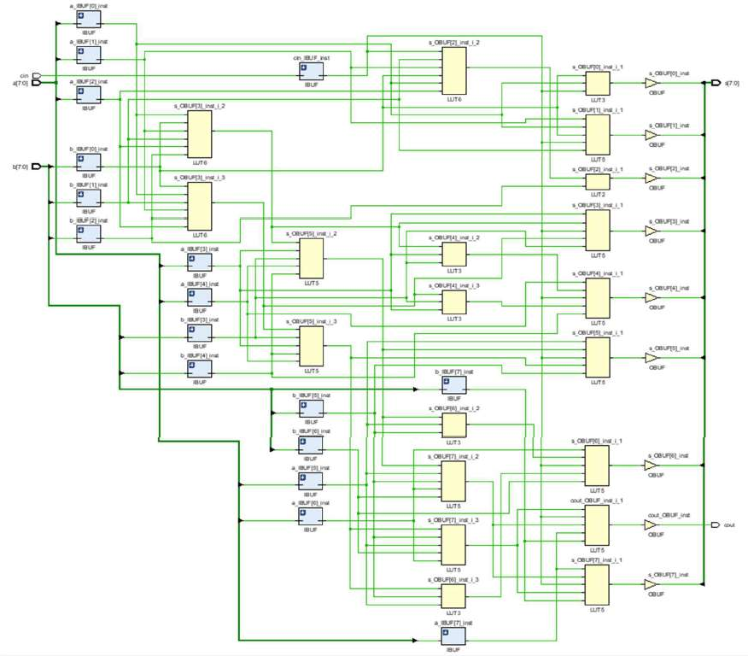

# Carry Save Adder

**Introduction:**

### This Verilog code implements an **8-bit Carry Save Adder (CSA)**, which efficiently adds three binary numbers (a, b, cin) by minimizing carry propagation. In the first stage, a set of full adders computes partial sums (s1) and carries (c1). In the second stage, these are further reduced using another chain of full adders to produce the final 9-bit sum (s) and a final carry- out (cout). The testbench carrysavetb verifies the design using multiple input cases. Carry Save Adders are widely used in multipliers and parallel arithmetic circuits for high-speed computation.

**Output waveform:**

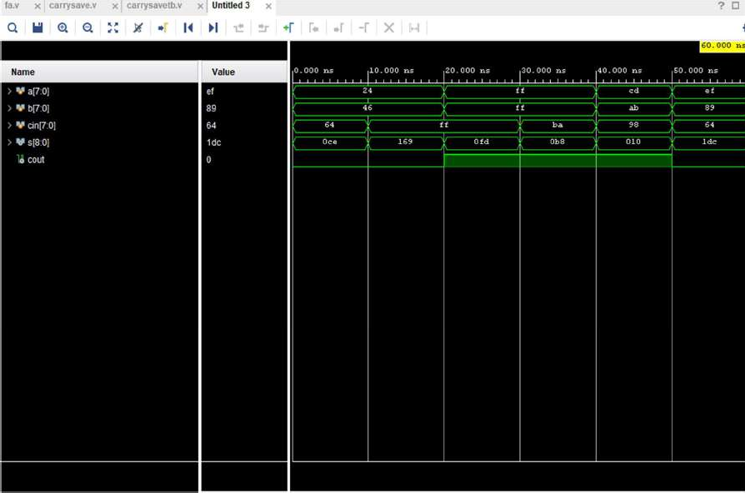

**Design Code:**

module fa(

input a, b, cin, output sum, cout);

assign sum = a^b^cin;

assign cout= (a&b)|(b&cin)|(cin&a); endmodule

module carrysave( input [7:0] a,

input [7:0] b,

input [7:0] cin,

output [8:0] s, output cout

);

wire [7:0] s1, c1;

wire [6:0] s2, c2;

genvar i; generate

for (i = 0; i < 8; i = i + 1) begin : stage1 fa fa1(a[i], b[i], cin[i], s1[i], c1[i]);

end endgenerate

fa fa2_0(s1[1], c1[0], 1'b0, s[1], c2[0]);

fa fa2_1(s1[2], c1[1], c2[0], s[2], c2[1]);

fa fa2_2(s1[3], c1[2], c2[1], s[3], c2[2]);

fa fa2_3(s1[4], c1[3], c2[2], s[4], c2[3]);

fa fa2_4(s1[5], c1[4], c2[3], s[5], c2[4]);

fa fa2_5(s1[6], c1[5], c2[4], s[6], c2[5]);

fa fa2_6(s1[7], c1[6], c2[5], s[7], c2[6]);

fa fa2_7(c1[7], c2[6], 1'b0, s[8], cout); assign s[0] = s1[0];

endmodule

**Testbench Code:**

module carrysavetb(); reg [7:0]a;

reg [7:0]b;

reg [7:0]cin;

wire [8:0]s; wire cout;

carrysave a1 (.a(a),.b(b),.cin(cin),.s(s),.cout(cout)); initial begin

a = 8'h24; b = 8'h46; cin = 8'h64; #10;

a = 8'h24; b = 8'h46; cin = 8'hFF; #10;

a = 8'hFF; b = 8'hFF; cin = 8'hFF; #10;

a = 8'hFF; b = 8'hFF; cin = 8'hBA; #10;

a = 8'hCD; b = 8'hAB; cin = 8'h98; #10;

a = 8'hEF; b = 8'h89; cin = 8'h64; #10;

$finish; end

endmodule

**Analysis:**

**Power Consumption:**

The image shows the power analysis of an FPGA design. The total on-chip power is **6.492 W**, with **8% (0.506 W)** being static power and **92% (5.986 W)** being dynamic power. The junction temperature is a safe **36.2°C**, with a thermal margin of **63.8°C**. No off-chip power is used, and the analysis confidence level is marked as **LOW**.

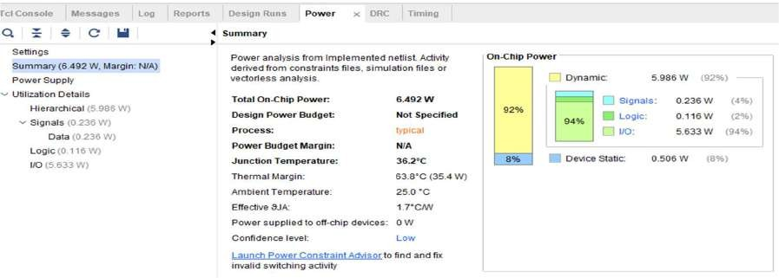

**Delay:**

The **minimum total setup delay** is **4.977 ns**. The **maximum total setup delay** is **6.234 ns**.

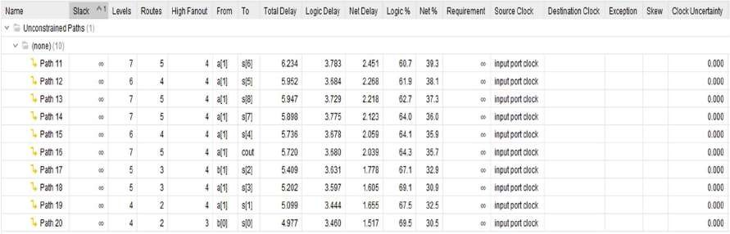

The **minimum total hold delay** is **1.916 ns**. The **maximum total hold delay** is **2.206 ns**.

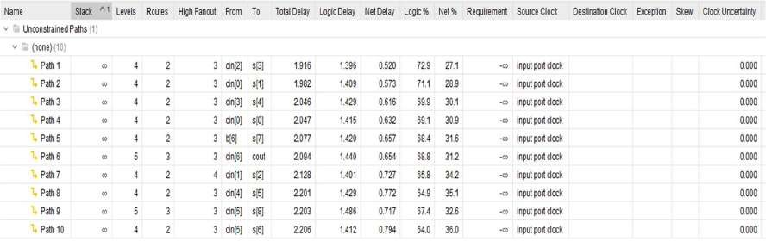

**Area:**

The image shows the **Post-Implementation Utilization Report** of an FPGA design. It indicates resource usage:

* **LUT** utilized only **1%**.
* 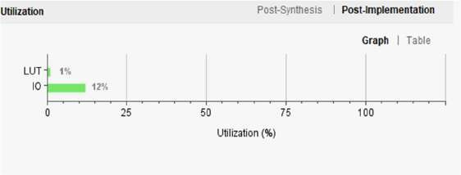**IO** has the highest usage at **12%**.

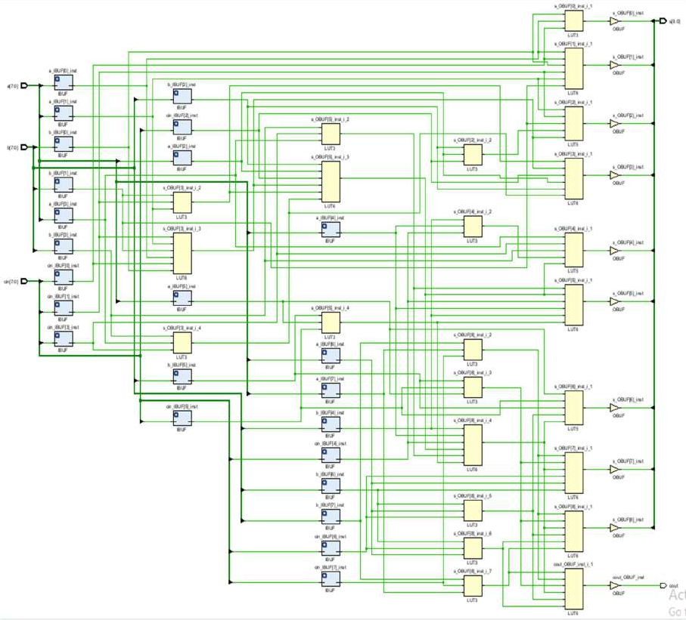**RTL Schematic:**

# Adder-Subtractor

**Introduction:**

This Verilog design implements an 8-bit Add/Subtract arithmetic unit with an integrated accumulator, enabling sequential operations while preserving the cumulative result over time. The module takes two 8-bit inputs a and b, and uses a control signal ctrl to determine the operation mode—performing addition when ctrl = 0 and subtraction when ctrl = 1.

The arithmetic operation is executed synchronously on the rising edge of the clock signal (clk), and the computed output is stored in the result register. Additionally, the design maintains an accumulator register that is updated with the new result after each clock cycle, effectively holding the running sum or difference based on the control logic. If the asynchronous reset signal rst is asserted, both result and accumulator are reset to zero, ensuring proper initialization or reinitialization during simulation or in hardware.

The associated testbench addsubtb rigorously validates the module by applying various combinations of inputs and control signals under timed clock conditions, checking correctness across different arithmetic scenarios including alternating addition and subtraction, edge conditions like zero inputs, and the influence of reset behavior. This design is particularly useful in digital processing systems that require continuous accumulation or comparison of results, such as in signal processing pipelines, real-time monitoring applications, or microcontroller-based computational blocks.

**Output waveform:**

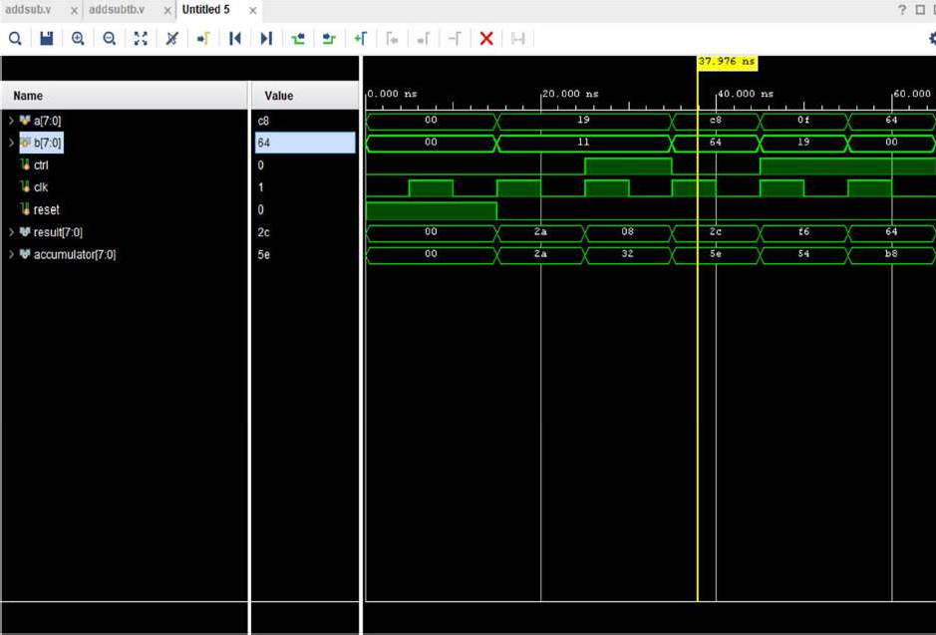

**Design Code:**

timescale 1ns / 1ps module addsub (

input [7:0] a,

input [7:0] b, input ctrl, input clk, input reset,

output reg [7:0] result, output reg [7:0] accumulator

);

wire [7:0] b_in;

wire [7:0] sum; wire carry;

assign b_in = ctrl ? ~b + 8'b00000001 : b; assign {carry, sum} = a + b_in;

always @(posedge clk or posedge reset) begin if (reset) begin

accumulator <= 8'b0; result <= 8'b0;

end else begin result <= sum;

accumulator <= accumulator + sum; end

end endmodule

**Testbench Code:**

module addsubtb; reg [7:0] a;

reg [7:0] b;

reg ctrl; reg clk; reg reset;

wire [7:0] result;

wire [7:0] accumulator;

// Instantiate the design (update module name if needed) addsub uut (

.a(a), .b(b), .ctrl(ctrl), .clk(clk), .reset(reset),

.result(result), .accumulator(accumulator)

);

initial begin clk = 0;

reset = 1;

a = 0; b = 0; ctrl = 0;

#15;

reset = 0;

a = 8'd25; b = 8'd17; ctrl = 0; #10;

a = 8'd25; b = 8'd17; ctrl = 1; #10;

a = 8'd200; b = 8'd100; ctrl = 0; #10;

a = 8'd15; b = 8'd25; ctrl = 1; #10;

a = 8'd100; b = 8'd0; ctrl = 1; #10;

$finish; end

always #5 clk = ~clk; endmodule

**Analysis:**

**Power Consumption:**

The image shows the power analysis of an FPGA design. The total on-chip power is **25.027 W**, with **4% (0.925 W)** being static power and **96% (24.102 W)** being dynamic power. The junction temperature is a safe **68.3°C**, with a thermal margin of **31.7°C**. No off-chip power is used, and the analysis confidence level is marked as **LOW**.

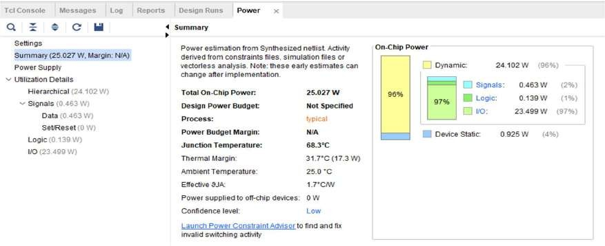

**Delay:**

The **minimum total setup delay** is **1.645 ns**. The **maximum total setup delay** is **1.789 ns**.

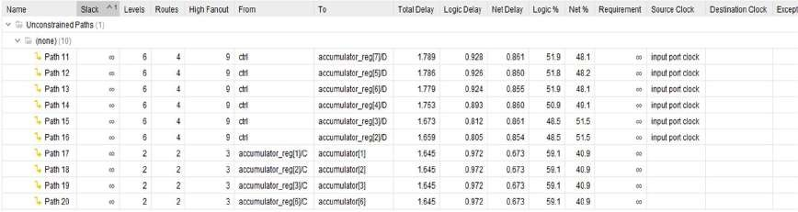

The **minimum total hold delay** is **0.133 ns**. The **maximum total hold delay** is **0.411 ns**.

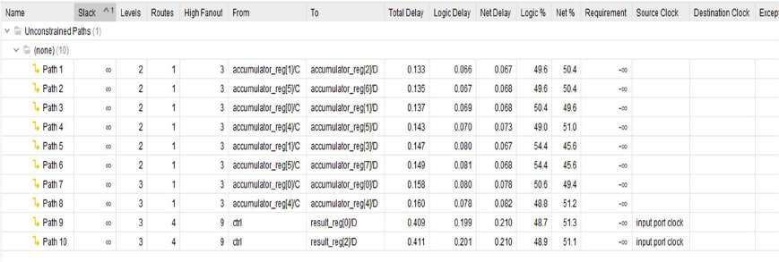

**Area:**

The image shows the **Post-Implementation Utilization Report** of an FPGA design. It indicates resource usage:

* **LUT** and **FF** are each utilized only **1%**.
* 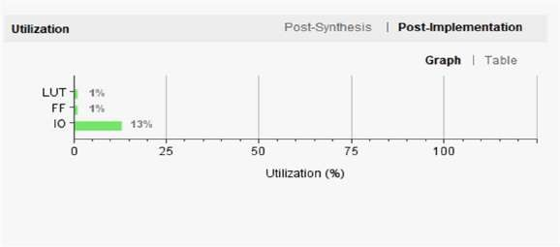**IO** has the highest usage at **13%**.

**RTL Schematic:**

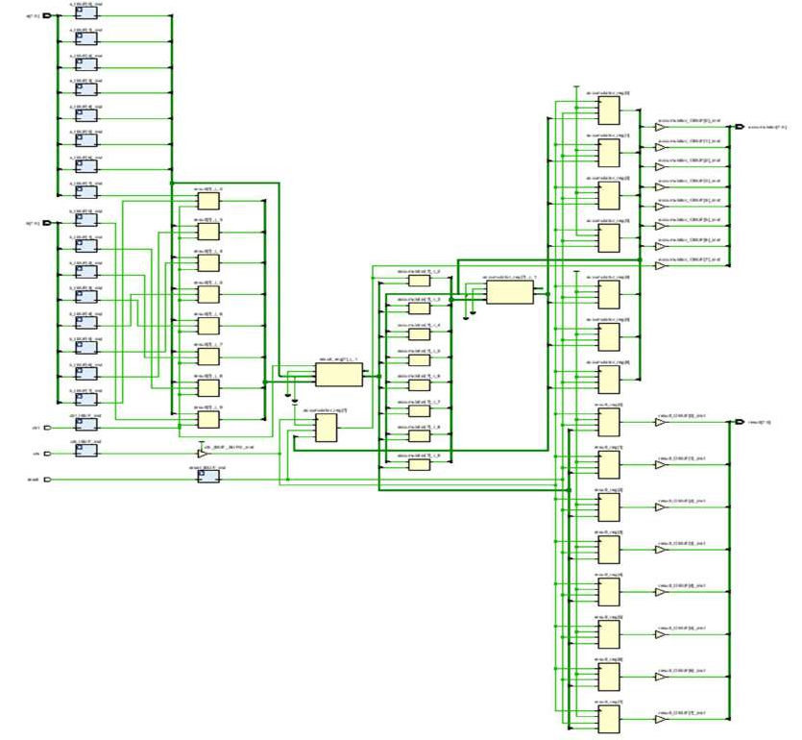

# Booth’s Multiplier

**Introduction:**

### This Verilog code implements **Booth’s Multiplication Algorithm** for signed 8-bit integers. The boothmul module multiplies two 8-bit inputs (multiplicand and multiplier) using an arithmetic shift-and-add/subtract technique. It produces a 16-bit product op, and a busy signal indicates ongoing computation. The logic checks bit pairs (Q[0] and Q_1) to decide whether to add, subtract, or shift. An alu module performs both addition and subtraction using two's complement logic. The testbench boothmultb verifies the multiplier with multiple input scenarios (positive and negative numbers), using clock-driven operations and control signals (start, load_a, load_b) for simulation control.

**Output waveform:**

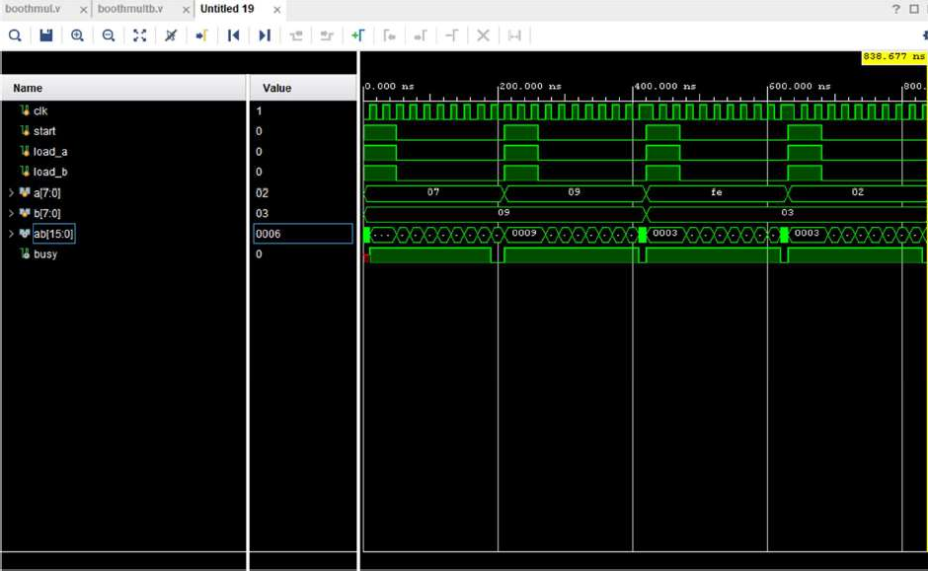

**Design Code:**

module boothmul(op, busy, mutipicand, multiplier, clk, start,load_a,load_b); output [15:0] op;

output busy;

input [7:0] mutipicand, multiplier; input clk, start,load_a,load_b;

reg [7:0] A, Q, M;

reg Q_1;

reg [3:0] count;

wire [7:0] sum, difference;

always @(posedge clk) begin

if (load_a & load_b ) begin if (start) begin

A <= 8'b0;

M <= mutipicand; Q <= multiplier; Q_1 <= 1'b0;

count <= 4'b0; end

end

else begin

case ({Q[0], Q_1})

2'b0_1 : {A, Q, Q_1} <= {sum[7], sum, Q};

2'b1_0 : {A, Q, Q_1} <= {difference[7], difference, Q}; default: {A, Q, Q_1} <= {A[7], A, Q};

endcase

count <= count + 1'b1; end

end

alu adder (sum, A, M, 1'b0);

alu subtracter (difference, A, ~M, 1'b1);

assign op= {A, Q};

assign busy = (count < 8); endmodule

//The following is an alu.

//It is an adder, but capable of subtraction:

//Recall that subtraction means adding the two's complement--

//a - b = a + (-b) = a + (inverted b + 1)

//The 1 will be coming in as cin (carry-in) module alu(out, a, b, cin);

output [7:0] out;

input [7:0] a;

input [7:0] b; input cin;

assign out = a + b + cin; endmodule

**Testbench Code:**

module boothmultb;

reg clk, start,load_a,load_b; reg [7:0] a, b;

wire [15:0] ab; wire busy;

boothmul multiplier1(ab, busy, a, b, clk, start,load_a,load_b); initial begin

clk = 0;

a = 7; b = 9;load_a=1;load_b=1; start = 1; #50 start = 0;load_a=0;load_b=0; #160

clk = 0;

a = 9; b = 9;load_a=1;load_b=1;start = 1; #50 start = 0;load_a=0;load_b=0; #160

clk = 0;

a = -2; b = 3;load_a=1;load_b=1; start = 1; #50 start = 0;load_a=0;load_b=0; #160

clk = 0;

a = 2; b = 3;load_a=1;load_b=1; start = 1; #50 start = 0;load_a=0;load_b=0; #160

$finish;

End

always #10 clk = !clk; endmodule

**Analysis:**

**Power Consumption:**

The image shows the power analysis of an FPGA design. The total on-chip power is **8.349 W**, with **6% (0.529 W)** being static power and **94% (7.819 W)** being dynamic power. The junction temperature is a safe **39.4°C**, with a thermal margin of **60.6°C**. No off-chip power is used, and the analysis confidence level is marked as **LOW**.

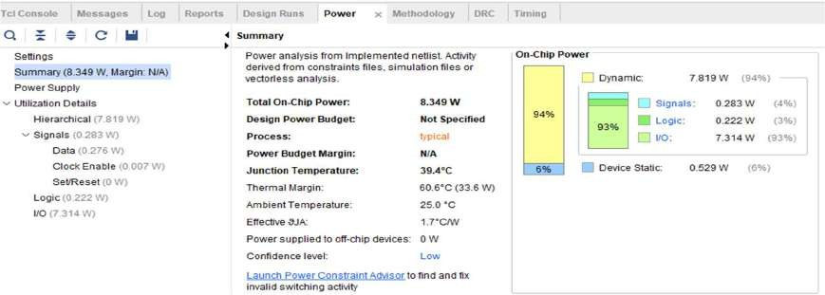

**Delay:**

The **minimum total setup delay** is **3.173 ns**. The **maximum total setup delay** is **3.479 ns**.

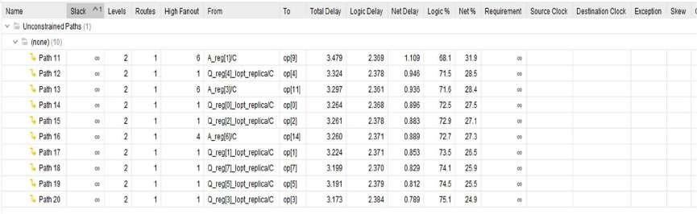

The **minimum total hold delay** is **0.101 ns**. The **maximum total hold delay** is **0.133 ns**.

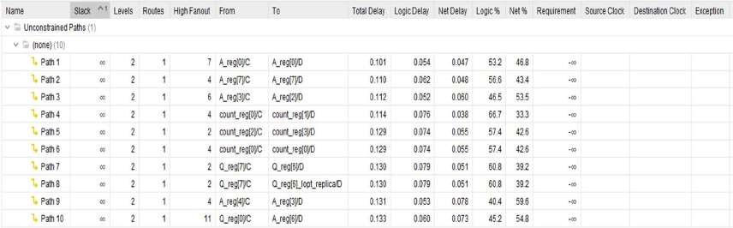

**Area:**

The image shows the **Post-Implementation Utilization Report** of an FPGA design. It indicates resource usage:

* **LUT** and **FF** are each utilized only **1%**.
* 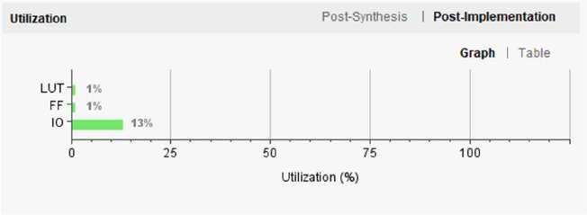**IO** has the highest usage at **13%**.

**RTL Schematic:**

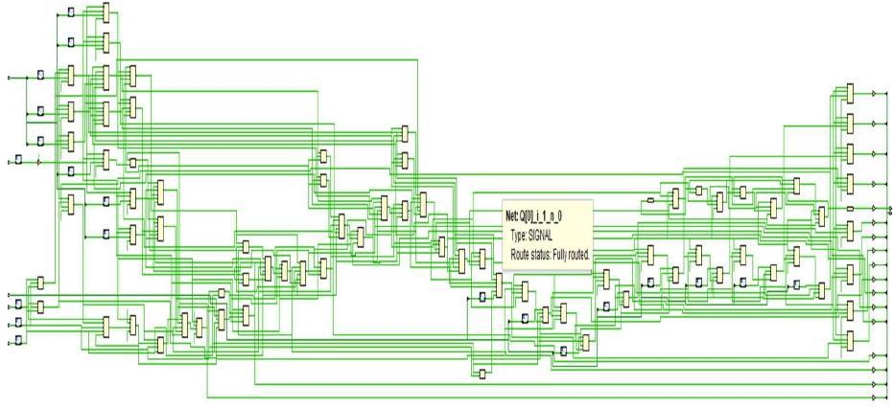

# Wallace Tree Multiplier

**Introduction:**

### This Verilog code implements an **8×8 Wallace Tree Multiplier**, which efficiently multiplies two 8-bit unsigned integers using **half adders (HA)** and **full adders (FA)**. The wallacemul module generates partial products and reduces them in stages through parallel addition using a tree structure, significantly improving speed compared to ripple-carry adders. The result is a 16-bit product computed on the rising edge of a clock signal. The testbench wallacemultb applies various test inputs (including edge cases like 255×255) and observes the output using

$monitor. It also generates a clock signal and performs timed input assignments to verify correct functionality.

**Output waveform:**

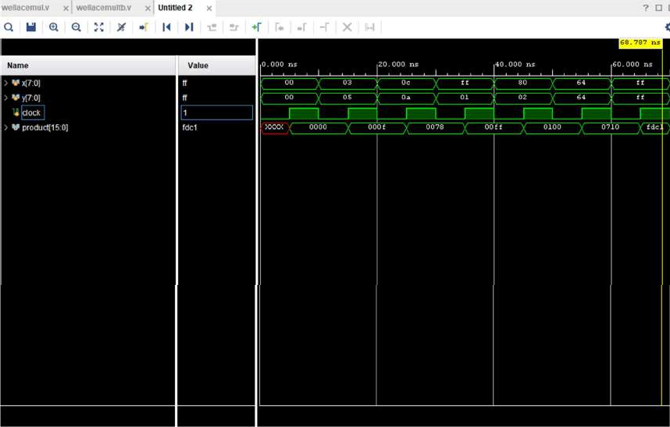

**Design Code:**

module HA(a,b,sum,carry); input a,b;

output sum,carry; assign sum=a^b; assign carry=a&b; endmodule

module FA(a,b,cin,sum,carry); input a,b,cin;

output sum,carry; reg T1,T2,T3,carry; assign sum=a^b^cin;

always @(a or b or cin) begin

T1=a&b; T2=a&cin; T3=a&cin; carry=T1|T2|T3; end

endmodule

module wallacemul(output reg [15:0] product, input [7:0] x, y, input clock); reg p [7:0][7:0]; // array which stores the partial products

wire [55:0] s ,c ; //iintermediate sum and carry integer i,j;

always@(y, x) //x is multiplicand AND y is multiplier begin

for ( i = 0; i <= 7; i = i + 1) for ( j = 0; j <= 7; j = j + 1) p[j][i] <= x[j] & y[i];

end

HA ha_11 ( .sum(s[0]), .carry(c[0]), .a(p[1][0]), .b( p[0][1])); //P1

FA fa_21 ( .sum(s[1]), .carry(c[1]), .a(p[2][0]), .b( p[1][1]), .cin( (c[0]) ) );

HA ha_21 ( .sum(s[2]), .carry(c[2]), .a(p[0][2]), .b( s[1])); //P2

FA fa_31 ( .sum(s[3]), .carry(c[3]), .a(p[3][0]), .b( p[2][1]), .cin( c[1]) );

FA fa_32 ( .sum(s[4]), .carry(c[4]), .a(p[1][2]), .b( s[3]), .cin( c[2]) );

HA ha_31 ( .sum(s[5]), .carry(c[5]), .a(p[0][3]), .b( s[4])); //P3

FA fa_41 ( .sum(s[6]), .carry(c[6]), .a(p[4][0]), .b( p[3][1]), .cin( c[3]) );

FA fa_42 ( .sum(s[7]), .carry(c[7]), .a(p[2][2]), .b(s[6]), .cin( c[4]) );

FA fa_43 ( .sum(s[8]), .carry(c[8]), .a(p[1][3]), .b(s[7]), .cin( c[5]) );

HA ha_41 ( .sum(s[9]), .carry(c[9]), .a(p[0][4]), .b( s[8])); //P4

FA fa_51 ( .sum(s[10]), .carry(c[10]), .a(p[5][0]), .b( p[4][1]), .cin( c[6]) );

FA fa_52 ( .sum(s[11]), .carry(c[11]), .a(p[3][2]), .b( s[10]), .cin( c[7]) );

FA fa_53 ( .sum(s[12]), .carry(c[12]), .a(p[2][3]), .b( s[11]), .cin( c[8]) );

FA fa_54 ( .sum(s[13]), .carry(c[13]), .a(p[1][4]), .b( s[12]), .cin( c[9]) );

|  |  |
| --- | --- |
| HA ha_55 ( .sum(s[14]), .carry(c[14]), .a(p[0][4]), .b( s[13])); | //P5 |
| FA fa_61 ( .sum(s[15]), .carry(c[15]), .a(p[6][0]), .b( p[5][1]), .cin( c[10]) ); |  |
| FA fa_62 ( .sum(s[16]), .carry(c[16]), .a(p[4][2]), .b( s[15]), .cin( c[11]) ); |  |
| FA fa_63 ( .sum(s[17]), .carry(c[17]), .a(p[3][3]), .b( s[16]), .cin( c[12]) ); |  |
| FA fa_64 ( .sum(s[18]), .carry(c[18]), .a(p[2][4]), .b( s[17]), .cin( c[13]) ); |  |
| HA ha_61 ( .sum(s[19]), .carry(c[19]), .a(p[1][5]), .b( s[18])); |  |
| HA ha_42 ( .sum(s[20]), .carry(c[20]), .a(p[0][6]), .b( s[19])); | //P6 |
| FA fa_71 ( .sum(s[21]), .carry(c[21]), .a(p[7][0]), .b( p[6][1]), .cin( c[15]) ); |  |
| FA fa_72 ( .sum(s[22]), .carry(c[22]), .a(p[5][2]), .b( s[21]), .cin( c[16]) ); |  |
| FA fa_73 ( .sum(s[23]), .carry(c[23]), .a(p[4][3]), .b( s[22]), .cin( c[17]) ); |  |
| FA fa_74 ( .sum(s[24]), .carry(c[24]), .a(p[3][4]), .b( s[23]), .cin( c[18]) ); |  |
| FA fa_75 ( .sum(s[25]), .carry(c[25]), .a(p[2][5]), .b( s[24]), .cin( c[19]) ); |  |
| FA fa_76 ( .sum(s[26]), .carry(c[26]), .a(p[1][6]), .b( s[25]), .cin( c[20]) ); |  |
| HA ha_71 ( .sum(s[27]), .carry(c[27]), .a(p[0][7]), .b( s[26])); | //P7 |
| FA fa_81 ( .sum(s[28]), .carry(c[28]), .a(p[7][1]), .b( p[6][2]), .cin( c[21]) ); |  |
| FA fa_82 ( .sum(s[29]), .carry(c[29]), .a(p[5][3]), .b( s[28]), .cin( c[22]) ); |  |
| FA fa_83 ( .sum(s[30]), .carry(c[30]), .a(p[4][4]), .b( s[29]), .cin( c[23]) ); |  |
| FA fa_84 ( .sum(s[31]), .carry(c[31]), .a(p[3][5]), .b( s[30]), .cin( c[24]) ); |  |
| FA fa_85 ( .sum(s[32]), .carry(c[32]), .a(p[2][6]), .b( s[31]), .cin( c[25]) ); |  |
| FA fa_86 ( .sum(s[33]), .carry(c[33]), .a(p[1][7]), .b( s[32]), .cin( c[26]) ); |  |
| HA ha_81 ( .sum(s[34]), .carry(c[34]), .a(s[33]), .b( c[27])); | //P8 |
| FA fa_91 ( .sum(s[35]), .carry(c[35]), .a(p[7][2]), .b( p[6][3]), .cin( c[28]) ); |  |
| FA fa_92 ( .sum(s[36]), .carry(c[36]), .a(p[5][4]), .b( s[35]), .cin( c[29]) ); |  |
| FA fa_93 ( .sum(s[37]), .carry(c[37]), .a(p[4][5]), .b( s[36]), .cin( c[30]) ); |  |
| FA fa_94 ( .sum(s[38]), .carry(c[38]), .a(p[3][6]), .b( s[37]), .cin( c[31]) ); |  |
| FA fa_95 ( .sum(s[39]), .carry(c[39]), .a(p[2][7]), .b( s[38]), .cin( c[32]) ); |  |
| FA fa_96 ( .sum(s[40]), .carry(c[40]), .a(s[39]), .b( c[33]), .cin( c[34]) ); | //P9 |
| FA fa_101 ( .sum(s[41]), .carry(c[41]), .a(p[7][3]), .b( p[6][4]), .cin( c[35]) ); |  |
| FA fa_102 ( .sum(s[42]), .carry(c[42]), .a(p[5][5]), .b( s[41]), .cin( c[36]) ); |  |
| FA fa_103 ( .sum(s[43]), .carry(c[43]), .a(p[4][6]), .b( s[42]), .cin( c[37]) ); |  |
| FA fa_104 ( .sum(s[44]), .carry(c[44]), .a(p[3][7]), .b( s[43]), .cin( c[38]) ); |  |
| FA fa_105 ( .sum(s[45]), .carry(c[45]), .a(s[44]), .b( c[39]), .cin( c[40]) ); | //P10 |
| FA fa_111 ( .sum(s[46]), .carry(c[46]), .a(p[7][4]), .b( p[6][5]), .cin( c[41]) ); |  |
| FA fa_112 ( .sum(s[47]), .carry(c[47]), .a(p[5][6]), .b( s[46]), .cin( c[42]) ); |  |
| FA fa_113 ( .sum(s[48]), .carry(c[48]), .a(p[4][7]), .b( s[47]), .cin( c[43]) ); |  |
| FA fa_114 ( .sum(s[49]), .carry(c[49]), .a(s[48]), .b( c[44]), .cin( c[45]) ); | //P1 |
| FA fa_121 ( .sum(s[50]), .carry(c[50]), .a(p[7][5]), .b( p[6][6]), .cin( c[46]) ); |  |
| FA fa_122 ( .sum(s[51]), .carry(c[51]), .a(p[5][7]), .b(s[50]), .cin( c[47]) ); |  |
| FA fa_123 ( .sum(s[52]), .carry(c[52]), .a(s[51]), .b(c[48]), .cin( c[49]) ); | //P12 |
| FA fa_131 ( .sum(s[53]), .carry(c[53]), .a(p[7][6]), .b( p[6][7]), .cin( c[50]) ); |  |
| FA fa_132 ( .sum(s[54]), .carry(c[54]), .a(s[53]), .b(c[51]), .cin( c[52]) ); | //P13 |
| FA fa_141 ( .sum(s[55]), .carry(c[55]), .a(p[7][7]), .b(c[53]), .cin( c[54]) ); | //P14 |
| always@(posedge clock) |  |
| product <= |  |

{c[55],s[55],s[54],s[52],s[49],s[45],s[40],s[34],s[27],s[20],s[14],s[9],s[5],s[2],s[0],p[0][0]};

//p[0][0]=P0

endmodule

Test bench:

module wallacemultb;

// Inputs reg [7:0] x;

reg [7:0] y; reg clock;

// Output

wire [15:0] product;

// Instantiate the Unit Under Test (UUT) wallacemul uut (

.product(product),

.x(x),

.y(y),

.clock(clock)

);

// Clock generation

always #5 clock = ~clock; // 100MHz clock (10ns period) initial begin

// Initialize Inputs clock = 0;

x = 0;

y = 0;

// Wait for global reset #10;

// Apply test vectors

x = 8'b00000011; y = 8'b00000101; // 3 x 5 = 15 #10;

x = 8'd12; y = 8'd10; // 12 x 10 = 120 #10;

x = 8'd255; y = 8'd1; // 255 x 1 = 255 #10;

x = 8'd128; y = 8'd2; // 128 x 2 = 256 #10;

x = 8'd100; y = 8'd100; // 100 x 100 = 10000 #10;

x = 8'd255; y = 8'd255; // 255 x 255 = 65025 #10;

// Finish simulation

$finish; end

initial begin

$monitor("Time = %0t | x = %d | y = %d | product = %d", $time, x, y, product); end

endmodule

**Analysis:**

**Power Consumption:**

The image shows the power analysis of an FPGA design. The total on-chip power is **20.027 W**, with **4% (0.783 W)** being static power and **86% (20.027 W)** being dynamic power. The junction temperature is a safe **61.0°C**, with a thermal margin of **39.0°C**. No off-chip power is used, and the analysis confidence level is marked as **LOW**.

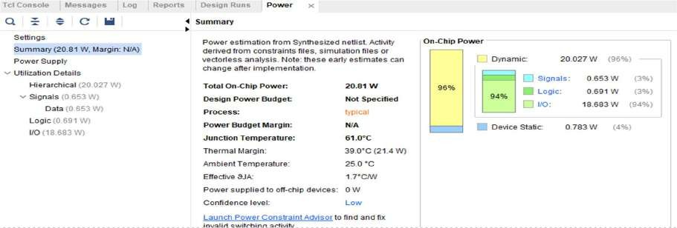

**Delay:**

The **minimum total setup delay** is **2.558 ns**. The **maximum total setup delay** is **3.328 ns**.

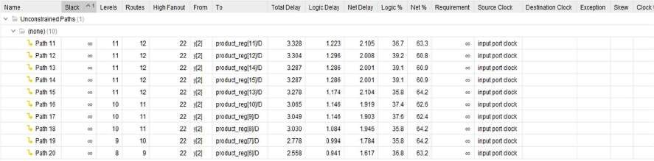

The **minimum total hold delay** is **0.477 ns**. The **maximum total hold delay** is **0.580 ns**.

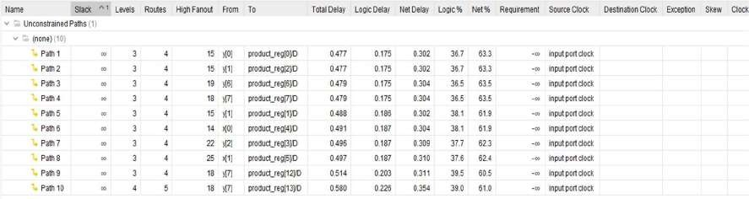

**Area:**

The image shows the **Post-Implementation Utilization Report** of an FPGA design. It indicates resource usage:

* **LUT** and **FF** are each utilized only **1%**.
* 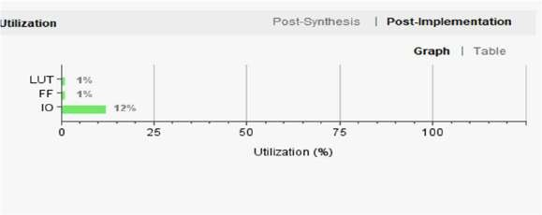**IO** has the highest usage at **12%**.

**RTL Schematic:**

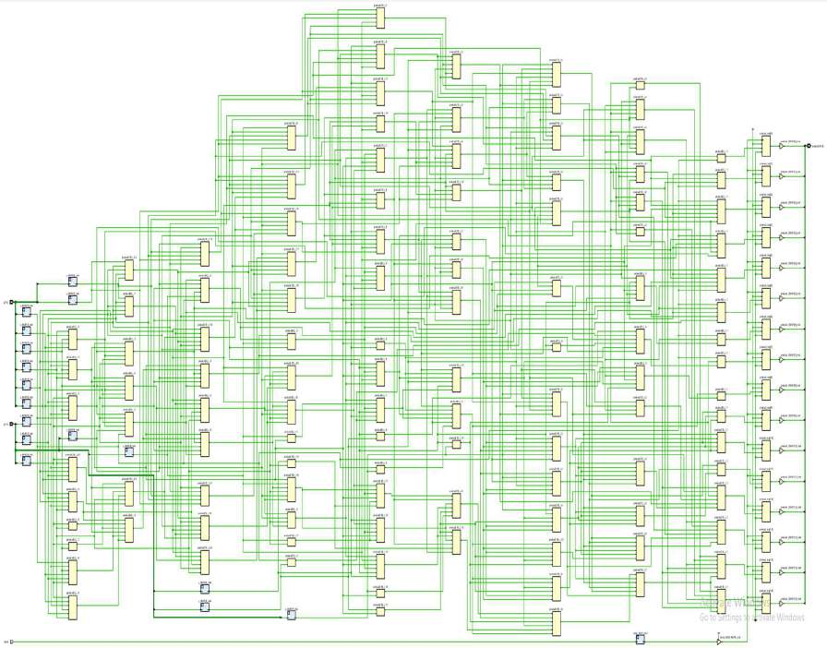

# Serial Unsigned Multiplier

## Introduction:

The given Verilog code implements an **8-bit Serial Unsigned Multiplier** using a shift-and-add method. It multiplies two 8-bit inputs (A and B) and produces a 16-bit product (Z). The module uses an accumulator (acc), a counter, and conditional addition based on the LSB of the multiplier. An external start signal (disp) initiates the operation, and a done flag indicates completion. The testbench applies various test cases, including edge and mid-range values, to verify correctness. This design demonstrates a clock-driven, resource-efficient approach to unsigned multiplication using serial computation and control signals.

# Output Waveform:

**Design code:**

module Adder_8bit ( input [7:0] A,

input [7:0] B,

output [7:0] Sum, output Cout

);

wire [7:0] carry;

// Full adders for each bit

assign {carry[0], Sum[0]} = A[0] + B[0];

assign {carry[1], Sum[1]} = A[1] + B[1] + carry[0];

assign {carry[2], Sum[2]} = A[2] + B[2] + carry[1];

assign {carry[3], Sum[3]} = A[3] + B[3] + carry[2];

assign {carry[4], Sum[4]} = A[4] + B[4] + carry[3];

assign {carry[5], Sum[5]} = A[5] + B[5] + carry[4];

assign {carry[6], Sum[6]} = A[6] + B[6] + carry[5];

assign {Cout, Sum[7]} = A[7] + B[7] + carry[6];

endmodule

module SerialUnSignedMul_8bit ( input clk,

input rst, input disp,

input [7:0] A, // multiplicand input [7:0] B, // multiplier

output reg [15:0] Z, // final product output reg Wait,

output reg done

);

reg [7:0] multiplicand;

reg [16:0] acc; // Accumulator for partial product reg [7:0] multiplier;

reg [3:0] count;

wire [8:0] x,y;

Adder_8bit Adder1(A,acc[15:8],x[7:0],x[8]);

Adder_8bit Adder2(0,acc[15:8],y[7:0],y[8]);

always @(posedge clk or posedge rst) begin if (rst) begin

multiplicand <= 0;

multiplier <= 0;

acc <= 0;

Z <= 0;

count <= 0;

done <= 0;

Wait <= 0; end

else if (disp && !Wait) begin

// Latch values, initialize multiplicand <= A; multiplier <= B;

count <= 8;

done <= 0;

Wait <= 1;

end else if (Wait) begin if (multiplier[0] == 1)

acc[16:8] = x; else

acc[16:8] = y;

multiplier = multiplier >> 1; acc = acc >> 1;

count = count - 1;

if (count == 0) begin Z <= acc;

done <= 1;

Wait <= 0; end

end end

always@(posedge disp) begin acc <= 0;

Z <= 0;

end endmodule

**Testbench code:**

module tb_SerialUnSignedMul(); reg clk, rst, start;

reg [7:0] A, B;

wire [15:0] Z;

wire Wait; // not used, but wired wire done;

// Instantiate the multiplier module SerialUnSignedMul_8bit DUT (

.clk(clk),

.rst(rst),

.disp(start),

.A(A),

.B(B),

.Z(Z),

.Wait(Wait),

.done(done)

);

// Clock Generation - 10 time unit period initial begin

clk = 0;

forever #5 clk = ~clk; end

initial begin

// Initial reset

rst = 1; start = 0; A = 0; B = 0;

#20;

rst = 0;

run_test(8'd6, 8'd7); // 6 * 7 = 42

run_test(8'd15, 8'd15); // 15 * 15 = 225 run_test(8'd255, 8'd1); // Max * 1 = 255 run_test(8'd0, 8'd128); // 0 * 128 = 0

run_test(8'd128, 8'd128); // 128 * 128 = 16384

run_test(8'd255, 8'd255); // Max * Max = 65025 run_test(8'd1, 8'd1); // 1 * 1 = 1 run_test(8'd255, 8'd0); // Max * 0 = 0 run_test(8'd0, 8'd0); // 0 * 0 = 0

run_test(8'd100, 8'd200); // 100 * 200 = 20000

run_test(8'd33, 8'd3); // 33 * 3 = 99

run_test(8'd77, 8'd11); // 77 * 11 = 847

run_test(8'd18, 8'd144); // 18 * 144 = 2592

run_test(8'd200, 8'd100); // symmetry check run_test(8'd50, 8'd50); // 50 * 50 = 2500

$finish; end

task run_test(input [7:0] a, input [7:0] b); begin

A = a;

B = b;

start = 1;

#20 start = 0; wait(done);

$display("A = %d, B = %d, Z = %d", A, B, Z); #10;

end endtask

endmodule

**Analysis:**

**Power Consumption:**

The image shows the power analysis of an FPGA design. The total on-chip power is **1.43 W**, with **32% (0.458 W)** being static power and **68% (0.972 W)** being dynamic power. The junction temperature is a safe **27.5°C**, with a thermal margin of **72.5°C**. No off-chip power is used, and the analysis confidence level is marked as **LOW**.

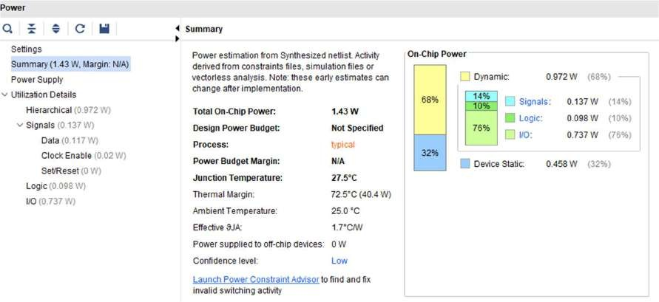

**Delay:**

The **minimum total setup delay** is **3.036 ns**. The **maximum total setup delay** is **3.531 ns**.

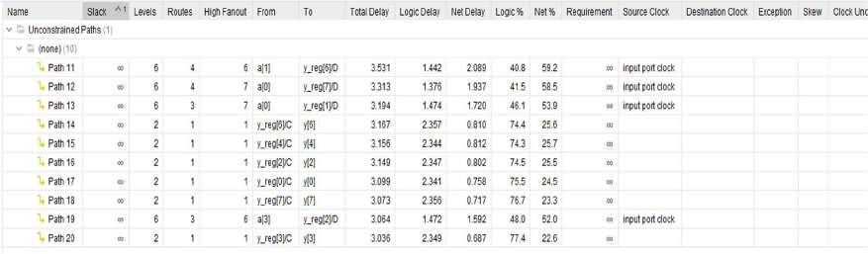

The **minimum total hold delay** is **0.099 ns**. The **maximum total hold delay** is **0.118 ns**.

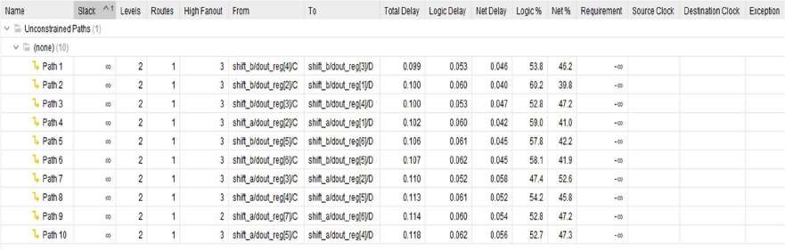

**Area:**

The image shows the **Post-Implementation Utilization Report** of an FPGA design. It indicates resource usage:

* **LUT** and **FF** are each utilized only **1%**.
* 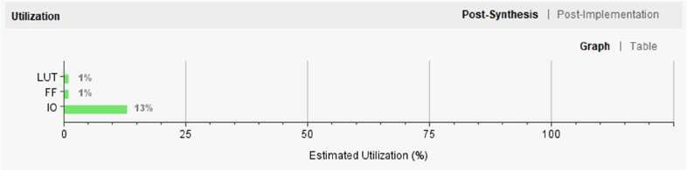**IO** has the highest usage at **13%**.

**RTL Schematic:**

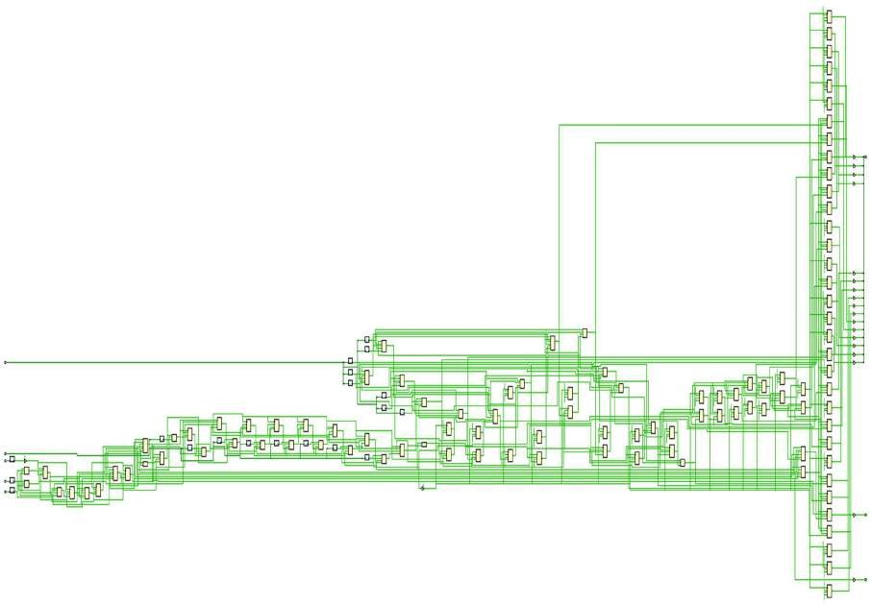

# ALU

**Introduction:**

### This Verilog code defines an 8-bit ALU (alu) with operations selected via 3 control bits (s2, s1, s0). It performs addition, subtraction, shift (left/right), rotate (left/right), and bitwise NOT using internal shift registers (usr). The ALU uses parallel load and control signals for each operand (a, b). A testbench (alu_tb) initializes the system, loads data, and applies different operations with clock cycles. It tests all supported operations while monitoring the output y and internal state reg_b_out. This setup simulates and verifies the correct functionality of the ALU under various input conditions.

**Output waveform:**

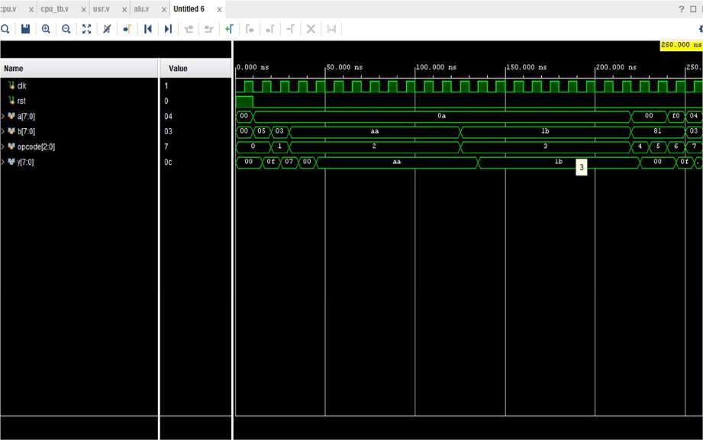

**Design code:**

module alu ( input [7:0] a,

input [7:0] b, input ctr, input rst, input clk,

input s0, s1, s2,

input lda, ldb, ctra, ctrb, output reg [7:0] y

);

wire [2:0] sel = {s2, s1, s0};

wire [7:0] reg_a_out, reg_b_out;

// Instantiate shift registers usr shift_a (

.clk(clk),

.rst(rst),

.sr((sel == 3'b010) && ctra), // Shift Right

.sl((sel == 3'b011) && ctra), // Shift Left

.load(lda),

.din(a),

.dout(reg_a_out)

);

usr shift_b (

.clk(clk),

.rst(rst),

.sr((sel == 3'b010) && ctrb), // Shift Right

.sl((sel == 3'b011) && ctrb), // Shift Left

.load(ldb),

.din(b),

.dout(reg_b_out)

);

always @(posedge clk or posedge rst) begin if (rst) begin

y <= 8'b0;

end else begin case (sel)

3'b000: y <= a + b; // Add 3'b001: y <= a - b; // Sub

3'b010: y <= (ctra) ? reg_a_out : (ctrb) ? reg_b_out : y; // Shift Right 3'b011: y <= (ctra) ? reg_a_out : (ctrb) ? reg_b_out : y; // Shift Left 3'b100: y <= (ctra) ? {a[0], a[7:1]} : (ctrb) ? {b[0], b[7:1]} : y; // Rotate Right

3'b101: y <= (ctra) ? {a[6:0], a[7]} : (ctrb) ? {b[6:0], b[7]} : y; // Rotate Left 3'b110: y <= (ctra) ? ~a : (ctrb) ? ~b : y; // NOT

default: y <= 8'b0;

endcase end

end endmodule

module usr ( input clk, input rst,

input sr, // shift right enable input sl, // shift left enable

input load, // parallel load enable input [7:0] din, // parallel data input output reg [7:0] dout

);

always @(posedge clk or posedge rst) begin if (rst)

dout <= 8'b0; else if (load)

dout <= din; else if (sr)

dout <= {1'b0, dout[7:1]}; // Logical shift right else if (sl)

dout <= {dout[6:0], 1'b0}; // Logical shift left

end endmodule

module alu_tb; reg [7:0] a, b; reg ctr, rst, clk; reg s0, s1, s2;

reg lda, ldb, ctra, ctrb; wire [7:0] y;

alu uut (

.a(a), .b(b), .ctr(ctr), .rst(rst), .clk(clk),

.s0(s0), .s1(s1), .s2(s2),

.lda(lda), .ldb(ldb),

.ctra(ctra), .ctrb(ctrb),

.y(y)

);

initial begin clk = 0;

forever #5 clk = ~clk; end

initial begin

$monitor("Time = %0t | y = %b | sel = %b | reg_b_out = %b",

$time, y, {s2,s1,s0}, uut.reg_b_out);

end

initial begin

rst = 1; a = 8'h0F; b = 8'hA5; s0 = 0; s1 = 0; s2 = 0;

lda = 0; ldb = 0;

ctra = 0; ctrb = 0; ctr = 0;

#10 rst = 0;

lda = 1; ldb = 1; #10;

lda = 0; ldb = 0;

// ADD (A + B)

s2 = 0; s1 = 0; s0 = 0; #10;

// SUB (A - B)

s2 = 0; s1 = 0; s0 = 1; #10;

// SHIFT RIGHT B

s2 = 0; s1 = 1; s0 = 0; // sel = 010

#10;

ctrb = 1;

#80;

ctrb = 0;

// Reload B for shift left ldb = 1;

#10;

ldb = 0;

// SHIFT LEFT B

s2 = 0; s1 = 1; s0 = 1; // sel = 011

#10;

ctrb = 1;

#80;

ctrb = 0;

#10;

s2 = 1; s1 = 0; s0 = 0;ctrb=1;ctra=0; // sel = 011 #10;

s2 = 1; s1 = 0; s0 = 1;ctrb=1;ctra=0; // sel = 011 #20;

s2 = 1; s1 = 1; s0 = 0;ctrb=0;ctra=1; // sel = 011 #10;

$stop; end

endmodule

**Analysis:**

**Power Consumption:**

The image shows the power analysis of an FPGA design. The total on-chip power is **4.062 W**, with **12% (0.481 W)** being static power and **88% (3.581 W)** being dynamic power. The junction temperature is a safe **32.0°C**, with a thermal margin of **68.0°C**. No off-chip power is used, and the analysis confidence level is marked as **LOW**.

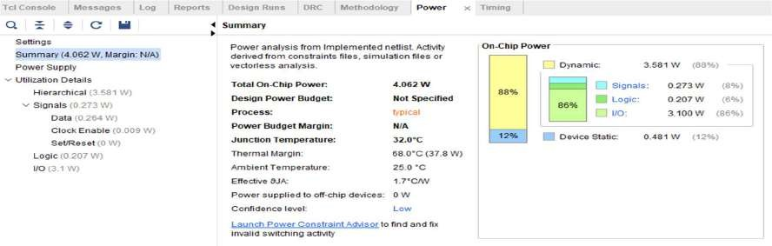

**Delay:**

The **minimum total setup delay** is **3.036 ns**. The **maximum total setup delay** is **3.531 ns**.

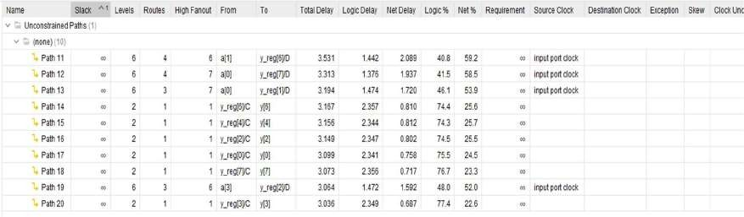

The **minimum total hold delay** is **0.099 ns**. The **maximum total hold delay** is **0.118 ns**.

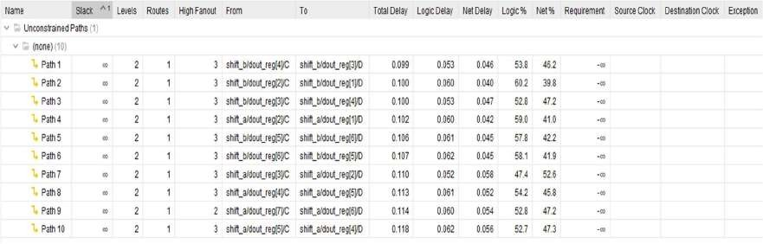

**Area:**

The image shows the **Post-Implementation Utilization Report** of an FPGA design. It indicates resource usage:

* **LUT** and **FF** are each utilized only **1%**.
* 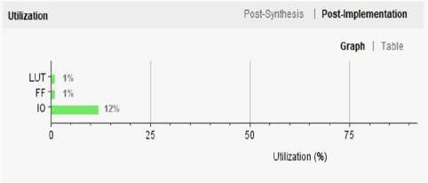**IO** has the highest usage at **12%**.

**RTL Schematic:**

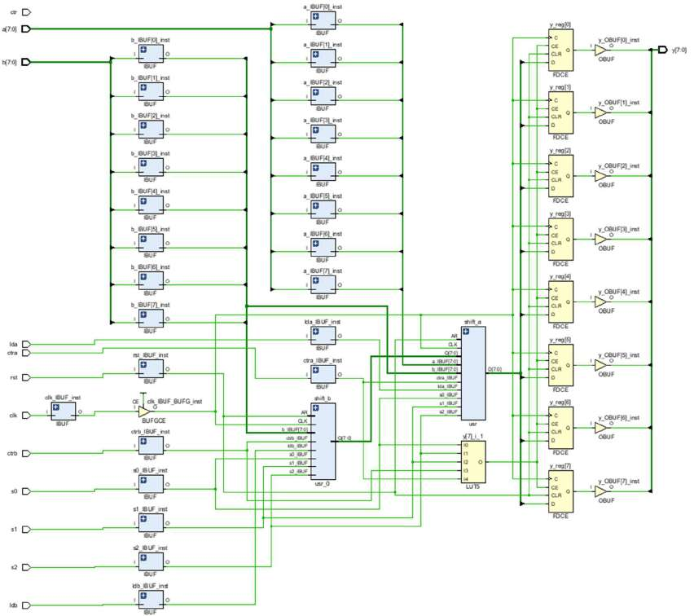

# CPU

**Introduction:**

This Verilog design implements a simple 8-bit CPU core featuring an Arithmetic Logic Unit (ALU) with built-in support for arithmetic, logic, and shift/rotate operations. The cpu module accepts two 8-bit inputs, a and b, along with a 3-bit opcode that selects the operation to be performed. Supported operations include addition, subtraction, bitwise NOT, multiplication, logical shifts (left/right), and rotate functions.

Internally, the design leverages modular components such as usr (Universal Shift Register) instances to implement shifting and rotating behaviors in a controlled and efficient manner. Based on the provided opcode, appropriate control signals are generated to trigger operations like data loading, directional shifting, and arithmetic processing. All operations are synchronized to the rising edge of the clock (clk), and a reset (rst) signal is included to initialize the system state.

The associated testbench cpu_tb applies a variety of test vectors across different opcodes and input values, using $monitor to display real-time updates of the output and internal states, thereby verifying the functional correctness of the CPU. This design demonstrates the integration of core ALU capabilities with shift logic, making it a compact and functional example of a basic synchronous CPU architecture suitable for educational and prototyping purposes.

**Output waveform:**



**Design Code:**

module cpu ( input clk, input rst, input [7:0] a,

input [7:0] b,

input [2:0] opcode,

output [7:0] y

);

wire s0, s1, s2; wire [7:0] alu_out;

assign {s2, s1, s0} = opcode; wire lda = 1'b0;

wire ldb = (opcode == 3'b010 || opcode == 3'b011); // load for shift ops

wire ctra = (opcode == 3'b000 || opcode == 3'b001 || opcode == 3'b100 || opcode == 3'b101 || opcode == 3'b110);

wire ctrb = (opcode == 3'b010 || opcode == 3'b011 || opcode == 3'b100 || opcode == 3'b101);

alu alu_inst (

.a(a),

.b(b),

.ctr(1'b1),

.rst(rst),

.clk(clk),

.s0(s0), .s1(s1), .s2(s2),

.lda(lda),

.ldb(ldb),

.ctra(ctra),

.ctrb(ctrb),

.y(alu_out)

);

assign y = alu_out; endmodule

module usr ( input clk, input rst,

input sr, // shift right enable input sl, // shift left enable

input load, // parallel load enable

input [7:0] din, // parallel data input output reg [7:0] dout

);

always @(posedge clk or posedge rst) begin if (rst)

dout <= 8'b0; else if (load)

dout <= din; else if (sr)

dout <= {1'b0, dout[7:1]}; // Logical shift right else if (sl)

dout <= {dout[6:0], 1'b0}; // Logical shift left

end endmodule

module alu ( input [7:0] a,

input [7:0] b, input ctr, input rst, input clk,

input s0, s1, s2,

input lda, ldb, ctra, ctrb, output reg [7:0] y

);

wire [2:0] sel = {s2, s1, s0};

wire [7:0] reg_a_out, reg_b_out;

usr shift_a (

.clk(clk),

.rst(rst),

.sr((sel == 3'b010) && ctra),

.sl((sel == 3'b011) && ctra),

.load(lda),

.din(a),

.dout(reg_a_out)

);

usr shift_b (

.clk(clk),

.rst(rst),

.sr((sel == 3'b010) && ctrb),

.sl((sel == 3'b011) && ctrb),

.load(ldb),

.din(b),

.dout(reg_b_out)

);

always @(posedge clk or posedge rst) begin if (rst) begin

y <= 8'b0;

end else begin case (sel)

3'b000: y <= a + b;

3'b001: y <= a - b;

3'b010: y <= (ctra) ? reg_a_out : (ctrb) ? reg_b_out : y; // Shift Right 3'b011: y <= (ctra) ? reg_a_out : (ctrb) ? reg_b_out : y; // Shift Left 3'b100: y <= (ctra) ? {a[0], a[7:1]} : (ctrb) ? {b[0], b[7:1]} : y; // Rotate Right

3'b101: y <= (ctra) ? {a[6:0], a[7]} : (ctrb) ? {b[6:0], b[7]} : y; // Rotate Left 3'b110: y <= (ctra) ? ~a : (ctrb) ? ~b : y; // NOT

3'b111: y <= a * b; // Multiply default: y <= y;

endcase end

end endmodule

**Testbench Code:**

module cpu_tb;

reg clk, rst; reg [7:0] a, b;

reg [2:0] opcode;

wire [7:0] y;

cpu uut (

.clk(clk),

.rst(rst),

.a(a),

.b(b),

.opcode(opcode),

.y(y)

);

initial begin clk = 0;

forever #5 clk = ~clk; end

initial begin

$monitor("Time=%0t | opcode=%b | a=%b | b=%b | y=%b", $time, opcode, a, b, y);

rst = 1;

a = 0;

b = 0;

opcode = 3'b000; #10 rst = 0;

// ADD: A + B

a = 8'd10; b = 8'd5; opcode = 3'b000; #10;

// SUB: A - B

a = 8'd10; b = 8'd3; opcode = 3'b001; #10;

// SHIFT RIGHT: B >> 1

b = 8'b10101010; opcode = 3'b010; #5; // assert ldb from cpu.v

#10; // load complete #80; // shift 8 bits

// SHIFT LEFT: B << 1

b = 8'b00011011; opcode = 3'b011; #5;

#10;

#80;

// ROR

a = 8'b00000000; b = 8'b10000001; opcode = 3'b100; #10;

// ROL

b = 8'b10000001; opcode = 3'b101; #10;

// NOT

a = 8'b11110000; opcode = 3'b110; #10;

// MUL

a = 8'd4; b = 8'd3; opcode = 3'b111; #10;

$stop; end

endmodule

**Analysis:**

**Power Consumption:**

The image shows the power analysis of an FPGA design. The total on-chip power is **4.62 W**, with **11% (0.486 W)** being static power and **89% (4.134 W)** being dynamic power. The junction temperature is a safe **33.0°C**, with a thermal margin of **67.0°C**. No off-chip power is used, and the analysis confidence level is marked as **LOW**.

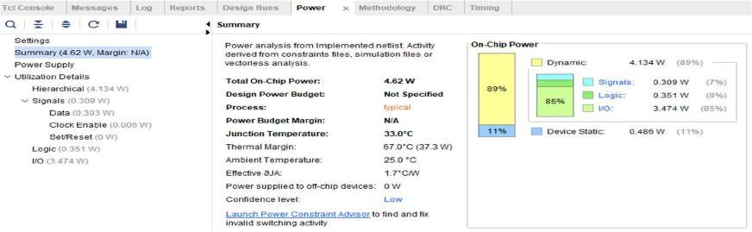

**Delay:**

The **minimum total setup delay** is **2.973 ns**. The **maximum total setup delay** is **4.619 ns**.

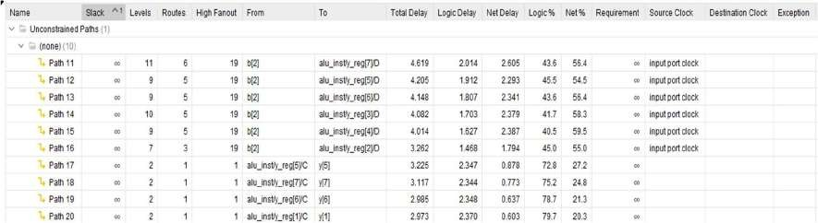

The **minimum total hold delay** is **0.130 ns**. The **maximum total hold delay** is **0.633 ns**.

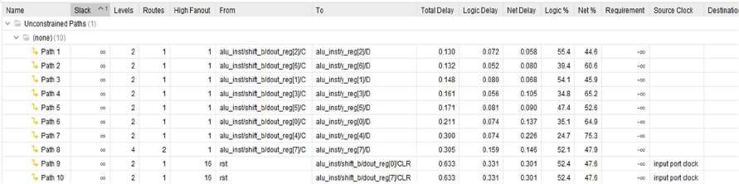

**Area:**

The image shows the **Post-Implementation Utilization Report** of an FPGA design. It indicates resource usage:

* **LUT** and **FF** are each utilized only **1%**.
* 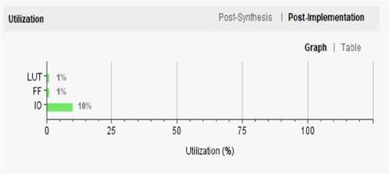**IO** has the highest usage at **10%**.

**RTL Schematic:**

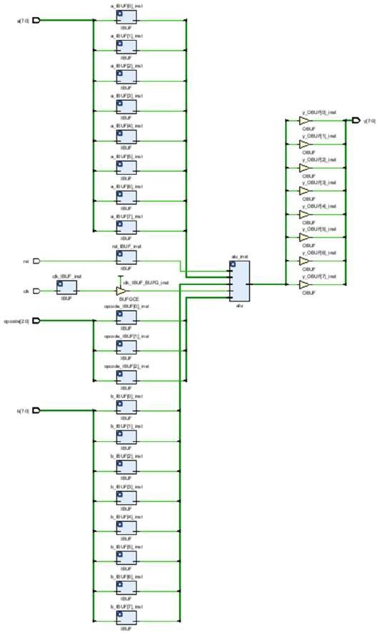

**MINI-PROJECT**

**Introduction:**

The Advanced Encryption Standard (AES) was published by the National Institute of Standards and Technology (NIST) in 2001. AES is a symmetric block cipher that is intended to replace DES as the approved standard for a wide range of applications.

The cipher takes a plaintext block size of 128 bits, or 16 bytes. The key length can be 16, 24, or 32 bytes (128, 192, or 256 bits). The algorithm is referred to as AES-128, AES-192, or AES-256, depending on the key length.

The cipher consists of N rounds, where the number of rounds depends on the key length: 10 rounds for a 16-byte key, 12 rounds for a 24-byte key, and 14 rounds for a 32-byte key. The first N - 1 rounds consist of four distinct transformation functions:

• SubBytes,

• ShiftRows,

• MixColumns, and

• AddRoundKey

The final round contains only three transformations, and there is a initial single transformation (AddRoundKey) before the first round, which can be considered Round 0. Each transformation takes one or more 4 x4 matrices as input and produces a 4x4 matrix as output. Also, the key expansion function generates N + 1 round keys, each of which is a distinct 4x4 matrix. Each round key serves as one of the inputs to the AddRoundKey transformation in each round.

**Detailed Structure:**

1. AES is not a Feistel structure. In Feistel structure, half of the data block is used to modify the other half of the data block and then the halves are swapped. AES instead processes the entire data block as a single matrix during each round using substitutions and permutation.

2. The key expanded into an array of forty-four 32-bit words.

3. Four different stages are used,

• Substitute bytes

• ShiftRows

• MixColumns

• AddRoundKey

4. The structure is simple. For both encryption and decryption, the cipher begins with an AddRoundKey stage, followed by nine rounds that each includes all four stages, followed by a tenth round of three stages.

5. Only the AddRoundKey stage makes use of the key. For this reason, the cipher begins and ends with an AddRoundKey stage. Any other stage, applied at the beginning or end, is reversible without knowledge of the key and so would add no security.

6. The AddRoundKey stage is, in effect, a form of Vernam cipher and by itself would not be formidable. This scheme is both efficient and highly secure.

7. Each stage is easily reversible. For the Substitute Byte, ShiftRows, and MixColumns stages, an inverse function is used in the decryption algorithm.

8. The decryption algorithm uses the expanded key in reverse order.

9. Once it is established that all four stages are reversible, it is easy to verify that decryption reverse order. However, the decryption algorithm is does recover the plaintext. At each horizontal point (e.g., the dashed line in the figure), State is the same for both encryption and decryption.

10. The final round of both encryption and decryption consists of only three stages.

**Substitute Bytes Transformation**

The forward substitute byte transformation is called SubBytes. It is represented by 16x16 matrix called an S-box. For each individual byte of State the value is mapped into a new byte. The leftmost 4 bits of the byte are used as a row value and the rightmost 4 bits are used as a column value. These row and column values serve as indexes into the S-box to select a unique 8-bit output value. For example, the hexadecimal value {95} references row 9, column 5 of the S-box, which contains the value {2A}.

**AddRoundKey Transformation**

In the forward add round key transformation, called AddRoundKey, the 128 bits of State are bitwise XORed with the 128 bits of the round key.

**ShiftRows Transformation**

The forward shift row transformation, also called ShiftRows.The first row of State is not altered. For the second row, a 1-byte circular left shift is performed. For the third row, a 2 byte circular left shift is performed. For the fourth row, a 3-byte circular left shift is performed. The following is an example of ShiftRows.

The inverse shift row transformation, called InvShiftRows, performs the circular shifts in the opposite direction for each of the last three rows, with a 1-byte circular right shift for the second row, and so on.

**MixColumns Transformation**

The forward mix column transformation, called MixColumns, operates on each column individually. Each byte of a column is mapped into a new value that is a function of all four bytes in that column. The transformation can be defined by the following matrix.

**Key Expansion Algorithm**

The input to this algorithm is 4 word key. The output is 44 words. The key is copied to the first 4-words of the expanded key. The remainder of the expanded key is filled in four words at a time. Each added word depends on the immediately preceding wordw(i-1) and the word four positions back, w(i-4).

**Applications of AES**

* **Wireless security:** AES is used in securing wireless networks, such as [Wi-Fi networks](https://www.geeksforgeeks.org/what-is-wi-fiwireless-fidelity/), to ensure data confidentiality and prevent unauthorized access.
* **Database Encryption:** AES can be applied to encrypt sensitive data stored in databases. This helps protect personal information, financial records, and other confidential data from unauthorized access in case of a data breach.
* **Secure communications:** AES is widely used in protocols such as internet communications, email, instant messaging, and voice/video calls. It ensures that the data remains confidential.
* **Data storage:** AES is used to encrypt sensitive data stored on hard drives, [USB drives](https://www.geeksforgeeks.org/what-are-the-security-risks-of-usb-drives/), and other storage media, protecting it from unauthorized access in case of loss or theft..
* **Secure Storage of Passwords:** AES encryption is commonly employed to store passwords securely. Instead of storing plaintext passwords, the encrypted version is stored. This adds an extra layer of security and protects user credentials in case of unauthorized access to the storage.
* **File and Disk Encryption:** [AES](https://www.geeksforgeeks.org/aes-full-form/) is used to encrypt files and folders on computers, external storage devices, and cloud storage. It protects sensitive data stored on devices or during data transfer to prevent unauthorized access.

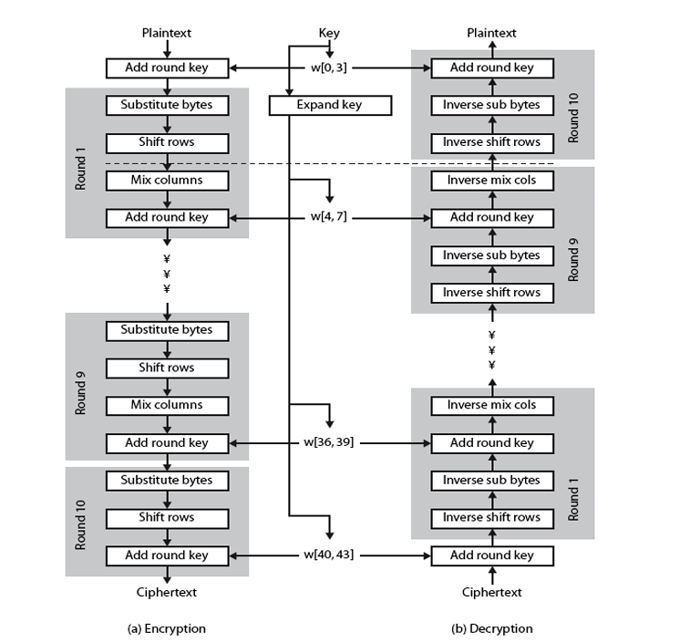

**Output waveform:**

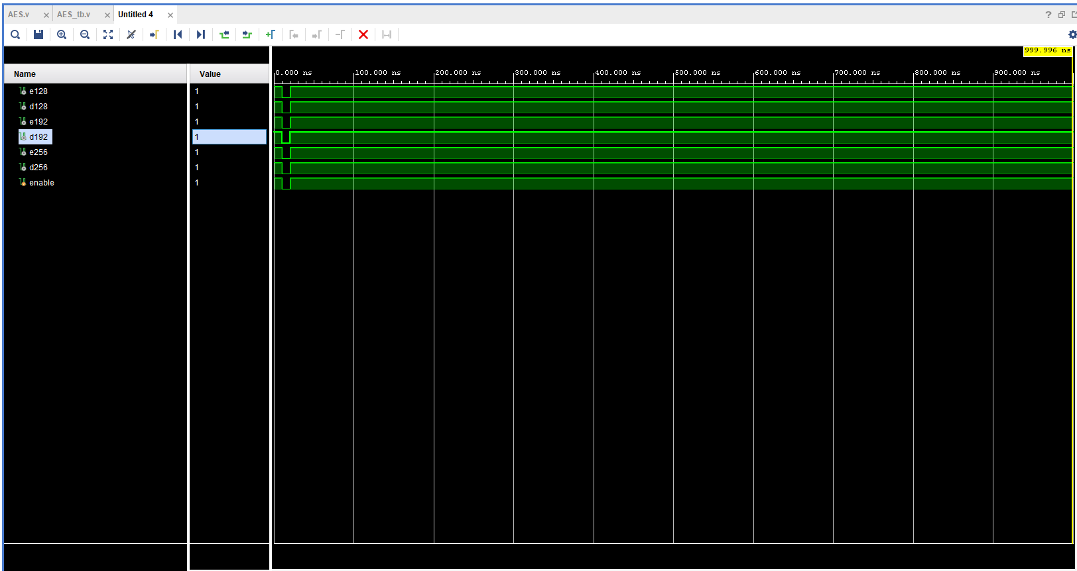

**Design Code:**

**AES:**

module AES(enable, e128, d128, e192, d192, e256, d256);

output wire e128;

output wire d128;

output wire e192;

output wire d192;

output wire e256;

output wire d256;

input enable;

// The plain text used as input

wire[127:0] in = 128'h00112233445566778899aabbccddeeff;

// The different keys used for testing (one of each type)

wire[127:0] key128 = 128'h000102030405060708090a0b0c0d0e0f;

wire[191:0] key192 = 192'h000102030405060708090a0b0c0d0e0f1011121314151617;

wire[255:0] key256 = 256'h000102030405060708090a0b0c0d0e0f101112131415161718191a1b1c1d1e1f;

// The expected outputs from the encryption module

wire[127:0] expected128 = 128'h69c4e0d86a7b0430d8cdb78070b4c55a;

wire[127:0] expected192 = 128'hdda97ca4864cdfe06eaf70a0ec0d7191;

wire[127:0] expected256 = 128'h8ea2b7ca516745bfeafc49904b496089;

// The result of the encryption module for every type

wire[127:0] encrypted128;

wire[127:0] encrypted192;

wire[127:0] encrypted256;

assign e128 = (encrypted128 == expected128 && enable) ? 1'b1 : 1'b0;

assign e192 = (encrypted192 == expected192 && enable) ? 1'b1 : 1'b0;

assign e256 = (encrypted256 == expected256 && enable) ? 1'b1 : 1'b0;

// The result of the decryption module for every type

wire[127:0] decrypted128;

wire[127:0] decrypted192;

wire[127:0] decrypted256;

AES_Encrypt a(in,key128,encrypted128);

AES_Encrypt #(192,12,6) b(in,key192,encrypted192);

AES_Encrypt #(256,14,8) c(in,key256,encrypted256);

AES_Decrypt a2(encrypted128,key128,decrypted128);

AES_Decrypt #(192,12,6) b2(encrypted192,key192,decrypted192);

AES_Decrypt #(256,14,8) c2(encrypted256,key256,decrypted256);

assign d128 = (decrypted128 == in && enable) ? 1'b1 : 1'b0;

assign d192 = (decrypted192 == in && enable) ? 1'b1 : 1'b0;

assign d256 = (decrypted256 == in && enable) ? 1'b1 : 1'b0;

endmodule

**Sub Bytes:**

module subBytes(in,out);

input [127:0] in;

output [127:0] out;

genvar i;

generate

for(i=0;i<128;i=i+8) begin :sub_Bytes

sbox s(in[i +:8],out[i +:8]);

end

endgenerate

endmodule

**Shift Rows:**

module shiftRows (in, shifted);

input [0:127] in;

output [0:127] shifted;

// First row (r = 0) is not shifted

assign shifted[0+:8] = in[0+:8];

assign shifted[32+:8] = in[32+:8];

assign shifted[64+:8] = in[64+:8];

assign shifted[96+:8] = in[96+:8];

// Second row (r = 1) is cyclically left shifted by 1 offset

assign shifted[8+:8] = in[40+:8];

assign shifted[40+:8] = in[72+:8];

assign shifted[72+:8] = in[104+:8];

assign shifted[104+:8] = in[8+:8];

// Third row (r = 2) is cyclically left shifted by 2 offsets

assign shifted[16+:8] = in[80+:8];

assign shifted[48+:8] = in[112+:8];

assign shifted[80+:8] = in[16+:8];

assign shifted[112+:8] = in[48+:8];

// Fourth row (r = 3) is cyclically left shifted by 3 offsets

assign shifted[24+:8] = in[120+:8];

assign shifted[56+:8] = in[24+:8];

assign shifted[88+:8] = in[56+:8];

assign shifted[120+:8] = in[88+:8];

endmodule

**Sbox:**

module sbox(a,c);

input [7:0] a;

output [7:0] c;

reg [7:0] c;

always @(a)

case (a)

8'h00: c=8'h63;

8'h01: c=8'h7c;

8'h02: c=8'h77;

8'h03: c=8'h7b;

8'h04: c=8'hf2;

8'h05: c=8'h6b;

8'h06: c=8'h6f;

8'h07: c=8'hc5;

8'h08: c=8'h30;

8'h09: c=8'h01;

8'h0a: c=8'h67;

8'h0b: c=8'h2b;

8'h0c: c=8'hfe;

8'h0d: c=8'hd7;

8'h0e: c=8'hab;

8'h0f: c=8'h76;

8'h10: c=8'hca;

8'h11: c=8'h82;

8'h12: c=8'hc9;

8'h13: c=8'h7d;

8'h14: c=8'hfa;

8'h15: c=8'h59;

8'h16: c=8'h47;

8'h17: c=8'hf0;

8'h18: c=8'had;

8'h19: c=8'hd4;

8'h1a: c=8'ha2;

8'h1b: c=8'haf;

8'h1c: c=8'h9c;

8'h1d: c=8'ha4;

8'h1e: c=8'h72;

8'h1f: c=8'hc0;

8'h20: c=8'hb7;

8'h21: c=8'hfd;

8'h22: c=8'h93;

8'h23: c=8'h26;

8'h24: c=8'h36;

8'h25: c=8'h3f;

8'h26: c=8'hf7;

8'h27: c=8'hcc;

8'h28: c=8'h34;

8'h29: c=8'ha5;

8'h2a: c=8'he5;

8'h2b: c=8'hf1;

8'h2c: c=8'h71;

8'h2d: c=8'hd8;

8'h2e: c=8'h31;

8'h2f: c=8'h15;

8'h30: c=8'h04;

8'h31: c=8'hc7;

8'h32: c=8'h23;

8'h33: c=8'hc3;

8'h34: c=8'h18;

8'h35: c=8'h96;

8'h36: c=8'h05;

8'h37: c=8'h9a;

8'h38: c=8'h07;

8'h39: c=8'h12;

8'h3a: c=8'h80;

8'h3b: c=8'he2;

8'h3c: c=8'heb;

8'h3d: c=8'h27;

8'h3e: c=8'hb2;

8'h3f: c=8'h75;

8'h40: c=8'h09;

8'h41: c=8'h83;

8'h42: c=8'h2c;

8'h43: c=8'h1a;

8'h44: c=8'h1b;

8'h45: c=8'h6e;

8'h46: c=8'h5a;

8'h47: c=8'ha0;

8'h48: c=8'h52;

8'h49: c=8'h3b;

8'h4a: c=8'hd6;

8'h4b: c=8'hb3;

8'h4c: c=8'h29;

8'h4d: c=8'he3;

8'h4e: c=8'h2f;

8'h4f: c=8'h84;

8'h50: c=8'h53;

8'h51: c=8'hd1;

8'h52: c=8'h00;

8'h53: c=8'hed;

8'h54: c=8'h20;

8'h55: c=8'hfc;

8'h56: c=8'hb1;

8'h57: c=8'h5b;

8'h58: c=8'h6a;

8'h59: c=8'hcb;

8'h5a: c=8'hbe;

8'h5b: c=8'h39;

8'h5c: c=8'h4a;

8'h5d: c=8'h4c;

8'h5e: c=8'h58;

8'h5f: c=8'hcf;

8'h60: c=8'hd0;

8'h61: c=8'hef;

8'h62: c=8'haa;

8'h63: c=8'hfb;

8'h64: c=8'h43;

8'h65: c=8'h4d;

8'h66: c=8'h33;

8'h67: c=8'h85;

8'h68: c=8'h45;

8'h69: c=8'hf9;

8'h6a: c=8'h02;

8'h6b: c=8'h7f;

8'h6c: c=8'h50;

8'h6d: c=8'h3c;

8'h6e: c=8'h9f;

8'h6f: c=8'ha8;

8'h70: c=8'h51;

8'h71: c=8'ha3;

8'h72: c=8'h40;

8'h73: c=8'h8f;

8'h74: c=8'h92;

8'h75: c=8'h9d;

8'h76: c=8'h38;

8'h77: c=8'hf5;

8'h78: c=8'hbc;

8'h79: c=8'hb6;

8'h7a: c=8'hda;

8'h7b: c=8'h21;

8'h7c: c=8'h10;

8'h7d: c=8'hff;

8'h7e: c=8'hf3;

8'h7f: c=8'hd2;

8'h80: c=8'hcd;

8'h81: c=8'h0c;

8'h82: c=8'h13;

8'h83: c=8'hec;

8'h84: c=8'h5f;

8'h85: c=8'h97;

8'h86: c=8'h44;

8'h87: c=8'h17;

8'h88: c=8'hc4;

8'h89: c=8'ha7;

8'h8a: c=8'h7e;

8'h8b: c=8'h3d;

8'h8c: c=8'h64;

8'h8d: c=8'h5d;

8'h8e: c=8'h19;

8'h8f: c=8'h73;

8'h90: c=8'h60;

8'h91: c=8'h81;

8'h92: c=8'h4f;

8'h93: c=8'hdc;

8'h94: c=8'h22;

8'h95: c=8'h2a;

8'h96: c=8'h90;

8'h97: c=8'h88;

8'h98: c=8'h46;

8'h99: c=8'hee;

8'h9a: c=8'hb8;

8'h9b: c=8'h14;

8'h9c: c=8'hde;

8'h9d: c=8'h5e;

8'h9e: c=8'h0b;

8'h9f: c=8'hdb;

8'ha0: c=8'he0;

8'ha1: c=8'h32;

8'ha2: c=8'h3a;

8'ha3: c=8'h0a;

8'ha4: c=8'h49;

8'ha5: c=8'h06;

8'ha6: c=8'h24;

8'ha7: c=8'h5c;

8'ha8: c=8'hc2;

8'ha9: c=8'hd3;

8'haa: c=8'hac;

8'hab: c=8'h62;

8'hac: c=8'h91;

8'had: c=8'h95;

8'hae: c=8'he4;

8'haf: c=8'h79;

8'hb0: c=8'he7;

8'hb1: c=8'hc8;

8'hb2: c=8'h37;

8'hb3: c=8'h6d;

8'hb4: c=8'h8d;

8'hb5: c=8'hd5;

8'hb6: c=8'h4e;

8'hb7: c=8'ha9;

8'hb8: c=8'h6c;

8'hb9: c=8'h56;

8'hba: c=8'hf4;

8'hbb: c=8'hea;

8'hbc: c=8'h65;

8'hbd: c=8'h7a;

8'hbe: c=8'hae;

8'hbf: c=8'h08;

8'hc0: c=8'hba;

8'hc1: c=8'h78;

8'hc2: c=8'h25;

8'hc3: c=8'h2e;

8'hc4: c=8'h1c;

8'hc5: c=8'ha6;

8'hc6: c=8'hb4;

8'hc7: c=8'hc6;

8'hc8: c=8'he8;

8'hc9: c=8'hdd;

8'hca: c=8'h74;

8'hcb: c=8'h1f;

8'hcc: c=8'h4b;

8'hcd: c=8'hbd;

8'hce: c=8'h8b;

8'hcf: c=8'h8a;

8'hd0: c=8'h70;

8'hd1: c=8'h3e;

8'hd2: c=8'hb5;

8'hd3: c=8'h66;

8'hd4: c=8'h48;

8'hd5: c=8'h03;

8'hd6: c=8'hf6;

8'hd7: c=8'h0e;

8'hd8: c=8'h61;

8'hd9: c=8'h35;

8'hda: c=8'h57;

8'hdb: c=8'hb9;

8'hdc: c=8'h86;

8'hdd: c=8'hc1;

8'hde: c=8'h1d;

8'hdf: c=8'h9e;

8'he0: c=8'he1;

8'he1: c=8'hf8;

8'he2: c=8'h98;

8'he3: c=8'h11;

8'he4: c=8'h69;

8'he5: c=8'hd9;

8'he6: c=8'h8e;

8'he7: c=8'h94;

8'he8: c=8'h9b;

8'he9: c=8'h1e;

8'hea: c=8'h87;

8'heb: c=8'he9;

8'hec: c=8'hce;

8'hed: c=8'h55;

8'hee: c=8'h28;

8'hef: c=8'hdf;

8'hf0: c=8'h8c;

8'hf1: c=8'ha1;

8'hf2: c=8'h89;

8'hf3: c=8'h0d;

8'hf4: c=8'hbf;

8'hf5: c=8'he6;

8'hf6: c=8'h42;

8'hf7: c=8'h68;

8'hf8: c=8'h41;

8'hf9: c=8'h99;

8'hfa: c=8'h2d;

8'hfb: c=8'h0f;

8'hfc: c=8'hb0;

8'hfd: c=8'h54;

8'hfe: c=8'hbb;

8'hff: c=8'h16;

endcase

endmodule

**Mix Colums:**

module mixColumns(state_in,state_out);

input [127:0] state_in;

output[127:0] state_out;

function [7:0] mb2; //multiply by 2

input [7:0] x;

begin

/* multiplication by 2 is shifting on bit to the left, and if the original 8 bits had a 1 @ MSB,

xor the result with {1b}*/

if(x[7] == 1) mb2 = ((x << 1) ^ 8'h1b);

else mb2 = x << 1;

end

endfunction

/*

multiplication by 3 is done by:

multiplication by {02} xor(the original x)

so that 2+1=3. where xor is the addition of elements in finite fields

*/

function [7:0] mb3; //multiply by 3

input [7:0] x;

begin

mb3 = mb2(x) ^ x;

end

endfunction

genvar i;

generate

for(i=0;i< 4;i=i+1) begin : m_col

assign state_out[(i*32 + 24)+:8]= mb2(state_in[(i*32 + 24)+:8]) ^ mb3(state_in[(i*32 + 16)+:8]) ^ state_in[(i*32 + 8)+:8] ^ state_in[i*32+:8];

assign state_out[(i*32 + 16)+:8]= state_in[(i*32 + 24)+:8] ^ mb2(state_in[(i*32 + 16)+:8]) ^ mb3(state_in[(i*32 + 8)+:8]) ^ state_in[i*32+:8];

assign state_out[(i*32 + 8)+:8]= state_in[(i*32 + 24)+:8] ^ state_in[(i*32 + 16)+:8] ^ mb2(state_in[(i*32 + 8)+:8]) ^ mb3(state_in[i*32+:8]);

assign state_out[i*32+:8]= mb3(state_in[(i*32 + 24)+:8]) ^ state_in[(i*32 + 16)+:8] ^ state_in[(i*32 + 8)+:8] ^ mb2(state_in[i*32+:8]);

end

endgenerate

endmodule

**Add Round Key:**

module addRoundKey(data, out, key);

input [127:0] data;

input [127:0] key;

output [127:0] out;

assign out = key ^ data;

endmodule

**Key Expanction:**

module keyExpansion #(parameter nk=4,parameter nr=10)(key,w);

// The first [(nk*32)-1 ]-bit key that we use to generate the rest of the keys of the other rounds.

// [(nk*32)-1 ] is the key length (128-bit key, 192-bit key or 256-bit key for nK=4,6 or 8 respectively).

input [0 : (nk * 32) - 1] key;

// w represents the array that will store all the generated keys of all rounds.

/* [(128 * (nr + 1)) - 1] this formula is meant to calculate the length of W ; so that it can store all the

generated keys of all rounds.*/

output reg [0 : (128 * (nr + 1)) - 1] w;

reg [0:31] temp;

reg [0:31] r;

reg [0:31] rot; // It stores the returned value from the function rotword().

reg [0:31] x; //It stores the returned value from the function subwordx().

reg [0:31] rconv; //It stores the returned value from the function rconx().

reg [0:31]new;

integer i;

/*

We generate all the keys needed in the encryption and decryption at the beginning of the encryption or decryption

and store them, then we use them in the AES_Encrypt and AES_Decrypt modules as needed according to the current

round.

*/

/*

The functions:

1) subwordx() applies a table lookup to all to all four bytes of the sent word. subwordx() calls the function

c() four times, each time it sends to c() 1-byte to perform the table lookup on it.

2) rconx() contains the values given by [x^(i-1),{00},{00},{00}], with x^(i-1) being powers

of x (x is denoted as {02}) in the field GF(28).

3) rotword() applies a cyclic shift of the bytes in a word. For example,{09cf4f3c} is changed into {cf4f3c09}

after applying this function.

*/

/*

The pseudo-code of the this algorithm is found in the NIST.pdf attached to the repository with some modification

in the code to fit with verilog.

*/

/*

For simplicity, We are going to explain the storing mechanism of the generated keys on an example of

128-bit key.It would be easy to apply the same concept on 192-bit and 256-bit keys. We would explain it in one

round only. The next rounds would perform the same operations.

-The example:

-Note that in case of 128-bit key w[0:1407].

1) when w=key then w= {1279*{0}:key} where 1279*{0} means that the first 1279 bits are all zero valued

and the end of the w array contains the current 128-bit key.

2) when temp = w[(128 * (nr + 1) - 32) +: 32] then temp=w[1376 +:32] so temp in the first round would contain

the last 32-bit word of the the current key.

3) After performing (temp = SubWord(RotWord(temp)) xor Rcon[i/Nk]) or (temp = SubWord(temp)), We would perform

(new = w[(128*(nr+1)-(nk*32))+:32] ^ temp) which is (new=w[1280+:32] ^ temp) in the first round,

where w[(128*(nr+1)-(nk*32))+:32] here is equivelent to w[i-Nk] in the pseudo-code. Now we have the new

generated key word (new) and we need to add it at the end of (W) array.

4) We would shift W by 32-bit to the left to empty space to the new generated key word.

5) w = {w[0 : (128 * (nr + 1) - 32) - 1], new} is w={w[0:1375],new} where w now contains w={1247*{0}:key:new}

where 1247*{0} means that the first 1247 bits are all zero valued and they are followed by the original

128-bit key, which are followed by the new generated 32-bit key.

6) Repeat this process for the rest of the rounds.At the end of all the rounds we would have all the W array

filled with all the keys.

*/

always@* begin

//The first [(nk*32)-1 ]-bit key is stored in W.

w = key;

for(i = nk; i < 4*(nr + 1); i = i + 1) begin

temp = w[(128 * (nr + 1) - 32) +: 32];

if(i % nk == 0) begin

rot = rotword(temp); // A call to the function rotword() is done and the returned value is stored in rot.

x = subwordx (rot); //A call to the function subwordx() is done and the returned value is stored in x.

rconv = rconx (i/nk); //A call to the function rconx() is done and the returned value is stored in rconv.

temp = x ^ rconv;

end

else if(nk >6 && i % nk == 4) begin

temp = subwordx(temp);

end

new = (w[(128*(nr+1)-(nk*32))+:32] ^ temp);

// We would shift W by 32 bit to the left to add the new generated key word (new) at its end.

w = w << 32;

w = {w[0 : (128 * (nr + 1) - 32) - 1], new};

end

end

function [0:31] rotword;

input [0:31] x;

begin

rotword={x[8:31],x[0:7]};

end

endfunction

function [0:31] subwordx;

input [0:31] a;

begin

subwordx[0:7]=c(a[0:7]);

subwordx[8:15]=c(a[8:15]);

subwordx[16:23]=c(a[16:23]);

subwordx[24:31]=c(a[24:31]);

end

endfunction

function [7:0] c(input [7:0] a);

begin

case (a)

8'h00: c=8'h63;

8'h01: c=8'h7c;

8'h02: c=8'h77;

8'h03: c=8'h7b;

8'h04: c=8'hf2;

8'h05: c=8'h6b;

8'h06: c=8'h6f;

8'h07: c=8'hc5;

8'h08: c=8'h30;

8'h09: c=8'h01;

8'h0a: c=8'h67;

8'h0b: c=8'h2b;

8'h0c: c=8'hfe;

8'h0d: c=8'hd7;

8'h0e: c=8'hab;

8'h0f: c=8'h76;

8'h10: c=8'hca;

8'h11: c=8'h82;

8'h12: c=8'hc9;

8'h13: c=8'h7d;

8'h14: c=8'hfa;

8'h15: c=8'h59;

8'h16: c=8'h47;

8'h17: c=8'hf0;

8'h18: c=8'had;

8'h19: c=8'hd4;

8'h1a: c=8'ha2;

8'h1b: c=8'haf;

8'h1c: c=8'h9c;

8'h1d: c=8'ha4;

8'h1e: c=8'h72;

8'h1f: c=8'hc0;

8'h20: c=8'hb7;

8'h21: c=8'hfd;

8'h22: c=8'h93;

8'h23: c=8'h26;

8'h24: c=8'h36;

8'h25: c=8'h3f;

8'h26: c=8'hf7;

8'h27: c=8'hcc;

8'h28: c=8'h34;

8'h29: c=8'ha5;

8'h2a: c=8'he5;

8'h2b: c=8'hf1;

8'h2c: c=8'h71;

8'h2d: c=8'hd8;

8'h2e: c=8'h31;

8'h2f: c=8'h15;

8'h30: c=8'h04;

8'h31: c=8'hc7;

8'h32: c=8'h23;

8'h33: c=8'hc3;

8'h34: c=8'h18;

8'h35: c=8'h96;

8'h36: c=8'h05;

8'h37: c=8'h9a;

8'h38: c=8'h07;

8'h39: c=8'h12;

8'h3a: c=8'h80;

8'h3b: c=8'he2;

8'h3c: c=8'heb;

8'h3d: c=8'h27;

8'h3e: c=8'hb2;

8'h3f: c=8'h75;

8'h40: c=8'h09;

8'h41: c=8'h83;

8'h42: c=8'h2c;

8'h43: c=8'h1a;

8'h44: c=8'h1b;

8'h45: c=8'h6e;

8'h46: c=8'h5a;

8'h47: c=8'ha0;

8'h48: c=8'h52;

8'h49: c=8'h3b;

8'h4a: c=8'hd6;

8'h4b: c=8'hb3;

8'h4c: c=8'h29;

8'h4d: c=8'he3;

8'h4e: c=8'h2f;

8'h4f: c=8'h84;

8'h50: c=8'h53;

8'h51: c=8'hd1;

8'h52: c=8'h00;

8'h53: c=8'hed;

8'h54: c=8'h20;

8'h55: c=8'hfc;

8'h56: c=8'hb1;

8'h57: c=8'h5b;

8'h58: c=8'h6a;

8'h59: c=8'hcb;

8'h5a: c=8'hbe;

8'h5b: c=8'h39;

8'h5c: c=8'h4a;

8'h5d: c=8'h4c;

8'h5e: c=8'h58;

8'h5f: c=8'hcf;

8'h60: c=8'hd0;

8'h61: c=8'hef;

8'h62: c=8'haa;

8'h63: c=8'hfb;

8'h64: c=8'h43;

8'h65: c=8'h4d;

8'h66: c=8'h33;

8'h67: c=8'h85;

8'h68: c=8'h45;

8'h69: c=8'hf9;

8'h6a: c=8'h02;

8'h6b: c=8'h7f;

8'h6c: c=8'h50;

8'h6d: c=8'h3c;

8'h6e: c=8'h9f;

8'h6f: c=8'ha8;

8'h70: c=8'h51;

8'h71: c=8'ha3;

8'h72: c=8'h40;

8'h73: c=8'h8f;

8'h74: c=8'h92;

8'h75: c=8'h9d;

8'h76: c=8'h38;

8'h77: c=8'hf5;

8'h78: c=8'hbc;

8'h79: c=8'hb6;

8'h7a: c=8'hda;

8'h7b: c=8'h21;

8'h7c: c=8'h10;

8'h7d: c=8'hff;

8'h7e: c=8'hf3;

8'h7f: c=8'hd2;

8'h80: c=8'hcd;

8'h81: c=8'h0c;

8'h82: c=8'h13;

8'h83: c=8'hec;

8'h84: c=8'h5f;

8'h85: c=8'h97;

8'h86: c=8'h44;

8'h87: c=8'h17;

8'h88: c=8'hc4;

8'h89: c=8'ha7;

8'h8a: c=8'h7e;

8'h8b: c=8'h3d;

8'h8c: c=8'h64;

8'h8d: c=8'h5d;

8'h8e: c=8'h19;

8'h8f: c=8'h73;

8'h90: c=8'h60;

8'h91: c=8'h81;

8'h92: c=8'h4f;

8'h93: c=8'hdc;

8'h94: c=8'h22;

8'h95: c=8'h2a;

8'h96: c=8'h90;

8'h97: c=8'h88;

8'h98: c=8'h46;

8'h99: c=8'hee;

8'h9a: c=8'hb8;

8'h9b: c=8'h14;

8'h9c: c=8'hde;

8'h9d: c=8'h5e;

8'h9e: c=8'h0b;

8'h9f: c=8'hdb;

8'ha0: c=8'he0;

8'ha1: c=8'h32;

8'ha2: c=8'h3a;

8'ha3: c=8'h0a;

8'ha4: c=8'h49;

8'ha5: c=8'h06;

8'ha6: c=8'h24;

8'ha7: c=8'h5c;

8'ha8: c=8'hc2;

8'ha9: c=8'hd3;

8'haa: c=8'hac;

8'hab: c=8'h62;

8'hac: c=8'h91;

8'had: c=8'h95;

8'hae: c=8'he4;

8'haf: c=8'h79;

8'hb0: c=8'he7;

8'hb1: c=8'hc8;

8'hb2: c=8'h37;

8'hb3: c=8'h6d;

8'hb4: c=8'h8d;

8'hb5: c=8'hd5;

8'hb6: c=8'h4e;

8'hb7: c=8'ha9;

8'hb8: c=8'h6c;

8'hb9: c=8'h56;

8'hba: c=8'hf4;

8'hbb: c=8'hea;

8'hbc: c=8'h65;

8'hbd: c=8'h7a;

8'hbe: c=8'hae;

8'hbf: c=8'h08;

8'hc0: c=8'hba;

8'hc1: c=8'h78;

8'hc2: c=8'h25;

8'hc3: c=8'h2e;

8'hc4: c=8'h1c;

8'hc5: c=8'ha6;

8'hc6: c=8'hb4;

8'hc7: c=8'hc6;

8'hc8: c=8'he8;

8'hc9: c=8'hdd;

8'hca: c=8'h74;

8'hcb: c=8'h1f;

8'hcc: c=8'h4b;

8'hcd: c=8'hbd;

8'hce: c=8'h8b;

8'hcf: c=8'h8a;

8'hd0: c=8'h70;

8'hd1: c=8'h3e;

8'hd2: c=8'hb5;

8'hd3: c=8'h66;

8'hd4: c=8'h48;

8'hd5: c=8'h03;

8'hd6: c=8'hf6;

8'hd7: c=8'h0e;

8'hd8: c=8'h61;

8'hd9: c=8'h35;

8'hda: c=8'h57;

8'hdb: c=8'hb9;

8'hdc: c=8'h86;

8'hdd: c=8'hc1;

8'hde: c=8'h1d;

8'hdf: c=8'h9e;

8'he0: c=8'he1;

8'he1: c=8'hf8;

8'he2: c=8'h98;

8'he3: c=8'h11;

8'he4: c=8'h69;

8'he5: c=8'hd9;

8'he6: c=8'h8e;

8'he7: c=8'h94;

8'he8: c=8'h9b;

8'he9: c=8'h1e;

8'hea: c=8'h87;

8'heb: c=8'he9;

8'hec: c=8'hce;

8'hed: c=8'h55;

8'hee: c=8'h28;

8'hef: c=8'hdf;

8'hf0: c=8'h8c;

8'hf1: c=8'ha1;

8'hf2: c=8'h89;

8'hf3: c=8'h0d;

8'hf4: c=8'hbf;

8'hf5: c=8'he6;

8'hf6: c=8'h42;

8'hf7: c=8'h68;

8'hf8: c=8'h41;

8'hf9: c=8'h99;

8'hfa: c=8'h2d;

8'hfb: c=8'h0f;

8'hfc: c=8'hb0;

8'hfd: c=8'h54;

8'hfe: c=8'hbb;

8'hff: c=8'h16;

endcase

end

endfunction

function[0:31] rconx;

input [0:31] r;

begin

case(r)

4'h1: rconx=32'h01000000;

4'h2: rconx=32'h02000000;

4'h3: rconx=32'h04000000;

4'h4: rconx=32'h08000000;

4'h5: rconx=32'h10000000;

4'h6: rconx=32'h20000000;

4'h7: rconx=32'h40000000;

4'h8: rconx=32'h80000000;

4'h9: rconx=32'h1b000000;

4'ha: rconx=32'h36000000;

default: rconx=32'h00000000;

endcase

end

endfunction

endmodule

**Inverse Sub Bytes:**

module inverseSubBytes(in,out);

input [127:0] in;

output [127:0] out;

genvar i;

generate

for(i=0;i<128;i=i+8) begin :sub_Bytes

inverseSbox s(in[i +:8],out[i +:8]);

end

endgenerate

endmodule

**Inverse Shift Row:**

module inverseShiftRows (in, shifted);

input [0:127] in;

output [0:127] shifted;

// First row (r = 0) is not shifted

assign shifted[0+:8] = in[0+:8];

assign shifted[32+:8] = in[32+:8];

assign shifted[64+:8] = in[64+:8];

assign shifted[96+:8] = in[96+:8];

// Second row (r = 1) is cyclically right shifted by 1 offset

assign shifted[8+:8] = in[104+:8];

assign shifted[40+:8] = in[8+:8];

assign shifted[72+:8] = in[40+:8];

assign shifted[104+:8] = in[72+:8];

// Third row (r = 2) is cyclically right shifted by 2 offsets

assign shifted[16+:8] = in[80+:8];

assign shifted[48+:8] = in[112+:8];

assign shifted[80+:8] = in[16+:8];

assign shifted[112+:8] = in[48+:8];

// Fourth row (r = 3) is cyclically right shifted by 3 offsets

assign shifted[24+:8] = in[56+:8];

assign shifted[56+:8] = in[88+:8];

assign shifted[88+:8] = in[120+:8];

assign shifted[120+:8] = in[24+:8];

endmodule

**Inverse Sbox:**

module inverseSbox(selector,sbout);

input [7:0] selector;

output reg [7:0] sbout;

always@(*)

begin

case(selector)

8'h00:sbout =8'h52;

8'h01:sbout =8'h09;

8'h02:sbout =8'h6a;

8'h03:sbout =8'hd5;

8'h04:sbout =8'h30;

8'h05:sbout =8'h36;

8'h06:sbout =8'ha5;

8'h07:sbout =8'h38;

8'h08:sbout =8'hbf;

8'h09:sbout =8'h40;

8'h0a:sbout =8'ha3;

8'h0b:sbout =8'h9e;

8'h0c:sbout =8'h81;

8'h0d:sbout =8'hf3;

8'h0e:sbout =8'hd7;

8'h0f:sbout =8'hfb;

8'h10:sbout =8'h7c;

8'h11:sbout =8'he3;

8'h12:sbout =8'h39;

8'h13:sbout =8'h82;

8'h14:sbout =8'h9b;

8'h15:sbout =8'h2f;

8'h16:sbout =8'hff;

8'h17:sbout =8'h87;

8'h18:sbout =8'h34;

8'h19:sbout =8'h8e;

8'h1a:sbout =8'h43;

8'h1b:sbout =8'h44;

8'h1c:sbout =8'hc4;

8'h1d:sbout =8'hde;

8'h1e:sbout =8'he9;

8'h1f:sbout =8'hcb;

8'h20:sbout =8'h54;

8'h21:sbout =8'h7b;

8'h22:sbout =8'h94;

8'h23:sbout =8'h32;

8'h24:sbout =8'ha6;

8'h25:sbout =8'hc2;

8'h26:sbout =8'h23;

8'h27:sbout =8'h3d;

8'h28:sbout =8'hee;

8'h29:sbout =8'h4c;

8'h2a:sbout =8'h95;

8'h2b:sbout =8'h0b;

8'h2c:sbout =8'h42;

8'h2d:sbout =8'hfa;

8'h2e:sbout =8'hc3;

8'h2f:sbout =8'h4e;

8'h30:sbout =8'h08;

8'h31:sbout =8'h2e;

8'h32:sbout =8'ha1;

8'h33:sbout =8'h66;

8'h34:sbout =8'h28;

8'h35:sbout =8'hd9;

8'h36:sbout =8'h24;

8'h37:sbout =8'hb2;

8'h38:sbout =8'h76;

8'h39:sbout =8'h5b;

8'h3a:sbout =8'ha2;

8'h3b:sbout =8'h49;

8'h3c:sbout =8'h6d;

8'h3d:sbout =8'h8b;

8'h3e:sbout =8'hd1;

8'h3f:sbout =8'h25;

8'h40:sbout =8'h72;

8'h41:sbout =8'hf8;

8'h42:sbout =8'hf6;

8'h43:sbout =8'h64;

8'h44:sbout =8'h86;

8'h45:sbout =8'h68;

8'h46:sbout =8'h98;

8'h47:sbout =8'h16;

8'h48:sbout =8'hd4;

8'h49:sbout =8'ha4;

8'h4a:sbout =8'h5c;

8'h4b:sbout =8'hcc;

8'h4c:sbout =8'h5d;

8'h4d:sbout =8'h65;

8'h4e:sbout =8'hb6;

8'h4f:sbout =8'h92;

8'h50:sbout =8'h6c;

8'h51:sbout =8'h70;

8'h52:sbout =8'h48;

8'h53:sbout =8'h50;

8'h54:sbout =8'hfd;

8'h55:sbout =8'hed;

8'h56:sbout =8'hb9;

8'h57:sbout =8'hda;

8'h58:sbout =8'h5e;

8'h59:sbout =8'h15;

8'h5a:sbout =8'h46;

8'h5b:sbout =8'h57;

8'h5c:sbout =8'ha7;

8'h5d:sbout =8'h8d;

8'h5e:sbout =8'h9d;

8'h5f:sbout =8'h84;

8'h60:sbout =8'h90;

8'h61:sbout =8'hd8;

8'h62:sbout =8'hab;

8'h63:sbout =8'h00;

8'h64:sbout =8'h8c;

8'h65:sbout =8'hbc;

8'h66:sbout =8'hd3;

8'h67:sbout =8'h0a;

8'h68:sbout =8'hf7;

8'h69:sbout =8'he4;

8'h6a:sbout =8'h58;

8'h6b:sbout =8'h05;

8'h6c:sbout =8'hb8;

8'h6d:sbout =8'hb3;

8'h6e:sbout =8'h45;

8'h6f:sbout =8'h06;

8'h70:sbout =8'hd0;

8'h71:sbout =8'h2c;

8'h72:sbout =8'h1e;

8'h73:sbout =8'h8f;

8'h74:sbout =8'hca;

8'h75:sbout =8'h3f;

8'h76:sbout =8'h0f;

8'h77:sbout =8'h02;

8'h78:sbout =8'hc1;

8'h79:sbout =8'haf;

8'h7a:sbout =8'hbd;

8'h7b:sbout =8'h03;

8'h7c:sbout =8'h01;

8'h7d:sbout =8'h13;

8'h7e:sbout =8'h8a;

8'h7f:sbout =8'h6b;

8'h80:sbout =8'h3a;

8'h81:sbout =8'h91;

8'h82:sbout =8'h11;

8'h83:sbout =8'h41;

8'h84:sbout =8'h4f;

8'h85:sbout =8'h67;

8'h86:sbout =8'hdc;

8'h87:sbout =8'hea;

8'h88:sbout =8'h97;

8'h89:sbout =8'hf2;

8'h8a:sbout =8'hcf;

8'h8b:sbout =8'hce;

8'h8c:sbout =8'hf0;

8'h8d:sbout =8'hb4;

8'h8e:sbout =8'he6;

8'h8f:sbout =8'h73;

8'h90:sbout =8'h96;

8'h91:sbout =8'hac;

8'h92:sbout =8'h74;

8'h93:sbout =8'h22;

8'h94:sbout =8'he7;

8'h95:sbout =8'had;

8'h96:sbout =8'h35;

8'h97:sbout =8'h85;

8'h98:sbout =8'he2;

8'h99:sbout =8'hf9;

8'h9a:sbout =8'h37;

8'h9b:sbout =8'he8;

8'h9c:sbout =8'h1c;

8'h9d:sbout =8'h75;

8'h9e:sbout =8'hdf;

8'h9f:sbout =8'h6e;

8'ha0:sbout =8'h47;

8'ha1:sbout =8'hf1;

8'ha2:sbout =8'h1a;

8'ha3:sbout =8'h71;

8'ha4:sbout =8'h1d;

8'ha5:sbout =8'h29;

8'ha6:sbout =8'hc5;

8'ha7:sbout =8'h89;

8'ha8:sbout =8'h6f;

8'ha9:sbout =8'hb7;

8'haa:sbout =8'h62;

8'hab:sbout =8'h0e;

8'hac:sbout =8'haa;

8'had:sbout =8'h18;

8'hae:sbout =8'hbe;

8'haf:sbout =8'h1b;

8'hb0:sbout =8'hfc;

8'hb1:sbout =8'h56;

8'hb2:sbout =8'h3e;

8'hb3:sbout =8'h4b;

8'hb4:sbout =8'hc6;

8'hb5:sbout =8'hd2;

8'hb6:sbout =8'h79;

8'hb7:sbout =8'h20;

8'hb8:sbout =8'h9a;

8'hb9:sbout =8'hdb;

8'hba:sbout =8'hc0;

8'hbb:sbout =8'hfe;

8'hbc:sbout =8'h78;

8'hbd:sbout =8'hcd;

8'hbe:sbout =8'h5a;

8'hbf:sbout =8'hf4;

8'hc0:sbout =8'h1f;

8'hc1:sbout =8'hdd;

8'hc2:sbout =8'ha8;

8'hc3:sbout =8'h33;

8'hc4:sbout =8'h88;

8'hc5:sbout =8'h07;

8'hc6:sbout =8'hc7;

8'hc7:sbout =8'h31;

8'hc8:sbout =8'hb1;

8'hc9:sbout =8'h12;

8'hca:sbout =8'h10;

8'hcb:sbout =8'h59;

8'hcc:sbout =8'h27;

8'hcd:sbout =8'h80;

8'hce:sbout =8'hec;

8'hcf:sbout =8'h5f;

8'hd0:sbout =8'h60;

8'hd1:sbout =8'h51;

8'hd2:sbout =8'h7f;

8'hd3:sbout =8'ha9;

8'hd4:sbout =8'h19;

8'hd5:sbout =8'hb5;

8'hd6:sbout =8'h4a;

8'hd7:sbout =8'h0d;

8'hd8:sbout =8'h2d;

8'hd9:sbout =8'he5;

8'hda:sbout =8'h7a;

8'hdb:sbout =8'h9f;

8'hdc:sbout =8'h93;

8'hdd:sbout =8'hc9;

8'hde:sbout =8'h9c;

8'hdf:sbout =8'hef;

8'he0:sbout =8'ha0;

8'he1:sbout =8'he0;

8'he2:sbout =8'h3b;

8'he3:sbout =8'h4d;

8'he4:sbout =8'hae;

8'he5:sbout =8'h2a;

8'he6:sbout =8'hf5;

8'he7:sbout =8'hb0;

8'he8:sbout =8'hc8;

8'he9:sbout =8'heb;

8'hea:sbout =8'hbb;

8'heb:sbout =8'h3c;

8'hec:sbout =8'h83;

8'hed:sbout =8'h53;

8'hee:sbout =8'h99;

8'hef:sbout =8'h61;

8'hf0:sbout =8'h17;

8'hf1:sbout =8'h2b;

8'hf2:sbout =8'h04;

8'hf3:sbout =8'h7e;

8'hf4:sbout =8'hba;

8'hf5:sbout =8'h77;

8'hf6:sbout =8'hd6;

8'hf7:sbout =8'h26;

8'hf8:sbout =8'he1;

8'hf9:sbout =8'h69;

8'hfa:sbout =8'h14;

8'hfb:sbout =8'h63;

8'hfc:sbout =8'h55;

8'hfd:sbout =8'h21;

8'hfe:sbout =8'h0c;

8'hff:sbout =8'h7d;

endcase

end

endmodule

**Inverse Mix Columns:**

module inverseMixColumns(state_in,state_out);

input [127:0] state_in;

output [127:0] state_out;

/*

Multiplication by 2 can be implemented at the byte level as a left shift and a subsequent

conditional bitwise XOR with {1b},where bitwise xor with {1b} is done if x[7]= 1.

Multiplication by higher powers of x can be implemented by repeated application of multiplication by 2.

*/

//This function multiply by {02} n-times

function[7:0] multiply(input [7:0]x,input integer n);

integer i;

begin

for(i=0;i<n;i=i+1)begin

if(x[7] == 1) x = ((x << 1) ^ 8'h1b);

else x = x << 1;

end

multiply=x;

end

endfunction

/*

Multiply by {0e} is done by :

(multiplying by {02} 3 times which is equivalent to multiplication by {08}) xor

(multiplying by {02} 2 times which is equivalent to multiplication by {04}) xor

(multiplying by {02})

so that 8+4+2= e. where xor is the addition of elements in finite fields

*/

function [7:0] mb0e; //multiply by {0e}

input [7:0] x;

begin

mb0e=multiply(x,3) ^ multiply(x,2)^ multiply(x,1);

end

endfunction

/*

Multiply by {0d} is done by :

(multiplying by {02} 3 times which is equivalent to multiplication by {08}) xor

(multiplying by {02} 2 times which is equivalent to multiplication by {04}) xor

(the original x)

so that 8+4+1= d. where xor is the addition of elements in finite fields

*/

function [7:0] mb0d; //multiply by {0d}

input [7:0] x;

begin

mb0d=multiply(x,3) ^ multiply(x,2)^ x;

end

endfunction

/*

Multiply by {0b} is done by :

(multiplying by {02} 3 times which is equivalent to multiplication by {08}) xor

(multiplying by {02}) xor (the original x)

so that 8+2+1= b. where xor is the addition of elements in finite fields

*/

function [7:0] mb0b; //multiply by {0b}

input [7:0] x;

begin

mb0b=multiply(x,3) ^ multiply(x,1)^ x;

end

endfunction

/*

Multiply by {09} is done by :

(multiplying by {02} 3 times which is equivalent to multiplication by {08}) xor (the original x)

so that 8+1= 9. where xor is the addition of elements in finite fields

*/

function [7:0] mb09; //multiply by {09}

input [7:0] x;

begin

mb09=multiply(x,3) ^ x;

end

endfunction

genvar i;

generate

for(i=0;i< 4;i=i+1) begin : m_col

assign state_out[(i*32 + 24)+:8]= mb0e(state_in[(i*32 + 24)+:8]) ^ mb0b(state_in[(i*32 + 16)+:8]) ^ mb0d(state_in[(i*32 + 8)+:8]) ^ mb09(state_in[i*32+:8]);

assign state_out[(i*32 + 16)+:8]= mb09(state_in[(i*32 + 24)+:8]) ^ mb0e(state_in[(i*32 + 16)+:8]) ^ mb0b(state_in[(i*32 + 8)+:8]) ^ mb0d(state_in[i*32+:8]);

assign state_out[(i*32 + 8)+:8]= mb0d(state_in[(i*32 + 24)+:8]) ^ mb09(state_in[(i*32 + 16)+:8]) ^ mb0e(state_in[(i*32 + 8)+:8]) ^ mb0b(state_in[i*32+:8]);

assign state_out[i*32+:8]= mb0b(state_in[(i*32 + 24)+:8]) ^ mb0d(state_in[(i*32 + 16)+:8]) ^ mb09(state_in[(i*32 + 8)+:8]) ^ mb0e(state_in[i*32+:8]);

end

endgenerate

endmodule

**Encrypt Round:**

module encryptRound(in,key,out);

input [127:0] in;

output [127:0] out;

input [127:0] key;

wire [127:0] afterSubBytes;

wire [127:0] afterShiftRows;

wire [127:0] afterMixColumns;

wire [127:0] afterAddroundKey;

subBytes s(in,afterSubBytes);

shiftRows r(afterSubBytes,afterShiftRows);

mixColumns m(afterShiftRows,afterMixColumns);

addRoundKey b(afterMixColumns,out,key);

endmodule

**Decrypt Round:**

module decryptRound(in,key,out);

input [127:0] in;

output [127:0] out;

input [127:0] key;

wire [127:0] afterSubBytes;

wire [127:0] afterShiftRows;

wire [127:0] afterMixColumns;

wire [127:0] afterAddroundKey;

inverseShiftRows r(in,afterShiftRows);

inverseSubBytes s(afterShiftRows,afterSubBytes);

addRoundKey b(afterSubBytes,afterAddroundKey,key);

inverseMixColumns m(afterAddroundKey,out);

endmodule

**AES Encryption:**

module AES_Encrypt#(parameter N=128,parameter Nr=10,parameter Nk=4)(in,key,out);

input [127:0] in;

input [N-1:0] key;

output [127:0] out;

wire [(128*(Nr+1))-1 :0] fullkeys;

wire [127:0] states [Nr+1:0] ;

wire [127:0] afterSubBytes;

wire [127:0] afterShiftRows;

keyExpansion #(Nk,Nr) ke (key,fullkeys);

addRoundKey addrk1 (in,states[0],fullkeys[((128*(Nr+1))-1)-:128]);

genvar i;

generate

for(i=1; i<Nr ;i=i+1)begin : loop

encryptRound er(states[i-1],fullkeys[(((128*(Nr+1))-1)-128*i)-:128],states[i]);

end

subBytes sb(states[Nr-1],afterSubBytes);

shiftRows sr(afterSubBytes,afterShiftRows);

addRoundKey addrk2(afterShiftRows,states[Nr],fullkeys[127:0]);

assign out=states[Nr];

endgenerate

endmodule

**AES Decryption:**

module AES_Decrypt#(parameter N=128,parameter Nr=10,parameter Nk=4)(in,key,out);

input [127:0] in;

input [N-1:0] key;

output [127:0] out;

wire [(128*(Nr+1))-1 :0] fullkeys;

wire [127:0] states [Nr+1:0] ;

wire [127:0] afterSubBytes;

wire [127:0] afterShiftRows;

keyExpansion #(Nk,Nr) ke (key,fullkeys);

addRoundKey addrk1 (in,states[0],fullkeys[127:0]);

genvar i;

generate

for(i=1; i<Nr ;i=i+1)begin : loop

decryptRound dr(states[i-1],fullkeys[i*128+:128],states[i]);

end

inverseShiftRows sr(states[Nr-1],afterShiftRows);

inverseSubBytes sb(afterShiftRows,afterSubBytes);

addRoundKey addrk2(afterSubBytes,states[Nr],fullkeys[((128*(Nr+1))-1)-:128]);

assign out=states[Nr];

endgenerate

endmodule

**Testbench Code:**

module AES_tb();

wire e128;

wire d128;

wire e192;

wire d192;

wire e256;

wire d256;

reg enable;

AES a(enable, e128, d128, e192, d192, e256, d256);

initial begin

$monitor("Encrypt128 = %b, Decrypt128 = %b, Encrypt192 = %b, Decrypt192 = %b, Encrypt256 = %b, Decrypt256 = %b",

e128, d128, e192, d192, e256, d256);

// Turning on enable to check that all tests passed

enable = 1;

#10;

// Turning off enable to check if the leds turn off

enable = 0;

#10;

// Turning on enable to check if the leds turn on again

enable = 1;

#10;

end

endmodule

**Analysis:**

**Power Consumption:**

The image shows the power analysis of an FPGA design. The **total on-chip power** consumption is **4.675 W**, with **6% (0.284 W)** being **static power** and **94% (4.391 W)** being **dynamic power**. Among the dynamic power, **I/O accounts for 99% (4.376 W)** and **internal signal switching contributes 1% (0.015 W)**. The **junction temperature** is **78.9°C**, with a **thermal margin** of **6.1°C (equivalent to 0.5 W)**. The **ambient temperature** is assumed to be **25.0°C**, and the **effective thermal resistance (θJA)** is **11.5°C/W**. **No power is supplied to off-chip devices**, and the **confidence level of the analysis is marked as LOW**, indicating a need for more accurate switching activity data.

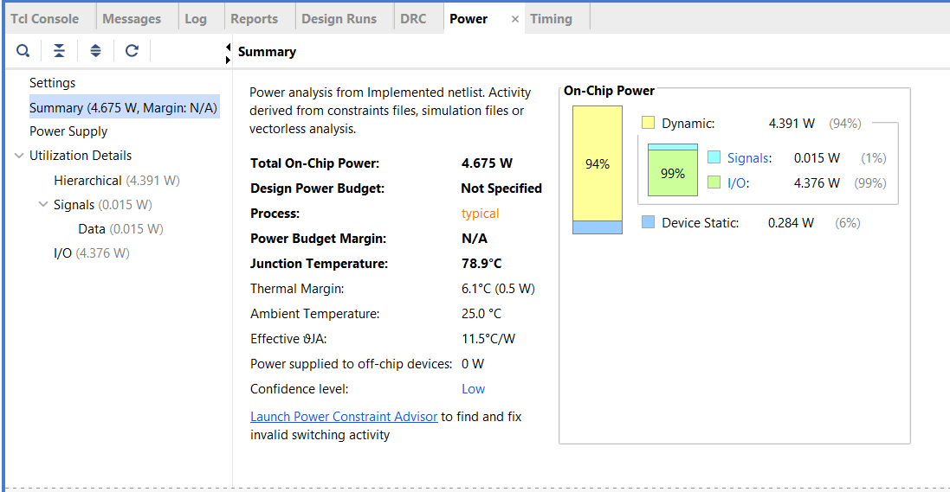

**Delay:**

The **minimum total setup delay** is **7.717 ns**. The **maximum total setup delay** is **8.478 ns**.

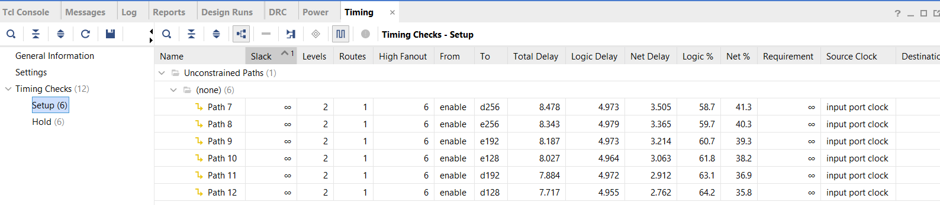

The **minimum total hold delay** is **2.142 ns**. The **maximum total hold delay** is **2.468 ns**.

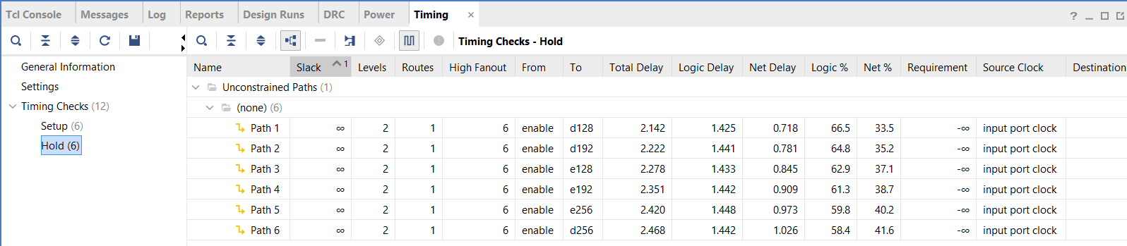

**Area:**

The image shows the **Post-Implementation Utilization Report** of an FPGA design. It indicates resource usage:

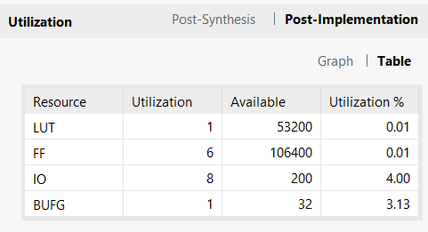

**RTL Schematic:**

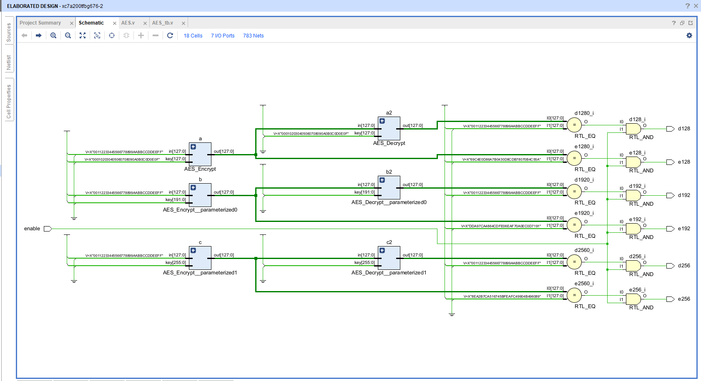

**CONCLUSION**

The project successfully explored the design, simulation, and analysis of core digital VLSI circuits, progressively building from fundamental arithmetic modules to a fully functional 8-bit ALU and CPU using Verilog HDL. A significant highlight of the work was the implementation of the AES cryptographic algorithm, supporting both encryption and decryption, demonstrating the real-world relevance of secure digital design.

Each module underwent comprehensive verification through simulation in Vivado, ensuring logical correctness and functionality. Furthermore, detailed timing, area, delay, and power analysis were carried out for each design. These evaluations provided crucial insights into trade-offs between performance and resource utilization, key considerations in modern VLSI design. The power report, delay optimization, and timing analysis helped identify critical paths and confirmed the design’s reliability under typical operating conditions.

Overall, this project not only strengthened the understanding of digital circuit design and HDL-based implementation but also emphasized the importance of performance analysis in developing efficient and scalable VLSI systems. The integration of cryptographic logic, such as AES, further enhanced the design scope, aligning it with industry-standard applications in secure communication and embedded systems.

**REFERENCES**

[1] National Institute of Standards and Technology, Announcing the Advanced Encryption Standard (AES), Federal Information Processing Standards Publication, no. 197, Nov. 2001.

[2] National Institute of Standards and Technology, Data Encryption Standard (DES), Federal Information Processing Standards Publication, no. 46-3, Oct. 1999.

[3] C.-C. Lu and S.-Y. Tseng. Integrated Design of AES (Advanced Encryption Standard) Encrypter and Decrypter. In Proc. Application Specific Systems, Architectures and Processors, pp. 277–285, July 2002.

[4] A. Satoh, S. Morioka, K. Takano, and S. Munetoh. A Compact Rijndael Hardware Architecture with S-Box Optimization. In Proc. ASIACRYPT 2001, LNCS 2248, pp. 239–254. Springer-Verlag, 2001.

[5] A. K. Lutz, J. Treichler, F. K. Gürkaynak, H. Kaeslin, G. Basler, A. Erni, S. Reichmuth, P. Rommens, S. Oetiker, and W. Fichtner. 2 Gbit/s Hardware Realizations of RIJNDAEL and SERPENT: A Comparative Analysis. In Proc. Cryptographic Hardware and Embedded Systems – CHES 2002, LNCS 2523, Springer-Verlag, pp. 144–158, 2003.

[6] I. Verbauwhede, P. Schaumont, and H. Kuo. Design and Perfomance Tesing of a 2.29-GB/s Rijndael Processor. IEEE Journal of Solid State Circuits, 38(3):569–572, Mar. 2003.

[7] N. S. Kim, T. Mudge, and R. Brown. A 2.3 Gb/s Fully Integrated and Synthesizable AES Rijndael Core. In Proc. IEEE Custom Integrated Circuits Conference, pp. 193–196, Sept. 2003.

[8] M. McLoone and J. V. McCanny. Rijndael FPGA Implementations Utilising Look-Up Tables. Journal of VLSI Signal Processing Systems for Signal, Image, and Video Technology. 34(3):261–275, July 2003.

[9] D.Richard Kuhn, Thomas J. Walsh, Steffen Fries. Security Considerations for Voice Over IP Systems. NIST Special Publication 800-58, April 2004.

[10] J. Wolkerstorfer, E. Oswald, and M. Lamberger. An ASIC Implementation of the AES SBoxes. In Proc. The Cryptographers’ Track at the RSA Conf. 2002 San Jose, CA, pp. 67–78, Feb. 2002.

[11] M. McLoone and J.V. McCanny. High Performance Single-chip FPGA Rijndael Algorithm Implementations. In Proc. of CHES 2001, LNCS 2162, pp. 65-76, 2001.

[12] F. X. Standaert, G. Rouvroy, J. J. Quisquater, and J. D. Legat. Efficient Implementation of Rijndael Encryption in Reconfigurable Hardware: Improvements and Design Tradeoffs. In Proc. of CHES 2003, LNCS 2779, Springer, pp. 334-350, Sep. 2003.